New York State
Student Information Repository System
(SIRS)

New York State
Student Identification System
(NYSSIS)
USERS GUIDE

Version 7.0 Released February 2015

The University of the State of New York
THE STATE EDUCATION DEPARTMENT
Information and Reporting Services
Albany, New York 12234

Contents
Introduction 2
Levels of the SIRS 2
Level 0 2
Level 1 3
Level 2 3
What Is NYSSIS? 4
How NYSSIS Works 4
NYSSIS Data Flow: Level 0 to Level 1 to Level 2 (Stages of SIRS) 6
Obtaining a Student ID Using NYSSIS 7
Loading Student Data to the SIRS Data Warehouse 7
Basic Student Identification data set required by NYSSIS 7
NYSSIS Student Identification Dataset 8
NYSSIS Student Identification Dataset Validation Rules 9
Submitting the NYSSIS Student Identification Dataset 10
Creating "Response Files" 11
NYSSIS ID Matching Process 11
Resolving Near Matches in the Hold Queue 11
How to request a NYSSIS User Account 12
NYSSIS User Interface Walk-Through 13
Logging in to NYSSIS 13
Accessing the Queue Resolution List 15
Queue Resolution List 17
Queue Near Match Candidates - Scenario 1 18
Queue Near Match Candidates - Scenario 2 19
Queue Compare to Specific Candidate 20
Queue Confirm Match 20
Queue Match Complete 22
Logging Out 23
Appendix A 24
SED NYSSIS application support contacts 24

Introduction

The New York State Student Identification System (NYSSIS) is a key element of the New York State Student Information Repository System (SIRS). The New York State Education Department (NYSED) initially developed NYSSIS to assign a stable, unique student identifier to every pre-kindergarten through grade 12 (“P-12”) student in New York State. Unique identifiers enhance student data reporting by ensuring that important educational records are associated with the correct students as students transfer between local educational agencies (LEAs), thus helping to improve overall data quality. In SIRS, each student record is uniquely identified with a 10-digit NYSSIS number, generally assigned when the student first enters a New York State public school, charter school or participating nonpublic school.
The purpose of SIRS is to provide a single source for standardized individual student records and other education-related data (course, attendance, teacher/staff, etc.) for analyses at the local, regional, and State levels, to improve student and teacher performance and to meet State and federal accountability requirements. As the reporting requirements for SIRS expand to include post-secondary education, so the function of a unique NYSSIS ID expands to accommodate longitudinal reporting beyond the P-12 grades. This document provides an overview of SIRS, contains template definitions of (and validation rules for) the data elements and records collected in order to assist vendors of information systems and LEAs in creating data files for submission, and includes tutorial-style walk-throughs of the NYSSIS application interface features and functions.

Levels of the SIRS

LEA SMS (Student Management System)

EXTRACT
Level 0
Application:
L1-hosted Data Collection &
Validation

L1 RIC / Big 5 Education Data Stores
Local Educational Agency (LEA) with
Student Management System
Local Educational Agency (LEA) without Student Management System
Regional Information Center or Big Five City School District
LEVEL.0
Level 2 STATEWIDE Education Data REPOSITORY
NEW YORK STATE STUDENT IDENTIFICATION SYSTEM (NYSSIS)
New York State Education Department
STUDENT IDs
(solid grey lines)
STUDENT DATA
(solid black lines)
LEVEL 1
LEVEL 2
NYS Student Information Repository System (SIRS)
L1 RIC / Big 5 Jobs:
NYSSIS ID Requests and Corrections
LOCAL
REGIONAL
STATE
Level 1 Container

Level 0 Historical
Application:
Contains select Prior School Year data domains. L2-hosted, with L1-specific views.
ALL LEAs
HISTORIC
STUDENT ID CHANGES
(dashed grey lines)
Manual input
Manual input
Other L1-hosted Data Collection & Validation Apps

Level 0

Level 0 is a term that, generically, refers to the concept of the most “Local” (beginning) level of data, and comes from the computer science convention of starting a count at zero before proceeding to one. In the context of SIRS data flow, Level 0 implies “origin”, and so refers to the authoritative source of data: Local Educational Agencies (LEAs). The label “Level 0” is also frequently used as a shorthand to refer to the name of the “Level 0 Application”, a web-based data collection and validation system hosted by most of the twelve Regional Information Centers (RICs) and some Big 5 City School Districts (more about the Level 0 Application below).
There are multiple data collection points within SIRS. The primary points are local student management systems (SMSs) used by the State's LEAs. Students’ demographic, enrollment and program data are typically collected in these local SMSs. LEAs may also use additional systems to collect specialized data; these SMSs may be the primary source for special education, free and reduced price lunch, and so on. Test scoring units within RICs or Big 5 City School Districts (CSDs) may also collect assessment data in separate SMSs. LEAs that have no SMS may still move data to SIRS by entering information directly into the "Level 0 Application" hosted by their regional “Level 1” (L1, or Regional) Data Center (more about Level 1 below).
In general, to support State reporting requirements, extracts (formatted sets of data) must be generated from local SMSs, then sent to an L1 Data Center. The L1 may then format some data to conform to standard State-mandated template specifications. Resultant data sets are then stored in the “Level 2” (L2, or Statewide) data warehouse, or SIRS, where some elements may undergo additional validation, calculations and/or aggregations (dependent on State and Federal business rules that must be supported). Data are then pushed by NYSED back to L1s and LEAs as various reports or other data extracts via systems designed for distinct business needs.
(The L1 regional and data operations use the eScholar® data warehouse system and data model, which define not only student demographic, enrollment, program and assessment data that are stored in SIRS, but also course, attendance, staff and teacher evaluation data, and other data domains as SIRS continues to expand.)
The “Level 0 Application” is a web-based application hosted by most RICs and select Big 5 CSDs (NYC has its own system that performs the same essential functions). The L0 Application allows LEAs to collect and verify current school year data, validating data against NYSED formatting and business rules. Data can be imported or entered directly into the L0 Application, using only the Local ID. The L0 Application’s primary function is to provide data validation, but also provides a way to enter data for LEAs with no formal SMS. Once verified, data may be exported from the L0 Application in a standardized format that can be loaded directly into an L1 repository. The L0 Application may also collect additional local/regional data not required by the State (or not otherwise collected in a local SMS) but may be used by the L1 for local/regional value-added reporting services.
The “Level 0 Historical Application” (L0H or L0Hist) is a web-based application hosted by most RICs and select Big 5 CSDs (NYC has its own system that performs the same essential functions). The L0H Application allows LEAs to correct select historic-only school year data (i.e., prior to the current school year), but only one record at a time may be changed. NYSSIS IDs may not be changed through L0H, only through the NYSSIS Application. Once NYSSIS IDs are changed in the NYSSIS application, these must then be pushed to L2 through the next L2 weekend data refresh cycle before these changes appear in L0H schemas for historical updates.

Level 1

Level 1 (L1) is a term referring to “Regional” and L1 Data Centers are usually repositories implemented and operated by a RIC or Big 5 City School District. All charter schools, participating nonpublic schools and public school districts (except Big 5 CSDs) must participate in a RIC-operated L1 repository. (Buffalo, Rochester and Syracuse CSDs contract with RICs; NYC has its own L1 operation; eScholar® serves as Yonkers’ L1.) Each L1 repository includes, at a minimum, all data elements defined in the SIRS Manual (located on the NYSED Information & Reporting Services (IRS) Web here: http://www.p12.nysed.gov/irs/sirs/home.html).
Data is loaded into L1 repositories using data templates and load “plans” (automated procedures) provided by eScholar® and the Level 2 (L2) data warehouse unit. L1 repositories may include additional data elements, not required by NYSED, that may be used for local data analysis and reporting (in addition to State reporting), as well as supporting pre-printing answer sheets for scanning services. Some demographic data elements not used in SIRS are used in NYSSIS to help create the unique student IDs that are stored and maintained by L1s. Data in the L1 repository will be available only to users with a legitimate educational interest.

Level 2

Level 2 (L2) is a term referring to “Statewide” and the L2 student information repository system (SIRS) is the statewide data warehouse where all Pre-K to grade 12 school data from Level 1 (L1) is aggregated. L2 provides standardized formatting and outcome measures for statewide data analysis and reporting. L2 holds demographic, enrollment, program, assessment and other types of student data records for all NYS public school, charter school and participating nonpublic students, It also hold student-course linkages, evaluation and other records for teachers and professional non-teaching staff. L2 provides educators and policy makers with a resource for data-driven decisions to improve curriculum and instruction. NYSSIS IDs are stored with each student record at L2 and are critical to maintaining a longitudinal history of a given student across his or her years within NYS education systems. Data in the L2 repository are available only to users with a legitimate educational interest and appropriate credentials.
Data in SIRS are accessed through the following:
- Verification reports, in the Level 2 Reporting (L2RPT) environment. More information about L2RPT is available at: http://www.p12.nysed.gov/irs/level2reports/home.html
- New York State Report Cards, available at: https://reportcards.nysed.gov
- Individual Student Reports for NYS Testing Program (NYSTP) assessments in grades 3–8 English language arts and mathematics; NYS English as a Second Language Achievement Test (NYSESLAT), and NYS Alternate Assessments (NYSAA) are available through L2RPT.
- Guided Analysis reports and the NYS Parent Web Site are no longer available, but teacher and administrator resources and data used to drive instruction are available at: http://www.engageny.org

What Is NYSSIS?

The New York State Student Identification System (NYSSIS) assigns a Unique Statewide Identifier (ID) to students in NYS public school districts, charter schools and participating nonpublic schools. NYSSIS enables these local educational agencies (LEAs) to obtain new NYSSIS IDs for students who do not have existing State IDs or to retrieve NYSSIS IDs that may have been previously assigned to students when enrolled elsewhere in NYS. IDs assigned by NYSSIS are used by Level 1 (L1) regional Data Centers to report LEAs’ student-level data to the Level 2 (L2) statewide Student Information Repository System (SIRS). While not presently required by NYSED, the NYSSIS ID may be stored in an LEA’s local student management system (SMS), where it can also be used by the LEA to obtain information from or provide information to other LEAs when students transfer.

How NYSSIS Works

- Student data are loaded from the LEA’s student management system to the L1 data warehouse:
LEAs extract student data (including first and last names, date of birth, location, etc.) with Local IDs from the local SMS and load these into the Level 0 Application (or equivalent) for error-checking and other validation. When data have been validated, the LEA “locks” the data in the L0/equivalent Application, indicating to the L1 host Data Center that these data are ready to be pulled into the L1 data warehouse.
- Student records are checked for NYSSIS IDs:
L1 data operators run load plans to compare student records from their current year Student table (containing demographics paired with location and Local IDs) against their Stud_Ident table (which additionally stores NYSSIS IDs, and is partitioned by School Year) to determine if the student is already stored with a known NYSSIS ID, or is previously unknown and requires a NYSSIS ID.
  - If a student already has a NYSSIS ID, the NYSSIS ID is attached and the record is loaded to the Level 1 Container (L1C) for submission to the Level 2 statewide repository (SIRS), and a copy of the record is sent to NYSSIS for updates to demographics (see below).
  - If a student has no NYSSIS ID, the record is included in a request file to be submitted to the NYSSIS Application for near-matching (assignment to an existing NYSSIS ID if the student has or had an ID elsewhere in the State system) or new ID assignment (see below).
- Student Identification Datasets are extracted and loaded into NYSSIS:
L1s extract a set of up to 25 student data elements, referred to as the "Student Identification Dataset” from the L1 data warehouse and submit them to the NYSSIS Application in a “request file”. Some elements are required and others are optional, but more elements generally means better ID-matching capability. Request files are submitted using Secure File Transfer Protocol (SFTP), ensuring the data transfer is confidential. (Detailed tables of Student Identification Dataset elements and validation rules appear later in this manual.)
- NYSSIS ID matching/assignment occurs, and new demographic updates are stored:
A request file, as noted above, may have some records that need a NYSSIS ID assignment, and others that already contain a pre-loaded NYSSIS ID.
  - Records that are submitted with a pre-loaded NYSSIS ID are checked against records in the NYSSIS database that already have that NYSSIS ID in the current school year. If there is a match with an existing record (with the same Local ID, location and current school year), the records are compared for changes to any of the correlating data elements (name, guardian, address, etc.). All updates from latest records are stored in the “NYSSIS Synch” database, located in the “Level 1 Container” (L1C), a staging area from which L2 statewide warehouse data operators can then pull updated data into SIRS. (The NYSSIS Synch table reflects the latest demographic data elements supplied by the authoritative source – LEAs – and used by NYSSIS and L1s for near-matching resolution. It is also used by L2 to update IDs in L2 and L0 Historical.)
  - When an ID needs to be assigned, NYSSIS checks its database to determine whether the Student Identification set matches any records already in the database.
    - If no match is found, an ID is created and added to the end of a “response file” containing newly assigned NYSSIS IDs to be returned to the originating L1.
    - If a match is found, the ID previously assigned to the student is added to the end of a “response file” containing newly assigned NYSSIS IDs to be returned to the originating L1.
    - In some cases, it is not possible to determine within an acceptable degree of certainty that submitted data match existing records in the database. These cases are called "Near Matches" and NYSSIS places these records in a "Hold Queue" for staff members of the LEA to review. The LEA is notified automatically that new records are in their Hold Queue, and an authorized user must log in to NYSSIS and determine whether the data match an already-assigned ID or the student requires a new ID.
- Response Files are built and created in NYSSIS:
As noted above, NYSSIS accumulates all newly assigned records, adding them to an ongoing open Response File. Generally, the main response file type is a “QA” file for LEAs, built with resolved Hold Queue records. (There is also a “UA” response file, for L1s only, built with records resolved through the L1 unlinking/linking process.) A response file remains open until an authorized user requests the Response File by clicking the Generate File(s) command. When the Generate File(s) button is clicked, a response file of all accumulated records is generated and made available for download from the NYSSIS application.
- Response Files with NYSSIS IDs are pulled into the L1 data warehouse:
L1s retrieve NYSSIS response files and load them in the L1 regional data warehouse, again using encrypted SFTP transfer. Student IDs are ultimately loaded with other student demographic data (and other data domain templates such as enrollment, program and assessment data) into the L1C, ready for L2 data operators to pull data into SIRS.

A pictorial diagram of the data flow from Level 0 through Level 1 to Level 2 is depicted on the following page.

NYSSIS Data Flow: Level 0 to Level 1 to Level 2 (Stages of SIRS)

Local (Level 0) Student Data with Local ID from Student Management System into
(a) “Level 0 Application” or
(b) other Level 1 data store¹
LEAs

Level 1 data store:
STUDENT table
and
STUD_IDENT table
(email
notification)
¹ Some RICs/Big 5 CSDs do not use the Level 0 Application, but instead use custom data validation/standardization systems.
² As indicated in the flow
diagram, all L0H updates are
migrated to L2. One process
not depicted in this flow diagram
is currently optional: Once updates
are made in L0H, L1 data operators
may extract these by using a load plan to import into their L1 data stores. (In future, if L1 imports are required, this would be modified via new load plans.)
Level 1 Container (L1C):
Staging location for L1 data
(to be pulled by Level 2
into data warehouse)
(Also staging for
NYSSIS Synch table.)
“Response File”
Containing Student Data and IDs returned to Level 1 for processing into L1 data store
Level 2 SIRS
Data Warehouse
NYSSIS Database
(ID Matching or New ID assignment occurs, and Response Files created)
LEA Local ID compared to stored Local-to-NYSSIS ID mapping in L1 data store; if no ID map, submit request file job to NYSSIS to find match or assign new NYSSIS ID
Student Identification Data Set (see 25 element template in this manual) extracted from L1 data store and submitted to NYSSIS
Updates to student IDs and associated data elements to NYSSIS Synch table in L1C
General flow of student data from Level 1 to Level 2 (REQUIRES NYSSIS ID)
Level 0 Historical (L0H) ²
LEAs Resolve “Near Matches” from NYSSIS “Hold Queue” Using a Secure URL
(LEAs log directly into L0H, and may change only one record at a time.)

Obtaining a Student ID Using NYSSIS

Loading Student Data to the SIRS Data Warehouse

LEA personnel should contact their RIC/Big 5 host for specific guidance on the exact format and structure their RIC/Big 5 requires to submit data to the SIRS. (While all RICs/Big 5 CSDs have certain elements and templates in common, each may employ slight variations in processing or other system-specific requirements.)

Basic Student Identification data set required by NYSSIS

The Student Identification set is a set of 25 data elements that enables NYSSIS to uniquely identify a student. Of these 25 data elements, the following are required:
- Local Student ID,
- Student's First Name,
- Student's Last Name,
- Student's Date of Birth,
…for processing an ID request in NYSSIS.

If one or more of these required fields are blank, the record is rejected by NYSSIS:
- BEDS code of responsibility,
- Building BEDS code of enrollment,
- School Year,
- (Local Student ID),
- (Student's First Name),
- (Student's Last Name),
- Grade Level,
- (Student's Date of Birth),
- Gender Description, and
- Race/Ethnicity Description

NYSSIS also rejects any student record that has an invalid Basic Educational Data System (BEDS) code for the LEA that is responsible for the student (i.e., the District of Responsibility) or the BEDS Code for the school building in which the student receives services (i.e., the Building of Enrollment). The more complete the data set submitted, the greater the likelihood that a correct match to an existing ID or an accurate determination of a new ID will be made.

Tables on the following two pages show:
- the Student Identification Dataset elements used by NYSSIS
- the Student Identification Dataset validation rules

NYSSIS Student Identification Dataset

NYSSIS File Fields | Type | Size | Format | Description
District of Responsibility BEDS Code** | Char | 12 | ############ | 12-digit BEDS code assigned by NYSED to district.
Building of Enrollment  BEDS Code** | Char | 12 | ############ | 12-digit BEDS code assigned by NYSED to specific building.
School Year** | Date | 10 | YYYY-06-30 | Closing date of school year.
Student Local ID (School/District ID)* | Char | 9 | ######### | ID assigned by LOCAL student information system (or L1 host). Will map to NYSSIS ID in both L2/SIRS and L1/regional warehouses.
Student’s Last Name* | Char | 25 |  | Student's Last Name
Student’s First Name* | Char | 25 |  | Student's First Name
Student’s Middle Initial | Char | 1 |  | Student's Middle Initial
First Date of Entry into  Grade 9 | Date | 10 | YYYY-MM-DD | Actual date student entered grade 9. Grades Pre-K to 8, do NOT project date (leave blank).
Grade Level** | Char | 7 |  | See NYS Student Information Repository System (SIRS) Manual:  http://www.p12.nysed.gov/irs/sirs/home.html
Date of Birth* | Date | 10 | YYYY-MM-DD | Date of student’s birth, derived from official source as dictated by district policy.
Gender Description** | Char | 6 | Male, Female
Home Language Description | Char | 40 |  | See NYS Student Information Repository System (SIRS) Manual:  http://www.p12.nysed.gov/irs/sirs/home.html
Race/Ethnicity Description** | Char | 40 |  | See NYS Student Information Repository System (SIRS) Manual:  http://www.p12.nysed.gov/irs/sirs/home.html
Immunization Date for First Polio Vaccination | Date | 10 | YYYY-MM-DD | Date of FIRST immunization (IPV or OPV). Use 1st day of month if day not indicated.
Student's Address Line 1 | Char | 30 |  | Home Address.
Student's Address Line 2 | Char | 30 |  | Additional line for home address, if needed.
Student's Address City | Char | 25 |  | Home address city.
Student's Address State Code | Char | 2 |  | Home address state abbreviation.
Student's Address Zip Code | Char | 10 | ##### or  #####-#### | Home address zip code.
Student's Guardian  Name One | Char | 40 | FirstName LastName | Full name of primary guardian
Student's Guardian  Name Two | Char | 40 | FirstName LastName | Full name of secondary guardian
Phone at Primary Residence | Char | 12 | ###-###-#### | Phone number at student’s primary residence.
Student’s Place of Birth | Char | 50 | City State/Province/  Region/Country | See NYS Student Information Repository System (SIRS) Manual:  http://www.p12.nysed.gov/irs/sirs/home.html
Enrollment Code | Char | 4 | #### | Enrollment ENTRY code.
Correction NYSSIS ID | Char | 10 | ########## | When NYSSIS ID is known (for records being sent up with corrections to other fields).

* Required fields needed for record(s) to be accepted into NYSSIS (cannot be NULL).
** Additional fields that may cause record(s) to be rejected by NYSSIS for having invalid values.

(See next page for validation rules.)

NYSSIS Student Identification Dataset Validation Rules

List of requirements/specs for preceding data set.
Provider:
- “LEA” if L1 pulls this from LEA-supplied data
- “L1” if L1 populates from own (or secondary) source.

NYSSIS File Fields | Provider | Validation rules
District of Responsibility BEDS Code** | L1 | ?
Building of Enrollment  BEDS Code** | L1 | ?
School Year** | ? | Closing date of school year must end with ‘-06-30’.
Student Local ID (School/District ID)* | LEA | L1 left-pads with zeroes to build to 9 digits.
Student’s Last Name* | LEA | Letters A through Z and normal name punctuations.
Student’s First Name* | LEA | Letters A through Z and normal name punctuations.
Student’s Middle Initial | LEA | Single character, only A through Z.
First Date of Entry into  Grade 9 | LEA
Grade Level** | ?
Date of Birth* | LEA
Gender Description** | LEA
Home Language Description | LEA | ?
Race/Ethnicity Description** | LEA | ?
Immunization Date for First Polio Vaccination | LEA | ?
Student's Address Line 1 | LEA
Student's Address Line 2 | LEA | If Address Line 2 is populated, Address Line 1 must NOT be null.
Student's Address City | LEA
Student's Address State Code | LEA
Student's Address Zip Code | LEA | Zip code can be either the standard five digits, or ten characters (five digits, a dash, then four digits)
Student's Guardian  Name One | LEA | Full name of primary guardian
Student's Guardian  Name Two | LEA | Full name of second guardian
Phone at Primary Residence | LEA | Phone number at student’s primary residence
Student’s Place of Birth | LEA | See NYS Student Information Repository System (SIRS) Manual:  http://www.p12.nysed.gov/irs/sirs/home.html
Enrollment Code | ?
Correction NYSSIS ID | L1

Submitting the NYSSIS Student Identification Dataset

Student information is loaded into the NYSSIS database via a “batch file” containing one or more student records (for one or more students). “Batching” simply means processing many records in bulk; for example, you would make a “batch” of cookies on one large sheet tray, not cook them one at a time. In NYSSIS, processing a batch file is like unloading a filing cabinet containing many manila folders (student records).
Batch Files
Student Records

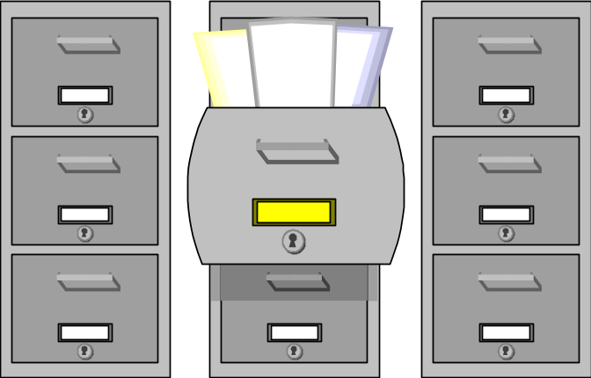

A student identification data record is a collection of data items that identify a student (e.g., Student's First Name, Student's Last Name, Student's Address Line 1, School Year, etc.). The following is a pictorial view of a student information data record:
Student Information Items
John
Doe
29 South Street
Albany

_ _ _ _
Male
One complete “Student Information Data Record”

Beginning of
Student Information
Data Record
End of Student Information Data Record
There may be many information items in a student information data record: some are required, others are optional.
(See complete dataset listed previously.)

Creating "Response Files"

Once IDs are assigned to one or more records, they are bundled into a single "Response File". This file is sent to the Level 1 center who requested IDs for those records, to be loaded by that Level 1 into its own data store, then uploaded to the Level 1 Container (after which it is pulled into the Level 2 Statewide data warehouse).
Student Record 1
Student Record 2
Student Record 3
Student Record 4
Student Record 5

Many student information records (with IDs) make up a
"Response File"

Over time, many student information records (e.g., Student Record 1 above) may be sent to NYSSIS. This often occurs when students move from school to school or district to district, but also may occur when updates to student information (corrections to typos in names, changes in guardian, etc.) are sent to NYSSIS. Student records collected over the years are never deleted from the NYSSIS database. Therefore many student information records, even per school year, may be associated with a particular NYSSIS ID.
When a student information record is submitted to NYSSIS and the NYSSIS matching engine determines it matches an existing NYSSIS ID, that existing ID is assigned to the student information record. At the same time the student information record is associated with that existing NYSSIS ID in the database.
This process results in additional data that can be used to match future submissions of a Student Identification data set for the same student. For example, if a student has a change of guardian over time, the NYSSIS system will maintain information on all of the guardians associated with that student. Therefore, if the student returns to a former guardian, NYSSIS will recognize this and be better able to automatically associate the new student data with an existing record in the NYSSIS database.

NYSSIS ID Matching Process

When a student information data record is loaded into NYSSIS for processing, NYSSIS checks the database to determine whether the Student Identification set matches any records already in the database.
- If no match is found, an ID is created and added to the end of the record.

- If a match is found, the ID already assigned to the student is added to the end of the record.

- - - - - - - - - -- - - _ _ _ _ _
John
Doe
29 South Street
Albany
Male
[NYSSIS ID]

- If NYSSIS cannot determine if the data submitted matches an existing record in the database, the record (called a” Near Match") is placed in a "Hold Queue."

Resolving Near Matches in the Hold Queue

A Near Match record is made up of the newly submitted student record and one or more records that are already in the NYSSIS that contain many similar elements but not enough to determine if the records are for the same student. The newly submitted record only nearly matches the records already in the NYSSIS. As such, the newly submitted record is placed in a Hold Queue with the records from the NYSSIS it nearly matches. Authorized LEA personnel must then review and resolve these Near Matches by determining if the student record should be matched with an existing NYSSIS ID or issued a new NYSSIS ID.
When the ‘View Candidates’ option is selected one of the three scenarios will occur:
- One or more candidates will be displayed with a percentage indicating the likelihood the two records match. The probability will range anywhere from 45% to 99%.

- A match candidate will be displayed, but the option to match to the record will not be available. This scenario is a result when the near match candidate does not have a statewide identifier assigned yet because the candidate record is also a ‘hold’ record. This usually occurs when duplicate data is submitted and/or a specific rule has been established to not match certain kinds of records. These rules are often enforced on twins and siblings where data is very similar, if not exact.

- No candidates displayed. Occurs when near match candidate is removed from the NYSSIS database or the number of students to compare with has significantly changed since the original hold decision.
LEAs are not permitted to delete student records from NYSSIS once they are added. All Near Matches must be resolved. Data accuracy is paramount to ensuring that LEAs do not create new records in error or match two unique student records in error.

How to request a NYSSIS User Account

NYSSIS is accessible to authorized users only. Users who require access are provided with a NYSSIS Login Account. These accounts are specific to an individual, not generic. Each LEA will have at least one authorized user, who will log into NYSSIS. A Username and Password will be provided to the authorized user for each LEA.
The primary purpose for accessing NYSSIS is to resolve Near Matches. This work may be performed as appropriate by RIC, Big 5 CSD and/or LEA personnel. In addition, certain administrative activities may be performed by RIC and Big 5 CSD NYSSIS Authorized Contacts.
For School District (LEA) Users
- Contact your district superintendent to have an account created and entitled to the NYSSIS application for your district through the SEDDAS application.
For Non-Public and Charter LEAs Users
- Contact your school principal to have an account created and entitled to the NYSSIS application for your school through the SEDDAS application.
Once approved, a NYSSIS Login Account will be assigned and a UserID and Password will be emailed the account owner. Authorized users can access the Web Interface by logging on to: http://portal.nysed.gov

NYSSIS User Interface Walk-Through

Logging in to NYSSIS

NYSSIS uses the NYSED Application Business Portal. Use of the NYSED Application Business Portal enables users who access other NYSED applications to have a single User Name and Password for each one.
Placing the URL http://portal.nysed.gov in the address bar of the browser takes the user to the NYSED Application Business Portal. To gain access, click the “Log On” button:
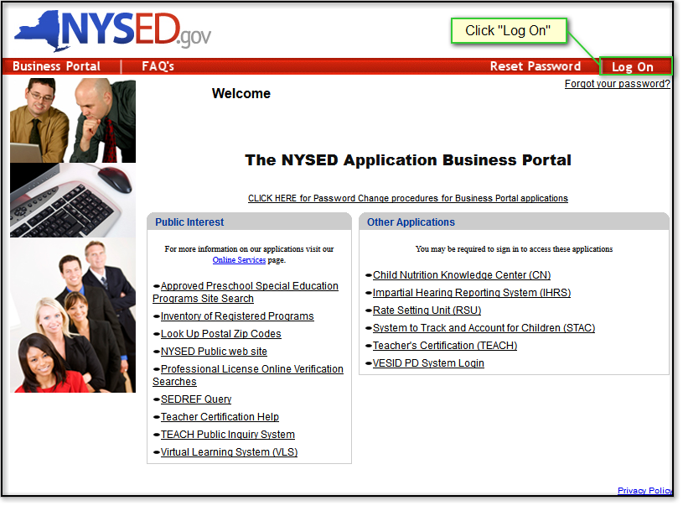
At the Sign In screen, enter your User Name and Password and click the "OK" button:
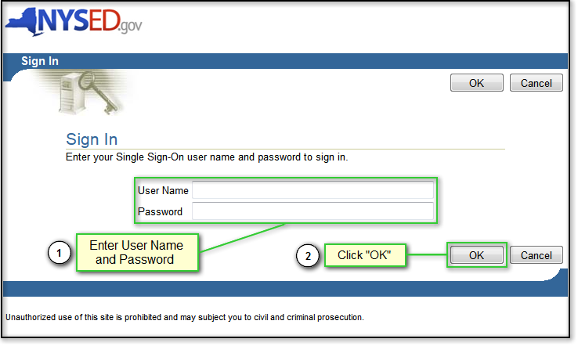
If the login is unsuccessful, the page will display the following message:
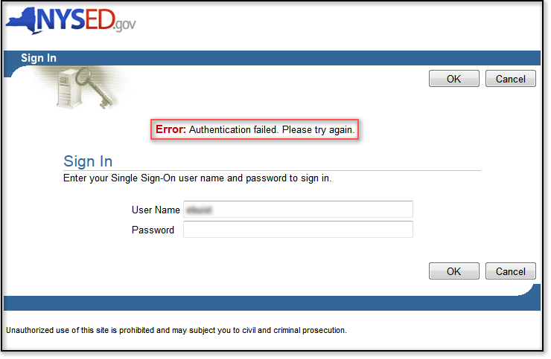

Your login will fail if you have not typed in your user name and/or password correctly. This error will also appear if your account has been locked after three unsuccessful login attempts.
If you continue to have problems logging into the Business Portal, contact your SEDDAS Delegated Administrator, Superintendent, or Principal.
If your login is successful, you will now see a My Applications menu listing each application you are authorized to access through this portal. Click on the NYSSIS link:

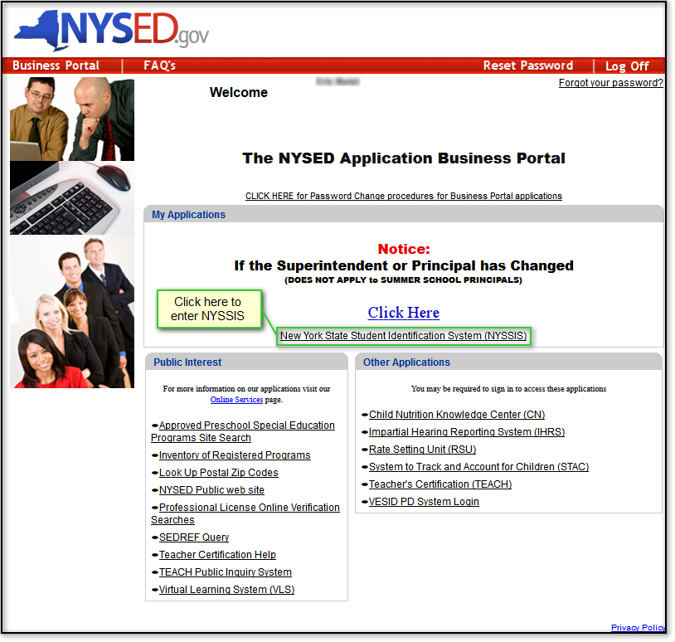

Accessing the Queue Resolution List

After clicking the NYSSIS link on the NYSED Application Business Portal, you will be taken to the NYSSIS Home Page. To view the Queue Resolution List for your institution, click on the “Queue” button:

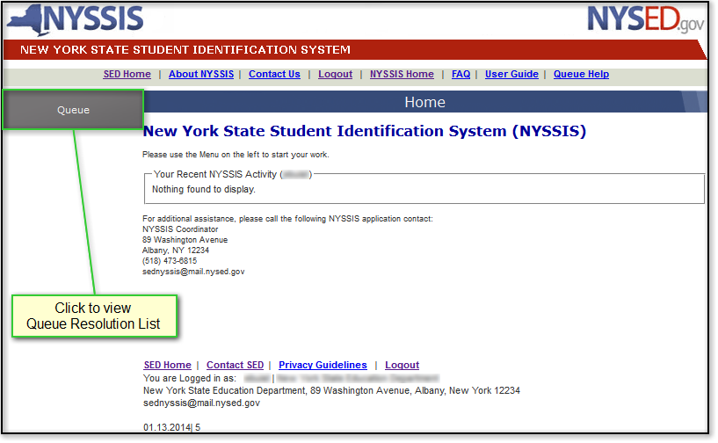

Queue Resolution List

The Queue Resolution List displays unresolved student records that the system could not automatically match to an existing NYSSIS ID. To see if there are Near Match Candidates for an unresolved student record, click its “Candidates” link:

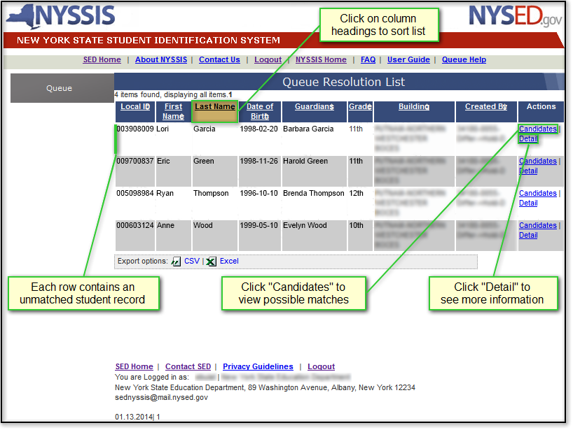

Queue Near Match Candidates - Scenario 1

If there are Near Match Candidates listed on this page, jump ahead to the next section (Scenario 2).
Otherwise, the unresolved student record from the Queue Resolution List may not have any existing Near Match Candidates in the NYSSIS database. If you believe there should already be a matching record in the NYSSIS database, but none are listed, contact your Level 1 Data Center for assistance.
If you are confident that this student is not already in the NYSSIS database, click the “New Student” button to assign this unresolved record a new NYSSIS ID and enter it into the NYSSIS database:

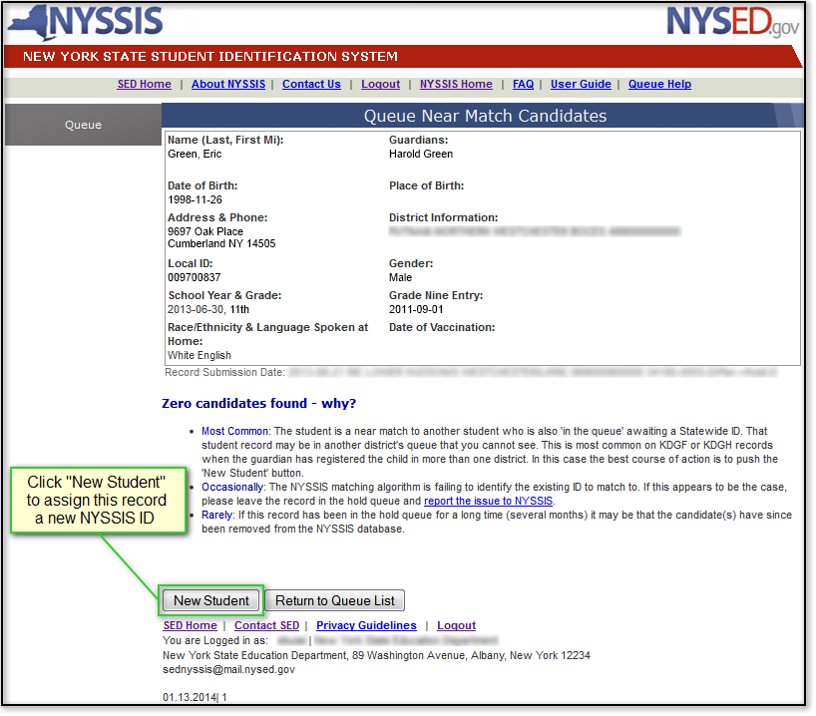

Queue Near Match Candidates - Scenario 2

If there are records in the NYSSIS database that closely match yours, they will be displayed as candidates on the Near Match Candidates page. The first column for each one will show its existing NYSSIS ID and the probability that it is a match to your unresolved record. Click on the “Compare” button to display a detailed comparison of how each candidate record matches or differs from yours.

If you are confident that none of the Near Match Candidates match your unresolved record, click on the “New Student” button to assign it a new NYSSIS ID and enter it into the NYSSIS database.

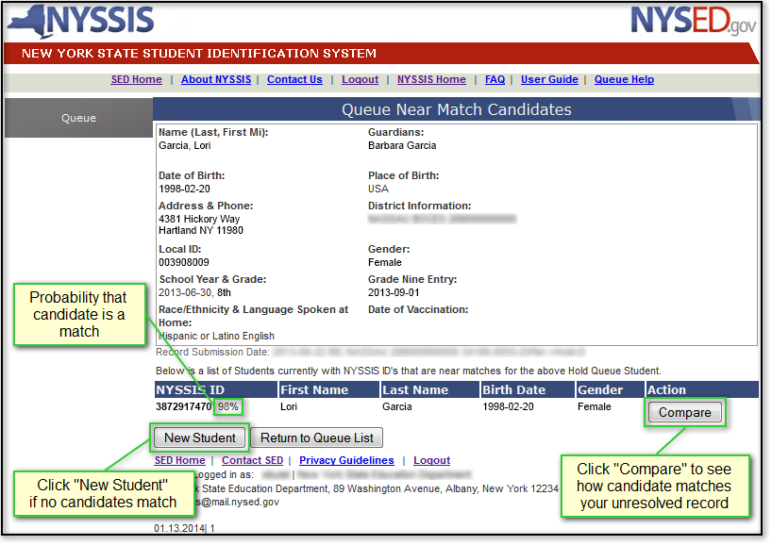

Queue Compare to Specific Candidate

The Compare to Specific Candidate screen displays detailed information from your unmatched record next to detailed information from the candidate record in the NYSSIS database. There may be multiple records already linked together under a single candidate NYSSIS ID.
If the unresolved record matches the candidate record, click “Confirm Match” to link it to the existing NYSSIS ID. If you are confident that the unresolved record does not match the candidate record, click “Return” to compare another candidate or to generate a new NYSSIS ID. Additional information found in student files at your location can also be used to help confirm or reject this potential match.

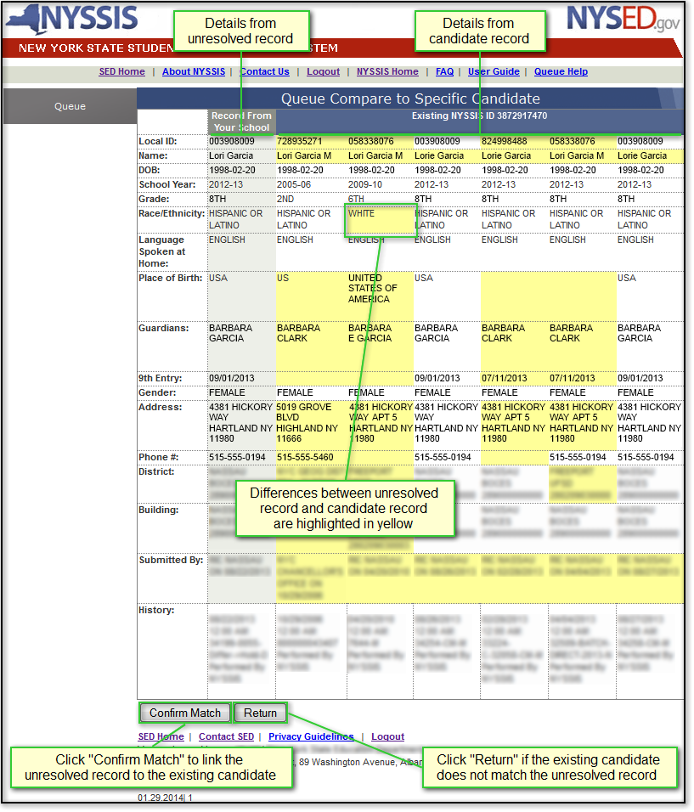

Queue Confirm Match

If you determine that the unresolved record matches the candidate record in the NYSSIS database, you will be asked to confirm or cancel the match. Click “Yes” to confirm this match. Otherwise, click “Cancel”.

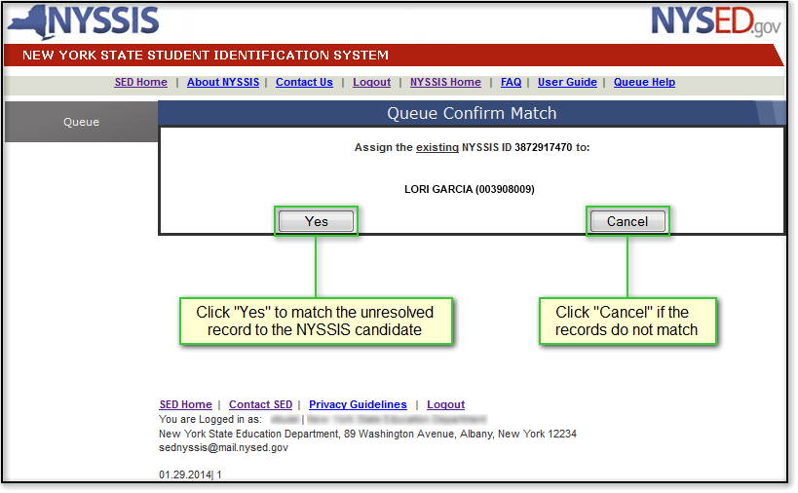

Queue Match Complete

If the unresolved record has been successfully linked to the existing NYSSIS candidate record and ID, it will be removed from the Queue Resolution List and a confirmation page will be displayed.

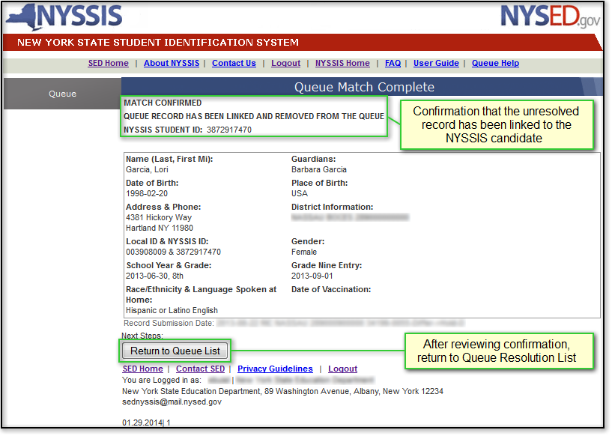

Logging Out

Once all unresolved records in the Queue Resolution List have been assigned new or existing NYSSIS IDs, the Queue Empty screen will be displayed, which shows recent activity in the NYSSIS system at your institution. The application may be exited by clicking the “Logout” link at the top of the page:

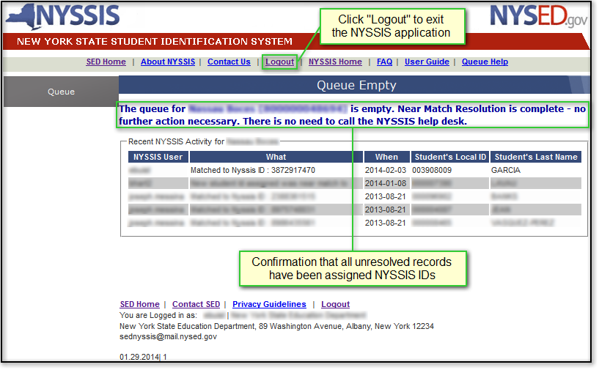

While the system is logging you out, you may briefly see the following screen:

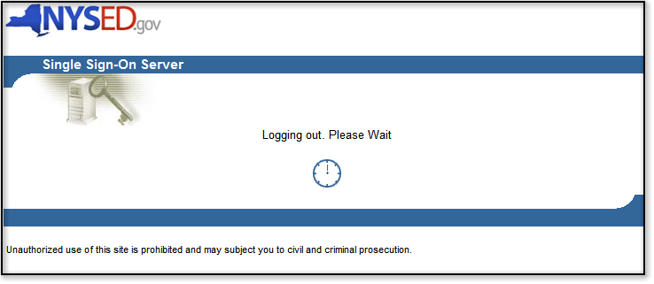

When a blank Sign In screen reappears, you have successfully been logged out.

Appendix A

SED NYSSIS application support contacts

NYSSIS Email (tech support) | sednyssis@nysed.gov
Policy/business rule guidance | dataquest@nysed.gov
Level 1 RIC/Big5 contacts | http://www.p12.nysed.gov/irs/sirs/ric-big5.html
NYSED Enterprise Help Desk | 800-697-1323
NYSED Fax | 518-474-2519

