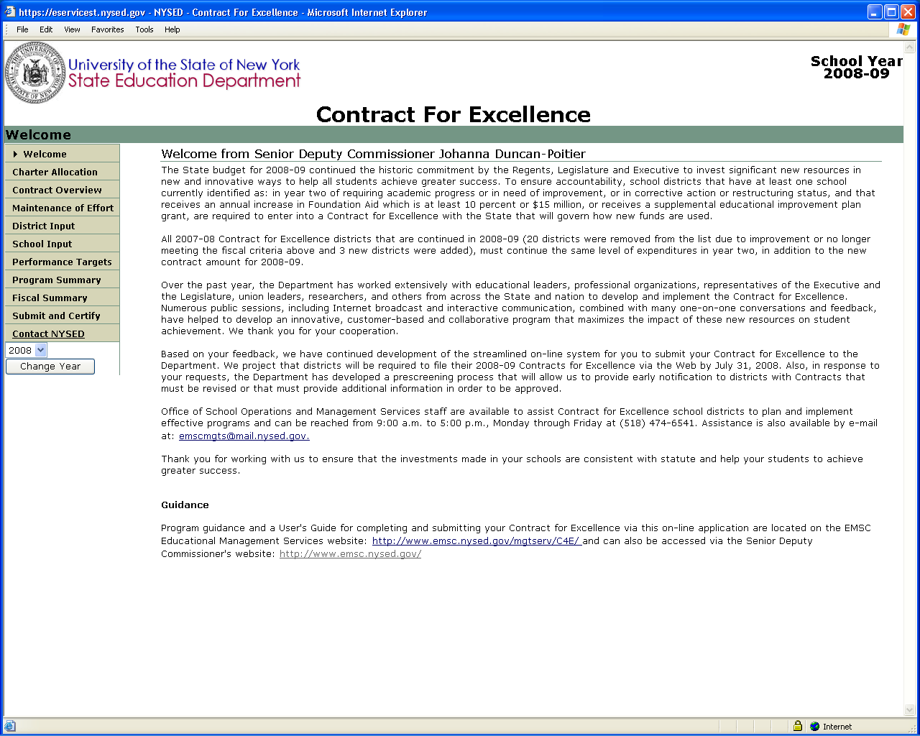
Direct link to our C4E website. Check often.
Direct e-mail link to submit additional materials electronically
Change year to see 2007 Contract.
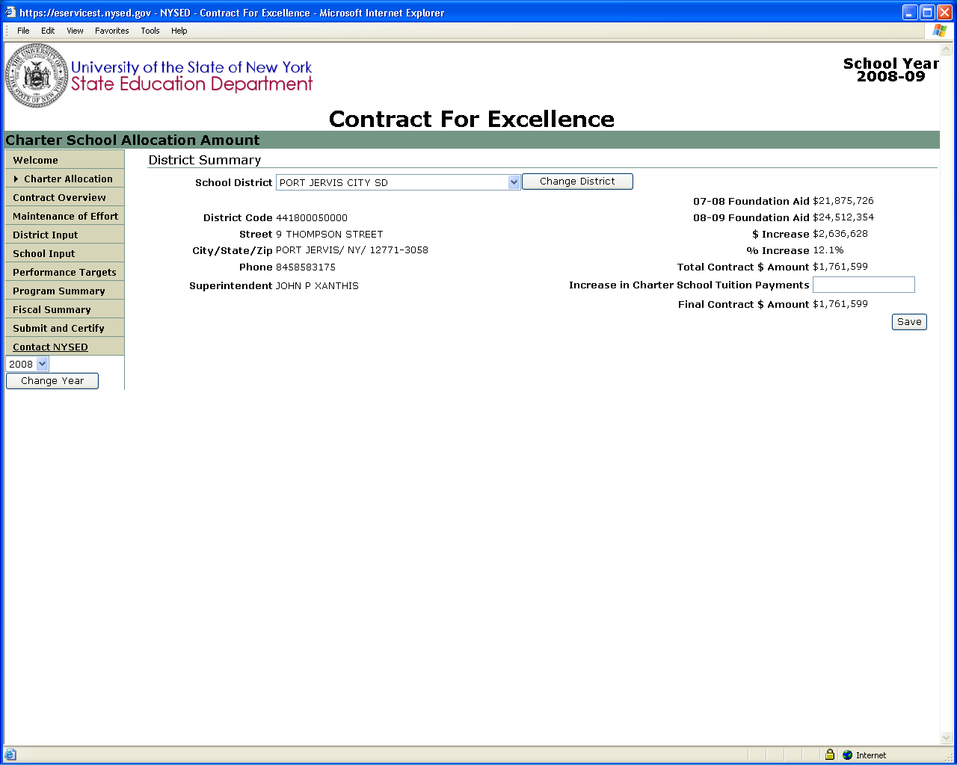
Increase in Charter School Tuition Payments MUST be the first thing done in the application because it is deducted from the Contract Amount.
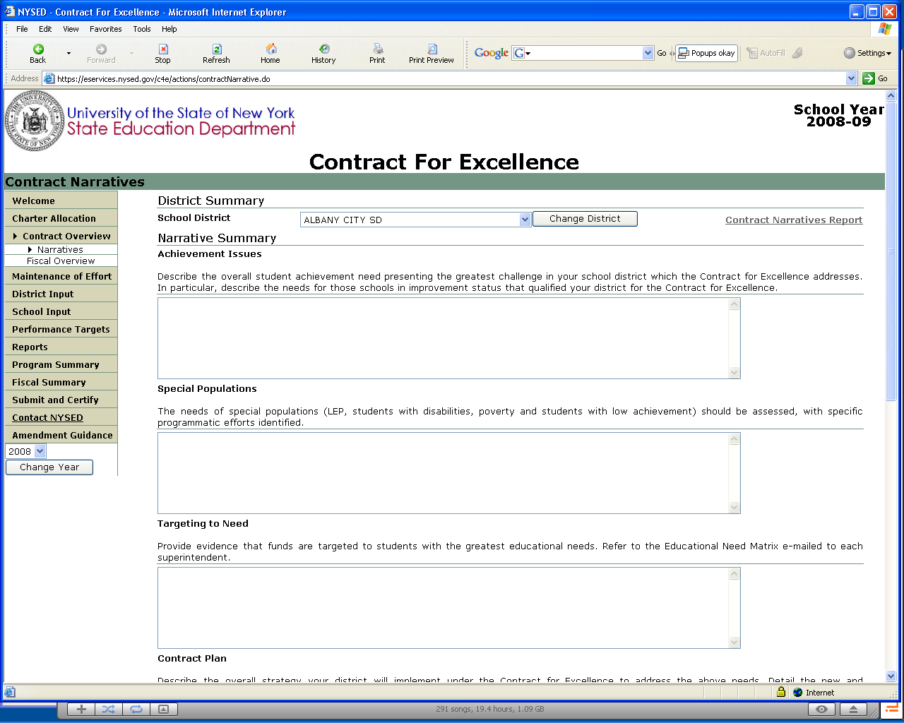
The Need Matrix will be linked on this page to help you find out your minimum allocations per school, based on need.
You must enter a response in each of the Narrative Sections.
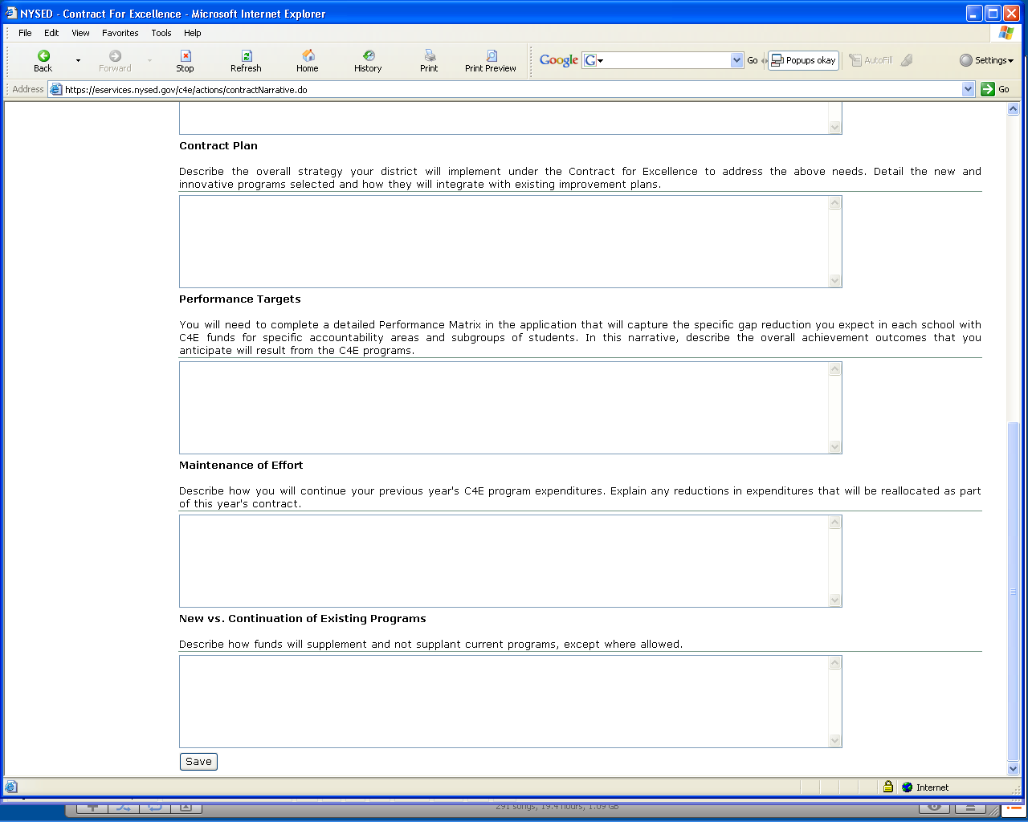
You must enter a response in each of the Narrative Sections.
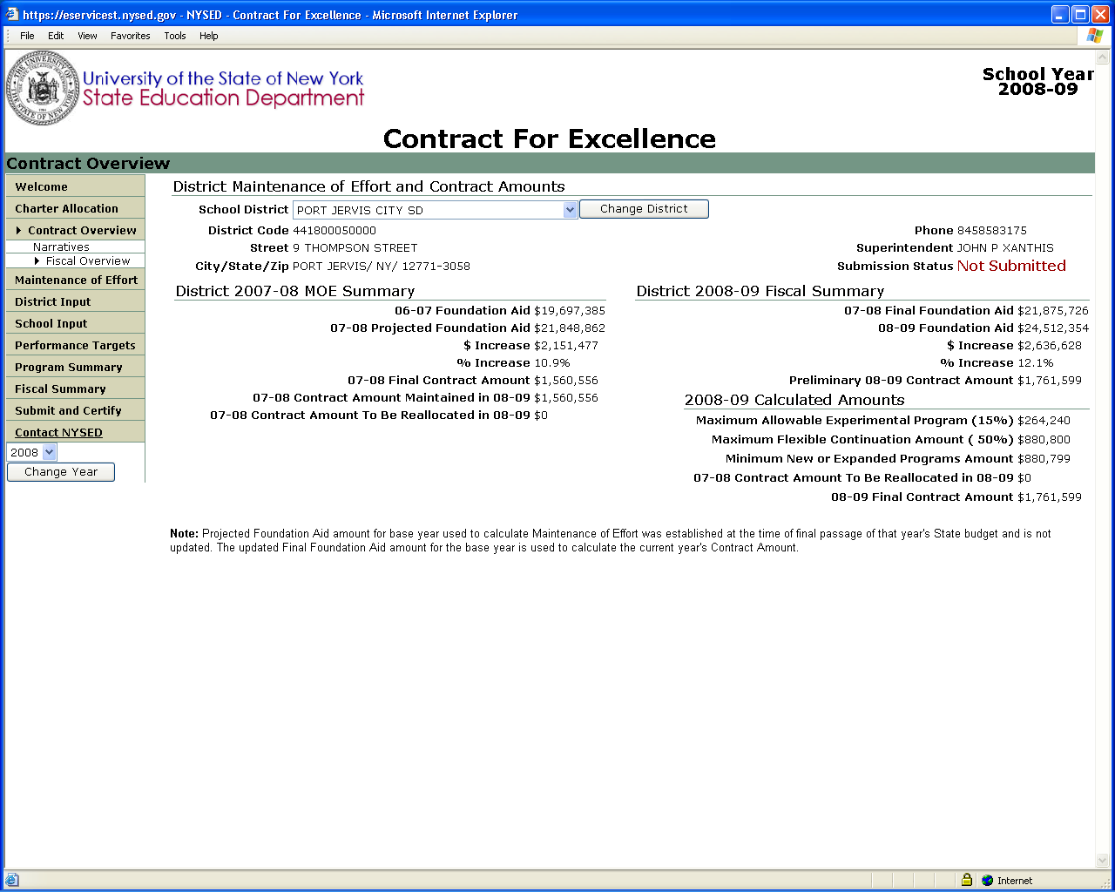
All data on this page will calculate automatically based on your data entry elsewhere in the application.
Note that all adjustments are made to your 2008-09 Contract Amount prior to adding Reallocation Amounts from expenditures not maintained from previous year.
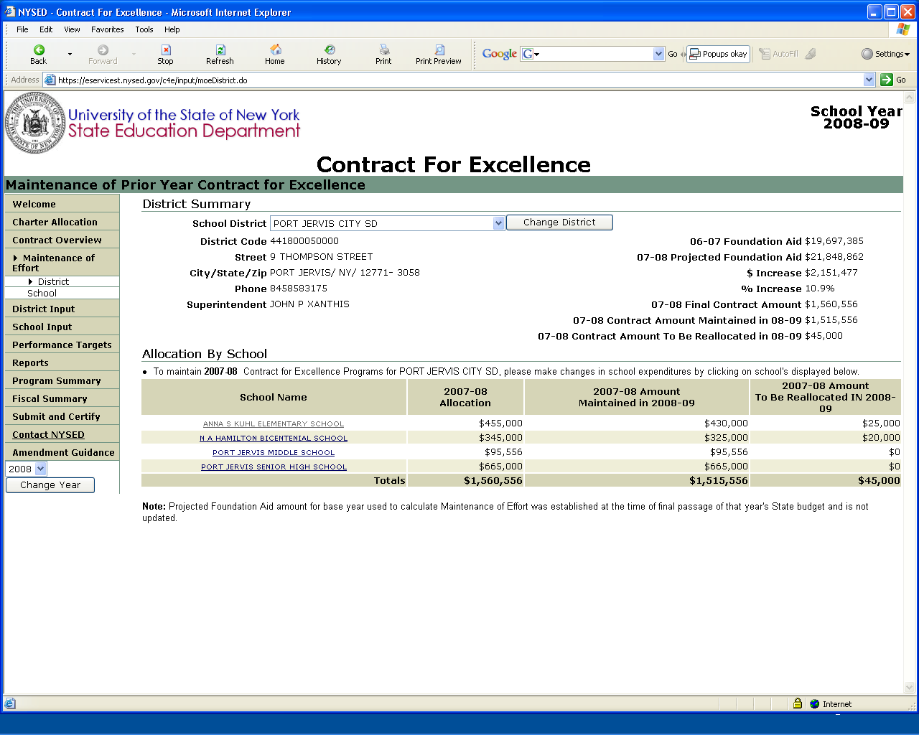
Similar to the Contract Overview page, all data on this page will calculate automatically based on your entries on the School level MOE page.
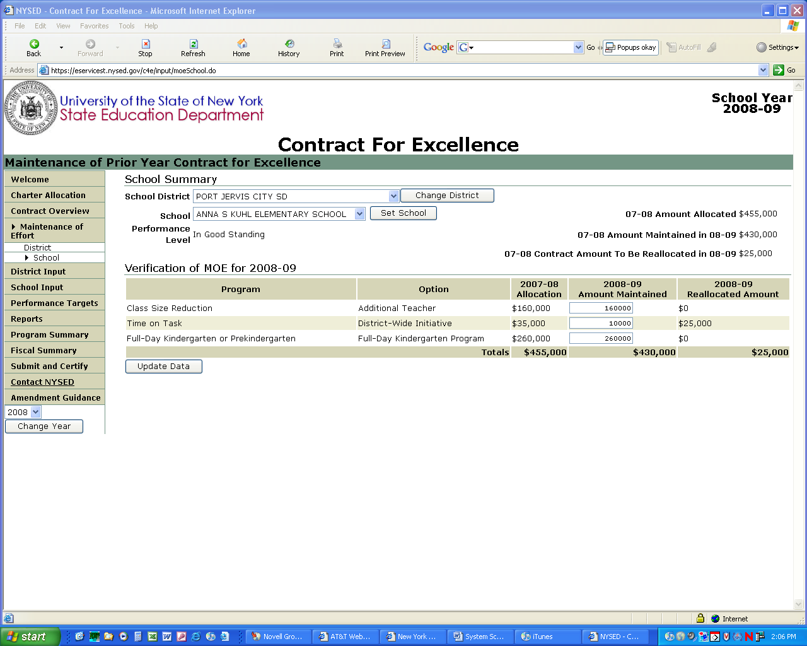
The default Amount Maintained equals last year’s allocation. If actual expenditures will be less for 2008-09, change here. ONLY ENTER DECREASES COMPARED TO 2007-08 ALLOCATION. The difference will calculate and adjust your total Contract Amount on the District and Contract Overview pages.
Once you have made the changes, click on Update Data to finalize.
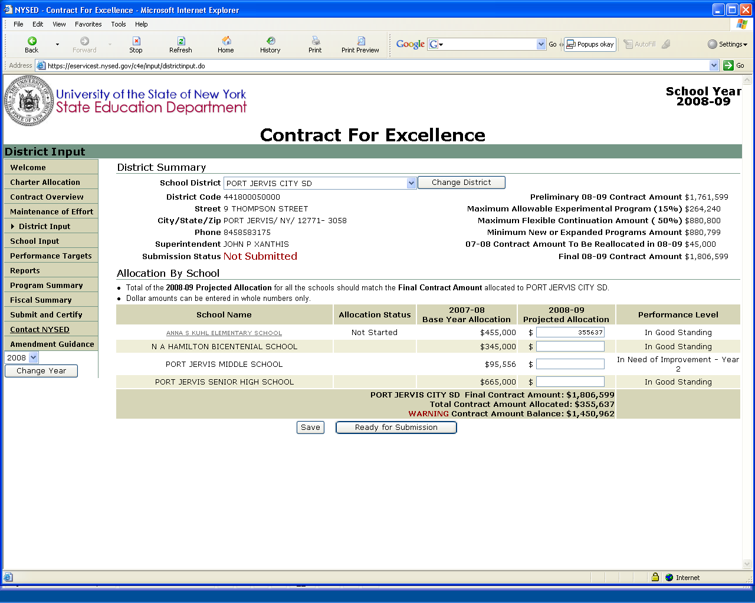
Just as last year, it is recommended that you first enter ALL of your school-level allocations on the District Input page, reducing your Contract Amount Balance to 0. You can always return to this page to adjust individual school allocations.
IMPORTANT
Do not click on Ready for Submission button until all school-level programs and options have been completed. This is meant as a final check for errors before you submit.
Save your allocations as you make them to avoid having to reenter data if there is a problem.
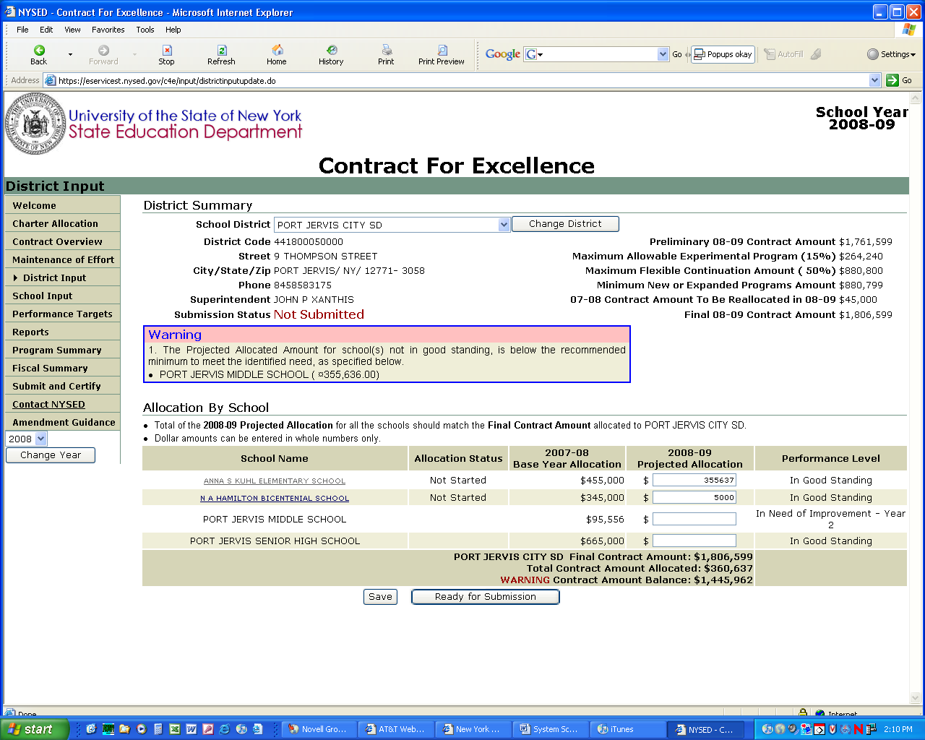
This is a new feature. If you make less than the minimum allocation to a school in improvement status based on the Educational Need Matrix , an error message will be shown. It will not prevent you from saving and submitting your Contract if it is explained in the narratives.
IMPORTANT
Do not click on Ready for Submission button until all school-level programs and options have been completed. This is meant as a final check for errors before you submit.
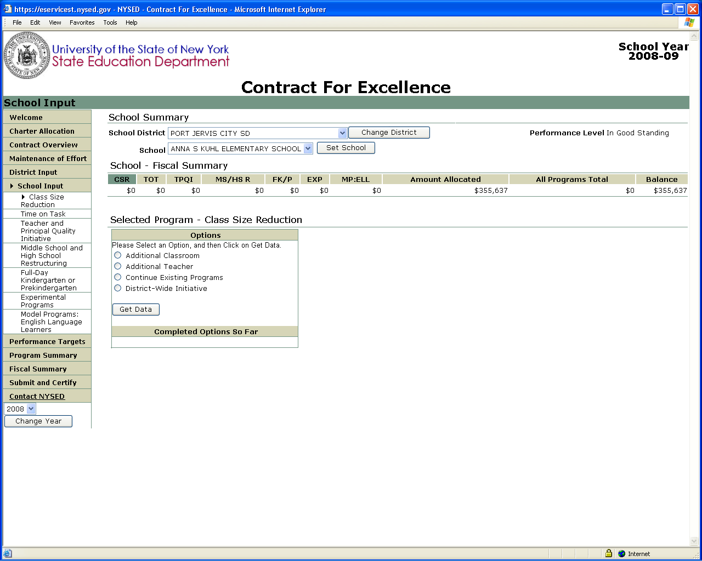
No change from last year in the process. Select school, allowable program and option and then “Get Data”.
Note the new “real time” status bar that shows allocations by program in the selected school as you make them.
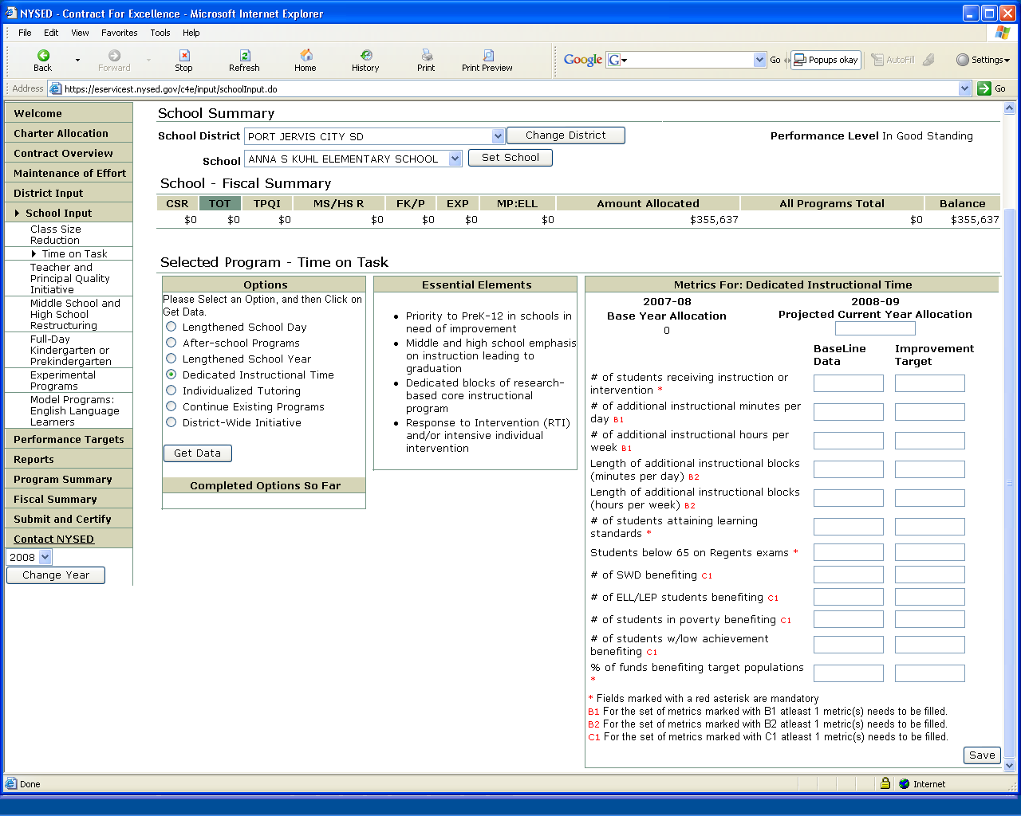
More metrics are required this year to improve the data collected to evaluate program results.
Note that we have grouped required metrics into logical groups that allow either/or choices.
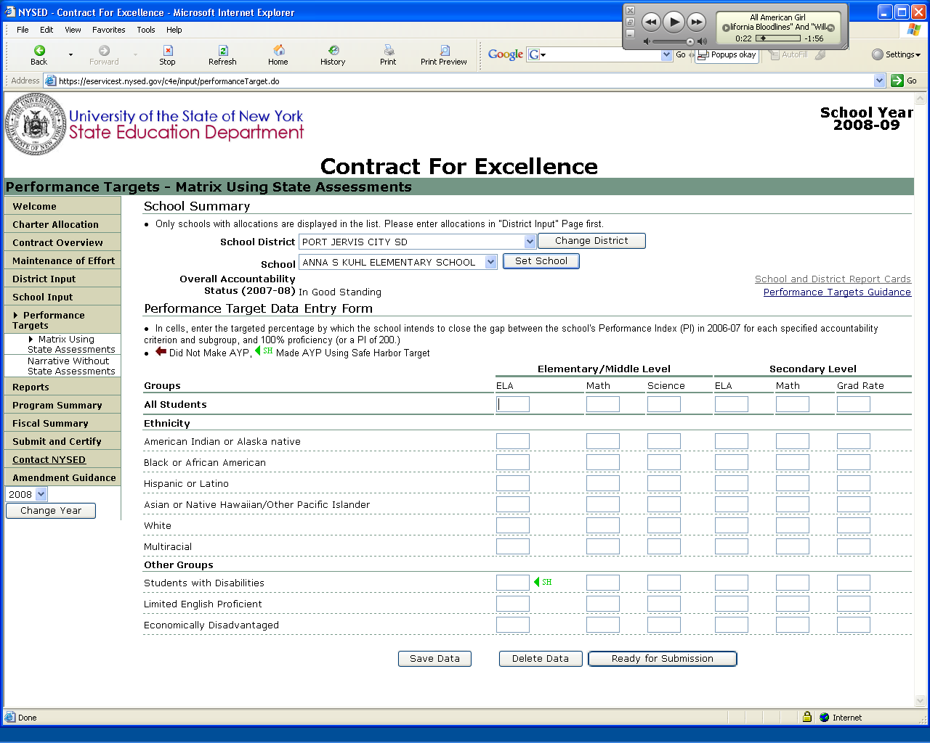
Last year’s Excel spreadsheet has been incorporated directly in the application.
Detailed information on completing form.
Direct link to the NYStart System to verify your data.
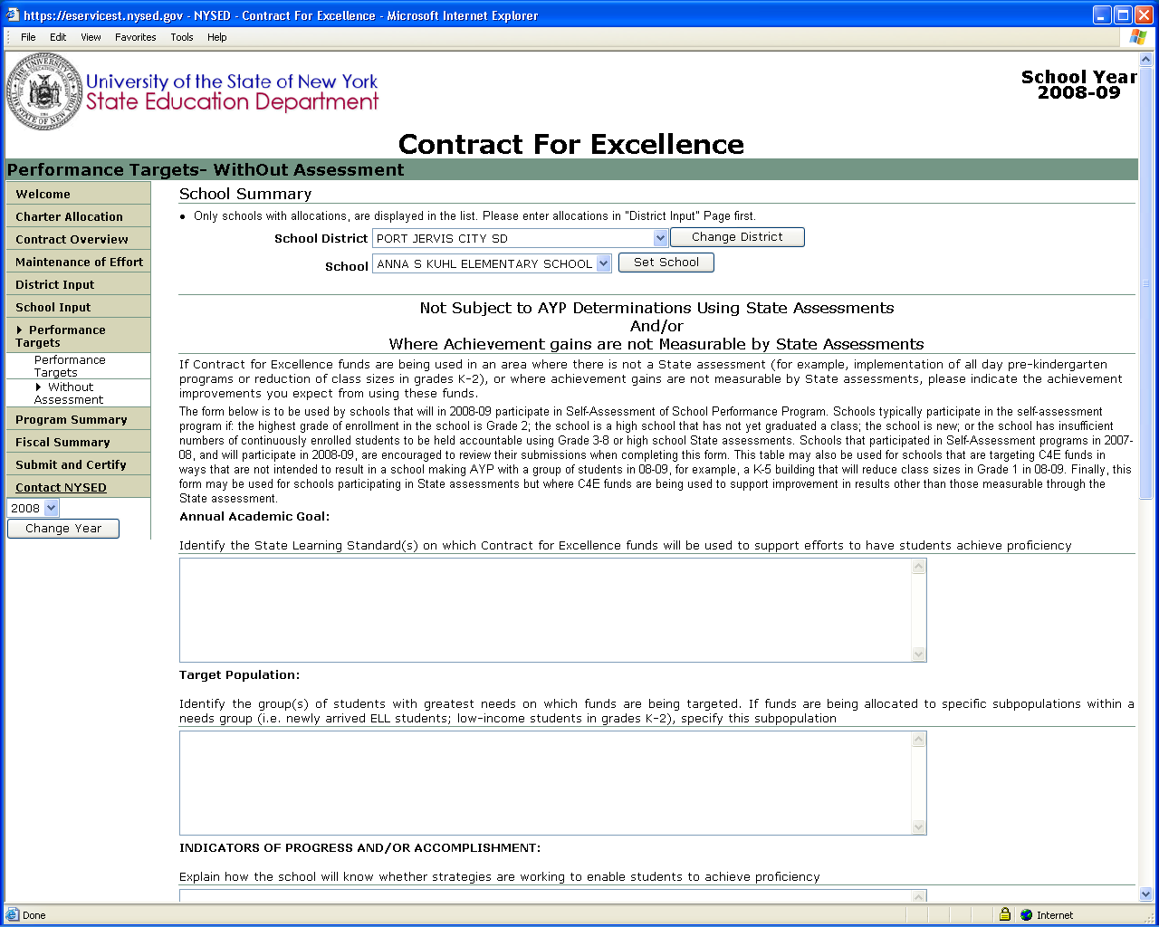
You must enter a response in each of the Narrative Sections.
Last year’s Word document has been incorporated directly in the application.
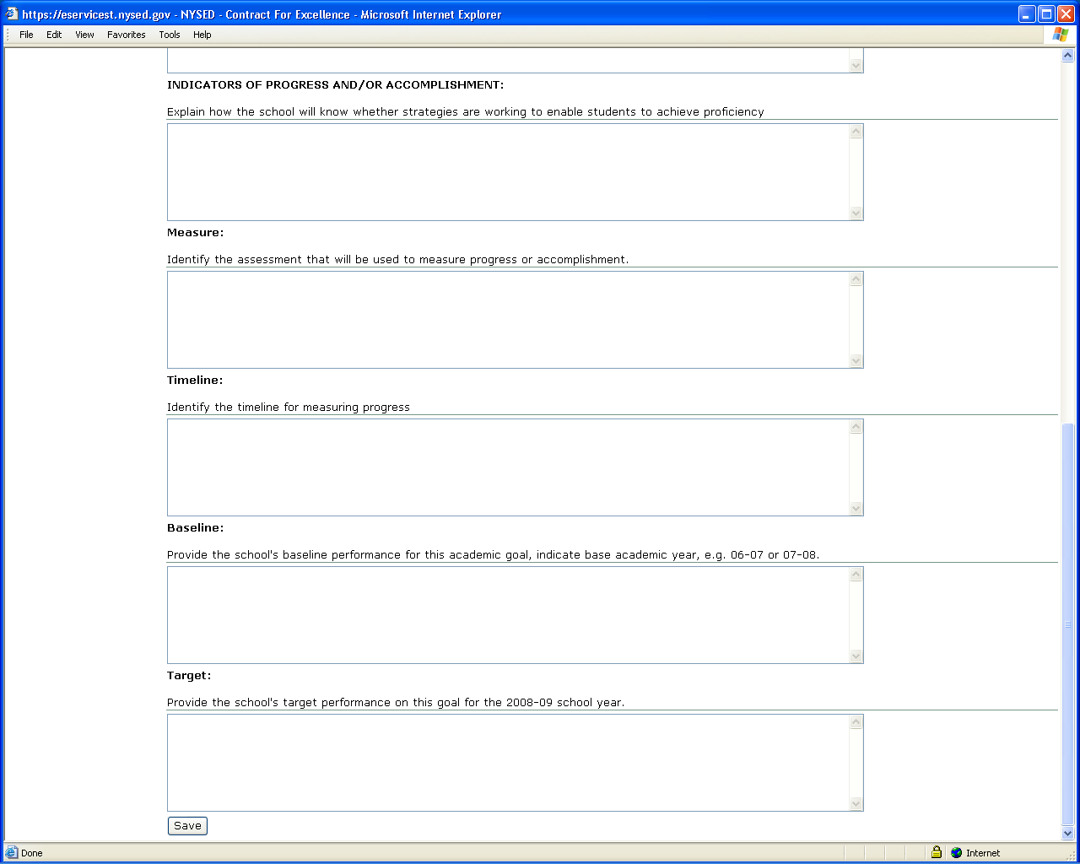
You must enter a response in each of the Narrative Sections.
Save often to ensure you don’t lose narratives.
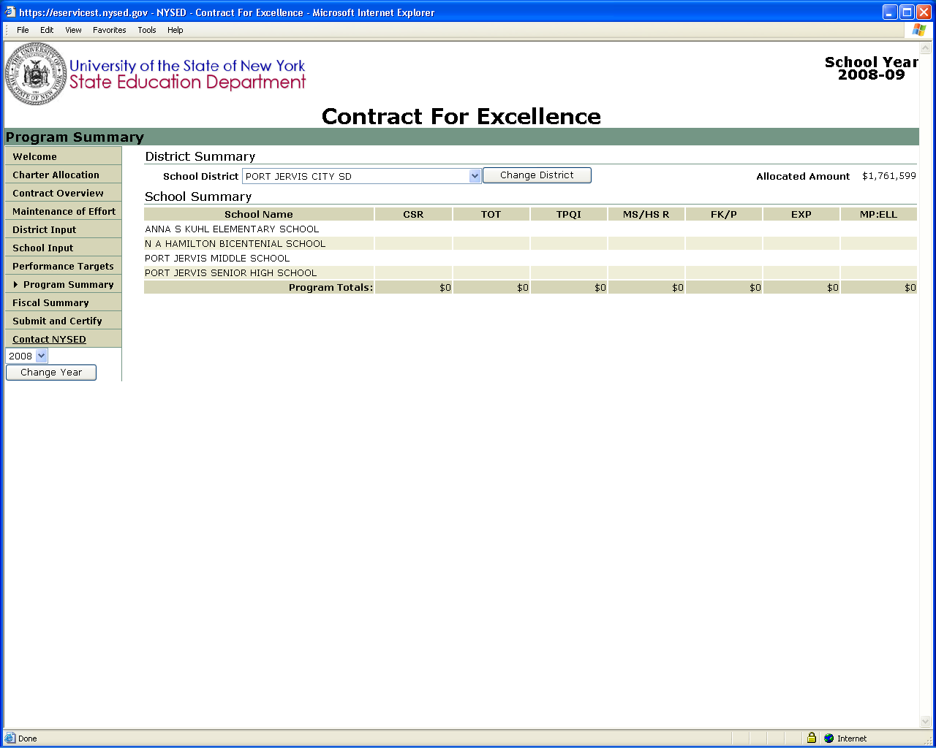
Same report format as last year.
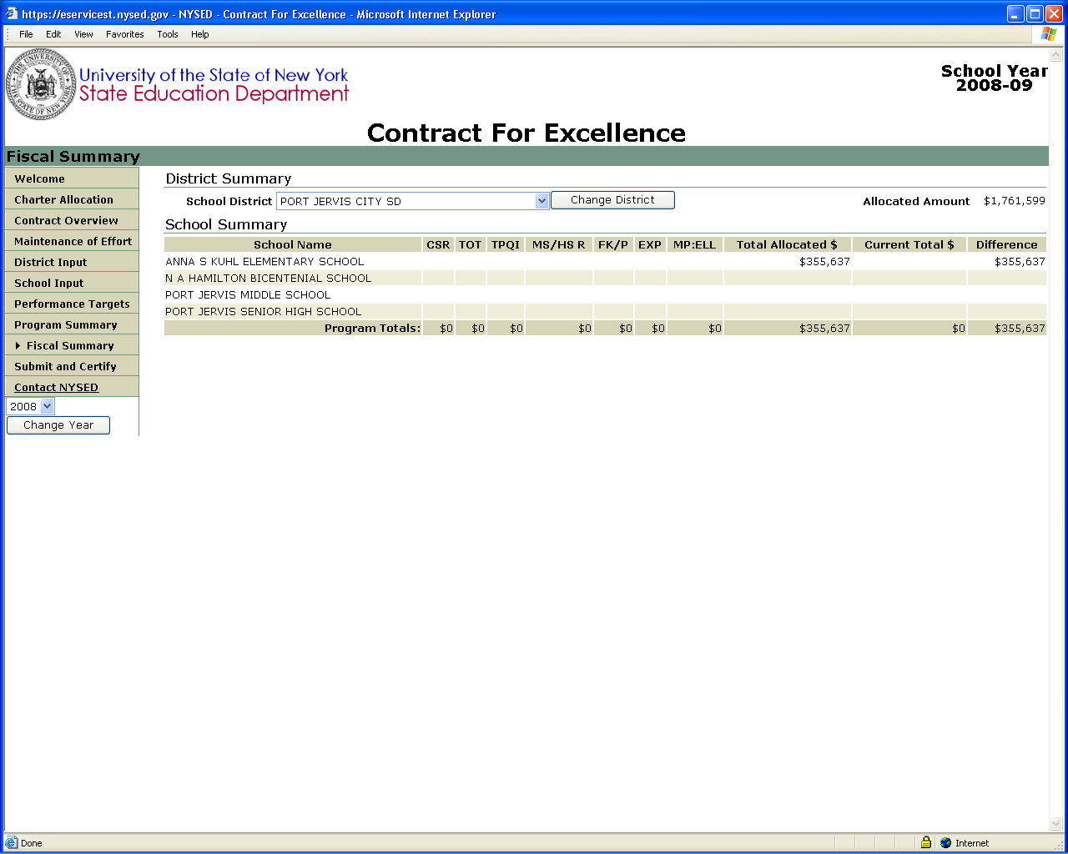
Same report format as last year.
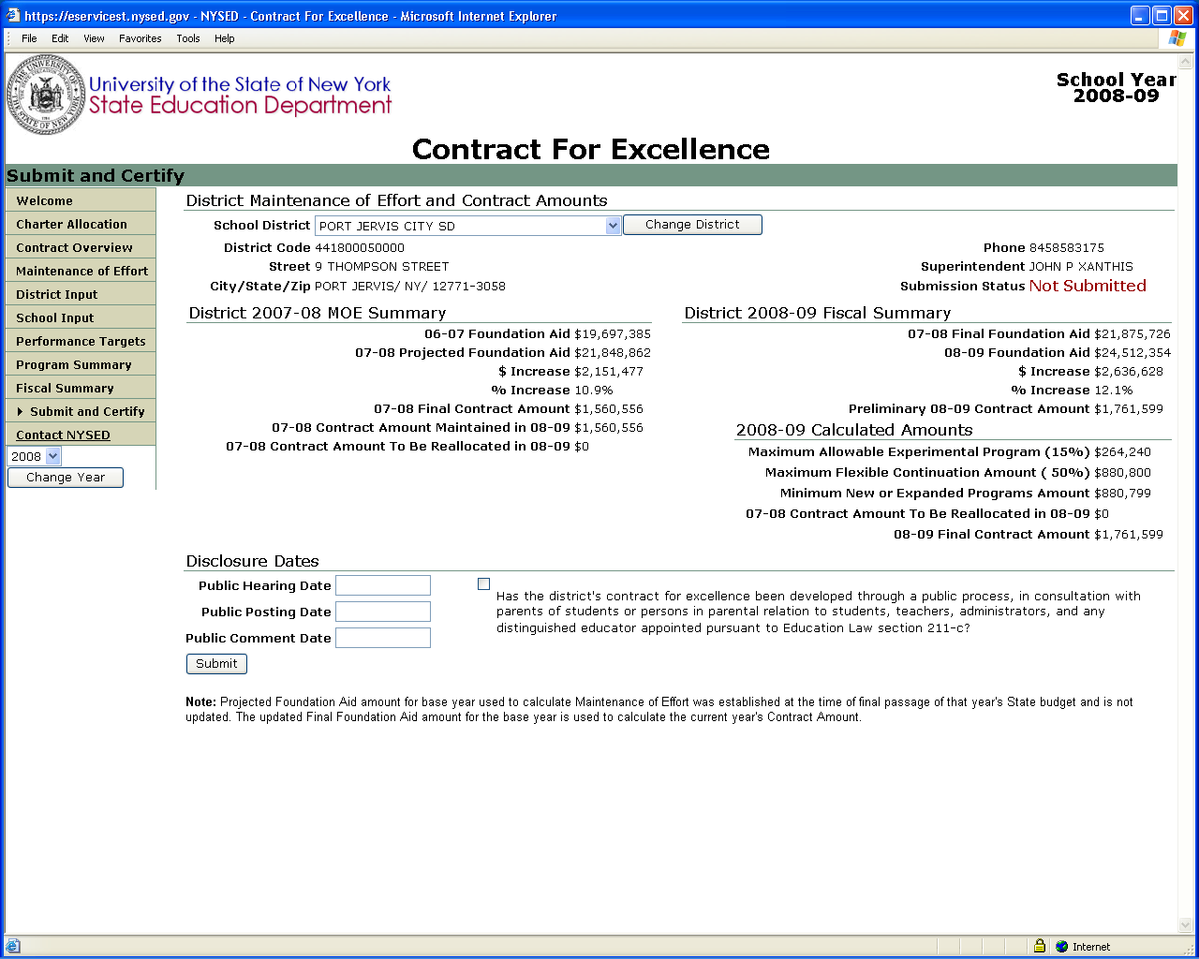
You must enter a date for each required public process requirement. And check off the Attestation.
Critical
You must click on the two “Ready for Submission” buttons on the District Input and Performance Targets pages before pressing the Submit button. All error messages must be cleared before you will be allowed to Certify and Submit.
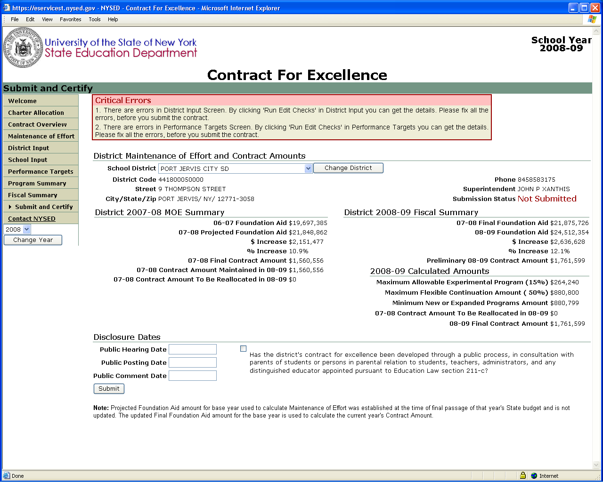
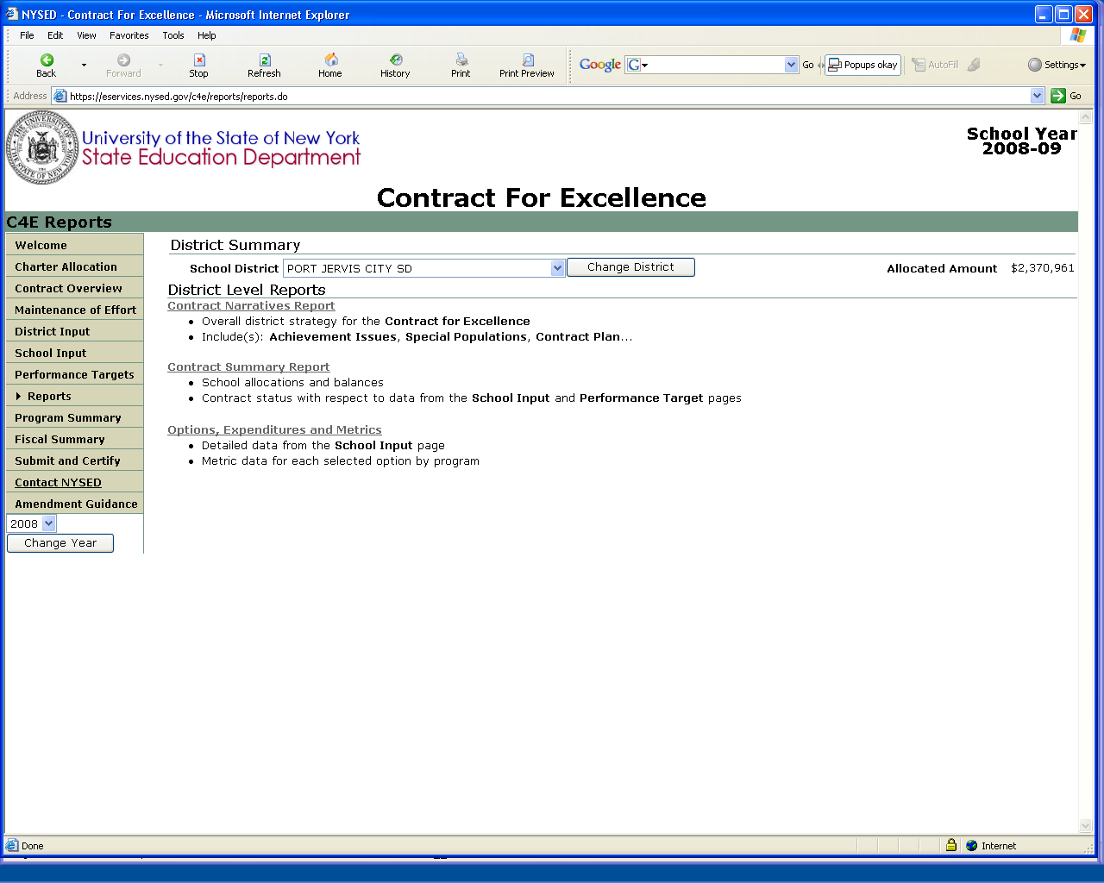
Comprehensive Reports will be generated in PDF format for printing and/or posting to meet your public disclosure requirements.


