Word to Accessible PDF

The Word File
- Before converting the Word file, to PDF, have the conversion settings (Adobe PDF, Change Conversion Settings) set as follows:

  - Under Settings, set your settings as shown.

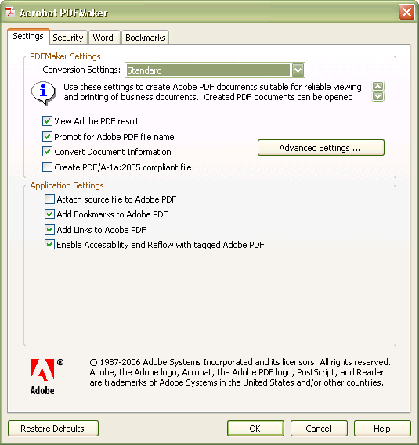

  - Click the Advanced Settings button.
    - Under General, set your settings as shown.

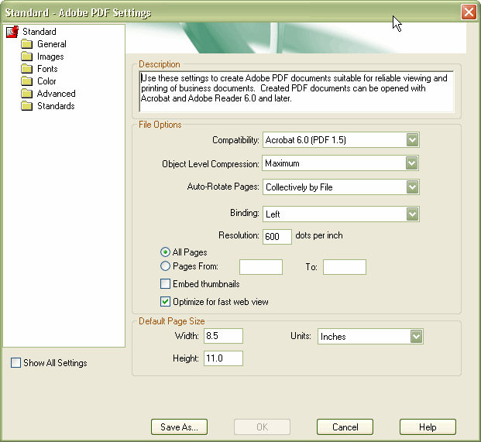

    - Click the Save As… button. Save file as ReportCard. Click Save.

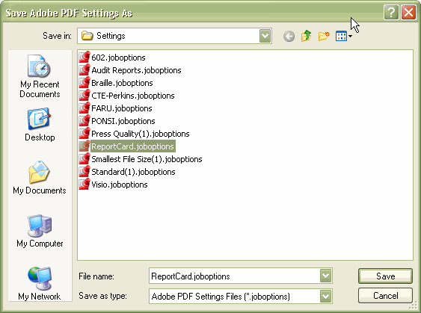

  - Under Word, set your settings as shown:

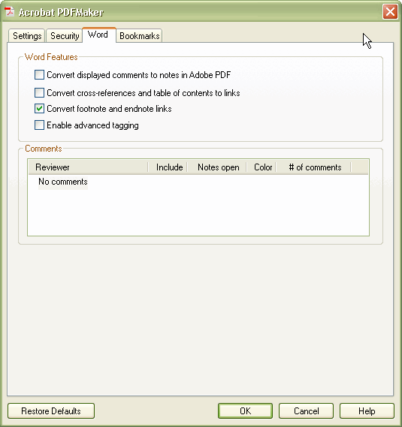

  - Under Bookmarks, set your settings as shown:

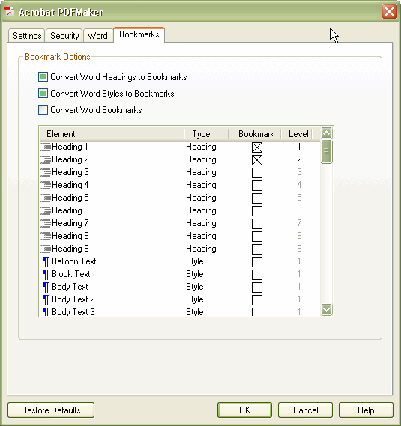

    - Click OK.
- Click Adobe PDF, Convert to Adobe PDF.

PDF File

When the document is converted, you will see something like this:

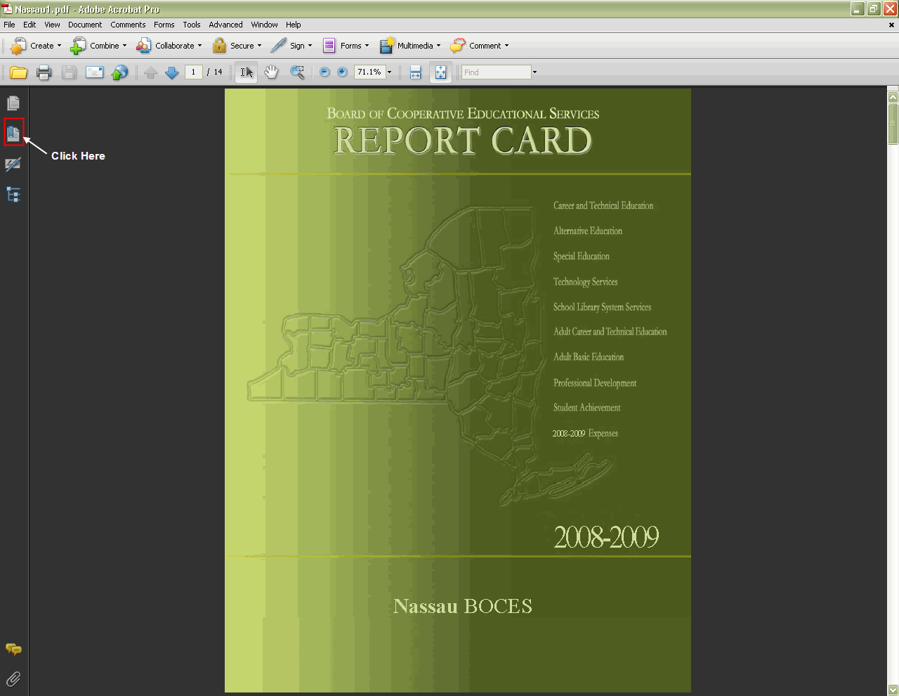

You can click on the bookmark icon, in the left-hand frame, in order to see the listing of bookmarks.

Some setting changes now have to be done to the PDF file:
- Click File, Properties, Description tab. Make sure that the correct Title info is filled in.
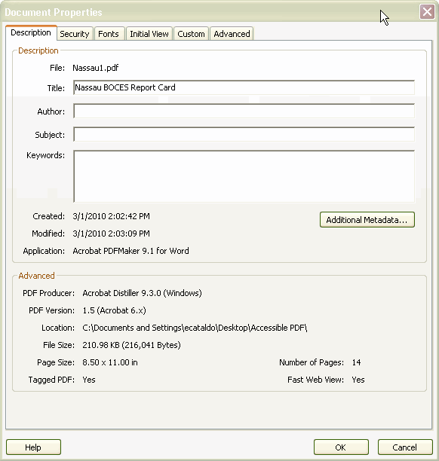
- Click Initial View tab. Under Layout and Magnification section, For Navigation tab, select Bookmarks Panel and Page.
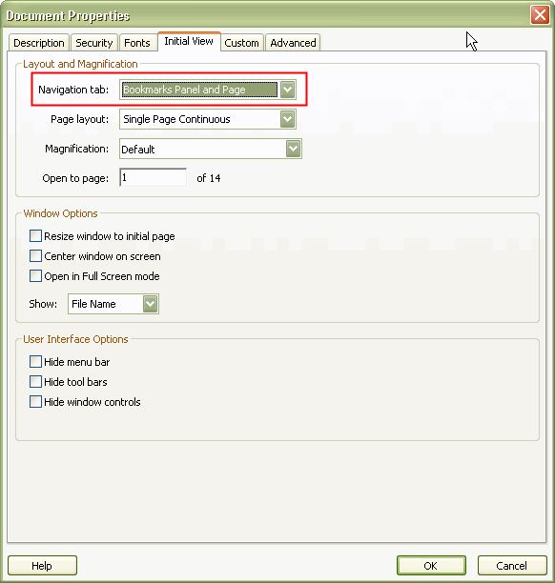
- Click the Advanced tab. Under Reading Options, Language, select English.
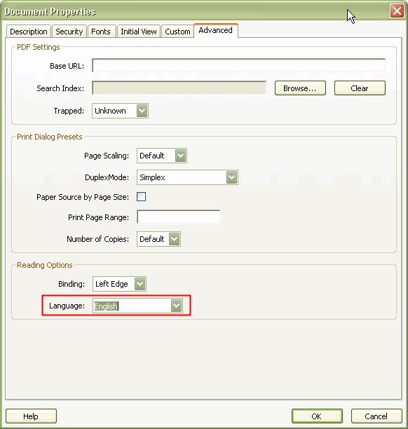
- Click OK.
- Save the file.

To check the PDF file, for accessibility:

- Open the file, in Adobe Acrobat. Click Advanced, Accessibility, Full Check. Select these options in the Accessibility Full Check screen. Click Start Checking.
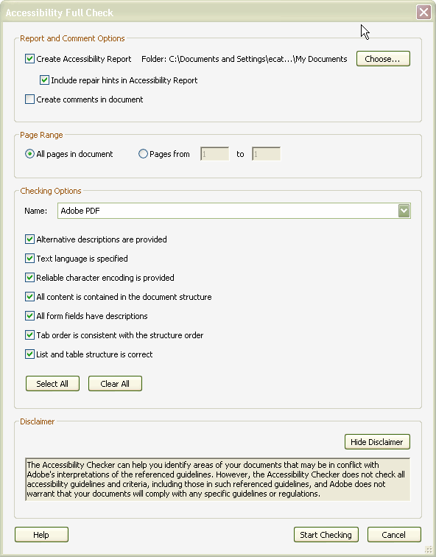
- If everything was created correctly, you should see this screen: Click OK.
- The Accessibility Report will open, in the left-hand frame.
