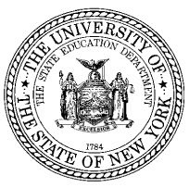 | THE STATE EDUCATION DEPARTMENT/THE UNIVERSITY OF THE STATE OF NEW YORK/ALBANY, NY 12234  Office of Educational Management Services  Room 475, Education Building Annex  Tel: (518)474-6541  Fax: (518)474-1983  emscmgts@nysed.gov
September 2017

TO: Religious and Independent School Leaders

FROM: Christina Coughlin, Coordinator

SUBJECT: State Office of Religious and Independent Schools (SORIS) Code in SEDREF

The New York State Education Department (NYSED) maintains its basic contact information and other key institutional data for nonpublic schools in a database system known as the State Education Department Reference File (SEDREF) system. The Office of Information and Reporting Services (IRS) and SORIS have been working to update information for nonpublic schools with multiple sites.

Our goal is to have each nonpublic school site entered in SEDREF with its own Basic Educational Data System (BEDS) Code to ensure NYSED has an accurate account of where students are located. SORIS received input from nonpublic school representatives on how to best achieve our goal. In order to recognize an educational entity as a whole, regardless of the number of sites, there is now a “SORIS Code” field in SEDREF. For example, a religious school has students in Kindergarten through 6th grade in one building and 7th through 12th grade in another. Each site will have its own BEDS Code and Institution ID. However, they will share a SORIS Code, which will enable us to recognize them as connected under the same organizational umbrella – for the purposes of grant funds and the like, such as Mandated Services Aid (MSA) and Comprehensive Attendance Policy (CAP) claims.
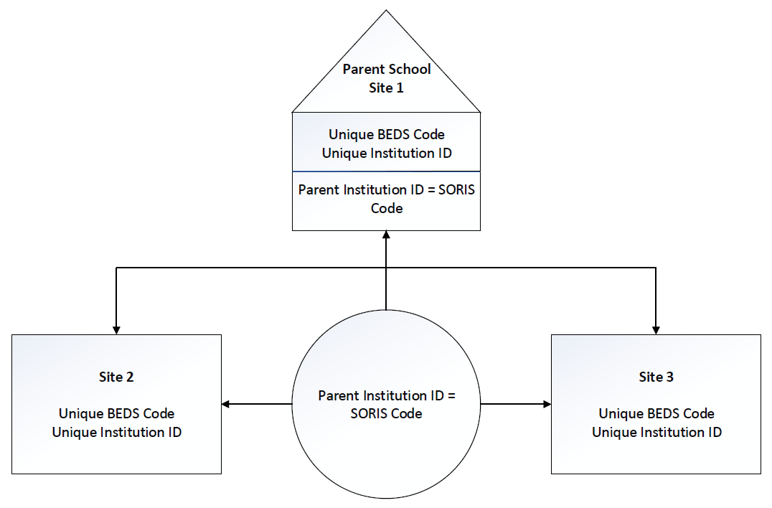
With any change comes pros and cons. When each nonpublic school site has its own information entered in SEDREF, it will be easier to identify eligible locations to receive federal and state funded programs and services, such as Child Nutrition and transportation. However, we realize that, initially, this will require more administrative work. We are continuing to work with our IT department to streamline the BEDS reporting processes and other steps to make this alignment work well for you and your schools.

- Why is this needed?
When religious and independent schools want to be recognized by NYSED, it is our responsibility to review the entity’s authorization to operate as a school and ensure all buildings where students are located are approved for instructional use and safe for those attending.

- What is the difference between an Institution ID, BEDS Code, SED Code, and SORIS Code?
Here is what a school’s information looks like in SEDREF:
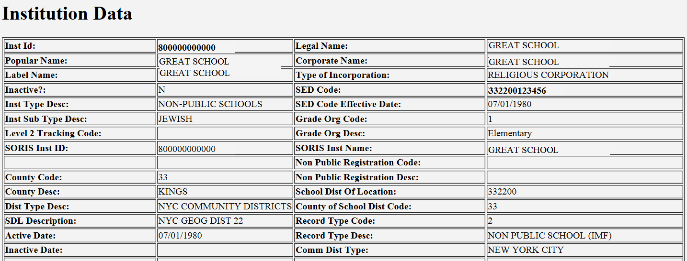
(You can check your school’s information by going to https://portal.nysed.gov/abp and clicking on “SEDREF Query” in the Public Links section.)

SED Code | 12-digit BEDS code number assigned by the SED P-12/IRS program office OR the Institution ID populated in for all other Institutions
Institution ID | 12-digit unique identifier for each institution, which is frequently used for funding purposes
SORIS Code | This is the same as the Institution ID for most nonpublic schools. For schools with more than one site, the school will determine which site will be the “parent” and that Institution ID will be used as the SORIS Code for all related school sites.

- What if my school has only one site?
Your school will still have a SORIS Code. It will be the same as your Institution ID. You do not need to take further action at this time.

- Will I need to report for each site separately?
Yes. BEDS reporting will need to be completed for each individual site to reflect the enrollment and program information at that site. We are continuing to work with our IT department to make this process less tedious in terms of State Education Department Delegated Account System (SEDDAS) log-in information and account management.

- My school has a site that needs a BEDS Code. What do I do?
SORIS staff will work with your school to obtain the documentation necessary for the issuance of a BEDS code. You will need to file an application for a BEDS code. The BEDS application can be found at http://www.p12.nysed.gov/nonpub/running/ (use the quick link for BEDS Application). You must complete and submit the Nonpublic School BEDS Application.

Also needed are:

- BEDS Report of Nonpublic Schools Fall 2017 (projected enrollment may be reported if submitted and approved prior to October 4, 2017), found at: http://www.p12.nysed.gov/irs/beds/IMF/NonpublicSchoolBEDSIMF.html
- School’s certificate of incorporation
- Current certificate of occupancy
- Current fire inspection, dated within past 12 months http://www.p12.nysed.gov/nonpub/documents/Initial_Fire_Report.docx
- Lease agreement, if the school name is not the same of that listed on the Certificate of Occupancy and/or Fire Inspection
- Determine which site will be the “parent” and indicate that on your BEDS Application

- What is the due date to submit BEDS applications?
We understand that this will be an ongoing process. BEDS applications must be submitted by June 29, 2018. It is important to let you know that BEDS applications approved after December 29, 2017 will not have new BEDS Codes issued until July 1, 2018.

- I already have multiple sites, each with their own BEDS Codes, for my school. What do I do?
Please email us at SORIS@nysed.gov to let us know the BEDS Codes for your school and which site you want to be the “parent.” We will contact you if additional information is needed.

- My school has a site with a Nonpublic School BEDS Code and has Child Nutrition feeding sites. Do I need to apply for new BEDS Codes?
Your school will probably receive a follow-up letter from our office soon. We have been working with the Child Nutrition program office to identify feeding sites that may be more appropriately coded as an educational entity. If you do not receive correspondence from us and have further questions, please send us an email at SORIS@nysed.gov.

Please contact the State Office of Religious and Independent Schools (SORIS) at (518)474-6541 or SORIS@nysed.gov with questions.

