March 2018
NPSE

New York State Nonpublic School Application

Reimbursement for School Safety Equipment

Year 5
(Please note that only one application per year can be processed for payment)
BEDS Code:

OSC Vendor ID:

Institution Code: 8000000-

School Name:
School Address:

Please complete the chart below using your school’s information from:
2017-18 Nonpublic School Safety Equipment Grant Allocation Listing

Remaining Funds Years 1-4 | + | New Allocation Year 5 | = | Total Available Funds | Approved, Unreimbursed Expenditures
(Column D) |  | (Column E) |  | (Column F) | (Column G)
$ |  | $ |  | $ | $

Section I-Choose option #1, #2, or #3 AND submit the applicable documentation:
#1 Use Total Available Funds to pay Approved but Unreimbursed eligible expenditures (Column G)
- Complete and submit pages 1-2.
- No further documentation is required.

#2 Use Total Available Funds to reimburse for eligible expenditures not included in prior years
- Complete pages 1-4.
- Complete Summary of Expenditures section. *
- Submit invoices listing items purchased.
- Provide proof of payment such as cancelled check.

#3 Use Total Available Funds to reimburse for a combination of the above two options.
- Complete pages 1-4.
- Complete Summary of Expenditures section. *
- Submit invoices listing items purchased.
- Provide proof of payment such as cancelled check.

Please note:
*Summary of Expenditures:
Section II Expenditures can be used for all funding years
Section III can be used for years 4 and 5 allocations only.

Collaborating Agency
◻ (check & complete this section only if applicable to your school) I hereby certify that the school listed is authorize to pool School Safety funds with a consortium, a diocese, or other provider. Please list the information requested below.

____________________________________ ___________________________________
Name of Lead Entity BEDS CODE (if applicable)

____________________________ ______________________ _______________________
Contact Name Contact Phone # Contact E-mail

School Safety Certification

◻ I hereby certify that the expenditures reported have been incurred and calculated in accordance with all applicable statutes, regulations and guidelines; that the school at which the services were performed is not a for-profit entity; that the claim is just and correct; that the balance is due and owing; and that any required building permits were obtained prior to the work being completed. Itemized receipts and proof of payment for the purchase and installation of approved items are available upon request.

Original Signature-  Chief Administrator |  | Chief Administrator Name  (PLEASE PRINT) | Date
Email Address |  | Telephone Number |  | Fax Number
Contact Person |  | Contact Number |  | Contact Email
Please submit proof of payment and reimbursement request form to:

NYS Education Department
State Office of Religious and Independent Schools (SORIS),
89 Washington Avenue, Room 1078 EBA,
Albany, New York 12234

NYSED Internal Use Only:
Reviewer Name:__________________________________ Date Approved:___________
Amount Approved:_______________________________
Payment Entered by:______________________________
Payment Date:________________ Payment Amount:__________
Payment Date:________________ Payment Amount:__________
Payment Date:________________ Payment Amount:__________
Payment Date:________________ Payment Amount:__________

p. 2

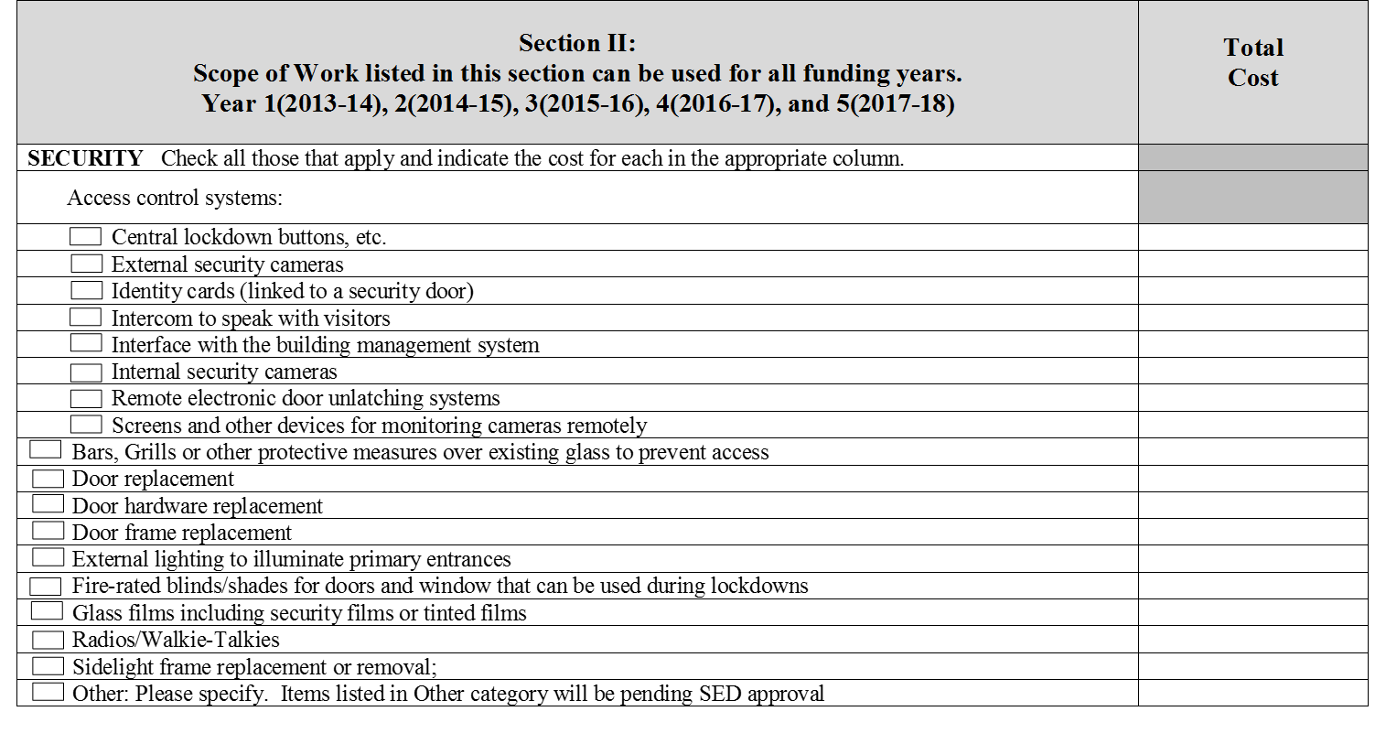
p. 3
Section III: Year 4 (2016-17) and Year 5 (2017-18)  Scope of Work listed in this section can be used for Years 4 and 5 funding only | Total Cost
ENVIRONMENTAL / HEALTH
Asbestos testing
Automatic External Defibrillator (AED)
Carbon monoxide detectors
Eyewash stations
Lead testing in school drinking water (The funds cannot be used to implement a lead remediation plan)
Parking decal or tag system for staff/students to identify vehicles
Radon testing
School security (Contracted Personnel)
School security employee personnel (Cost is the prorated time spent on security responsibilities. Complete Addendum A)
School security and safety Assessments to assist school officials in identifying potential vulnerabilities, and/or strengths
Software for tracking students during emergencies
Training to assist nonpublic schools in their efforts to create/maintain a safe learning environment free of crime and violence
FIRE PREVENTION
Annual inspection of fire extinguishers/fire alarms
Purchase of fire extinguishers and/or smoke detectors
Smoke detectors
Other: Please specify. Items listed in other category will be pending SED approval.
SECTION III SUBTOTAL BY CATEGORY
SECTION II SUBTOTAL BY CATEGORY (FROM PAGE 2)
GRAND TOTAL (SECTION II +SECTON III)

p. 4

