
CAYUGA-ONONDAGA BOCES
Career & Technical Education

Alternative Education

Special Education

Technology Services

Graduation Results

School Library System Services
Adult Career & Technical Education

Adult Basic Education

Professional Development

Student Achievement

2002-2003 Expenses
Board of Cooperative Educational Services
2003-2004 Report Card

Table of Contents
Page

Component/Non-Component District List ii

Indicators of BOCES Performance

Career & Technical Education 1-2
Alternative Education 3
Adult Career & Technical Education 4
Adult Basic Education 4

Special Education
Special Education Enrollment and Tuition in BOCES Programs 5
State Testing Program 6
Professional Development 7
Technology Services 8
School Library System Services 9

Student Achievement Report for Supervisory Districts

Grade 4 and Grade 8 English Language Arts and Math Assessments 10
Math and English Regents Examinations 11
Graduation Results/Distribution of Graduates 12

2002-2003 Expenses 13

Prior editions of the BOCES Report Card included other data representing BOCES special education programs and services. The following data were not available for this report:

- Services Provided by BOCES.
- Percent of Students with Disabilities Provided Special Education Services in Integrated Settings.
- Students with Disabilities Exiting BOCES Special Education Programs.
- Postsecondary Education and Employment Plans of Student with Disabilities.
CAYUGA-ONONDAGA BOCES
0590

COMPONENT DISTRICTS

● AUBURN CITY SD
● CATO MERIDIAN CSD
● JORDAN ELBRIDGE CSD
● MORAVIA CSD
● PORT BYRON CSD
● SKANEATELES CSD
● SOUTHERN CAYUGA CSD
● UNION SPRINGS CSD
● WEEDSPORT CSD

Career & Technical Education (CTE)

BOCES CTE classes, offered primarily on a half-day basis, prepare high school students from component districts for skilled workforce careers. Most CTE programs require two years to complete. Data source: BOCES Survey.
 |  | General Education Students |  | Students with Disabilities |  | General Education Students | Students with Disabilities
Number of 11th/12th grade students enrolled in a CTE two-year sequence |  | 2002-03 |  | 2002-03 |  | 2003-04 | 2003-04
First-year students ….…………………….………….. |  | 153 |  | 87 |  | 167 | 93
Second-year students ……………………………….…. |  | 90 |  | 57 |  | 95 | 54
Second-year students completing ……………………… |  | 80 |  | 48 |  | 72 | 38
Number of 11th/12th grade students enrolled in one-year programs
“New Vision” ………………………….…..………… |  | 38 |  | 1 |  | 49 | 2
Other one-year programs ….………………….………. |  | 0 |  | 0 |  | 0 | 0
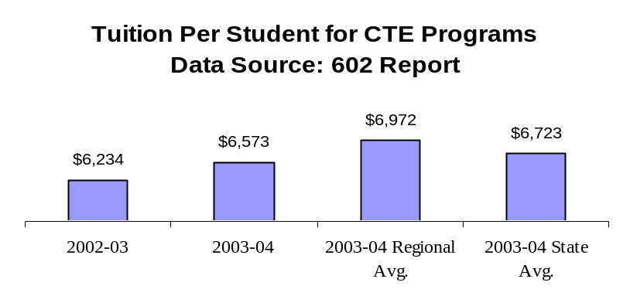
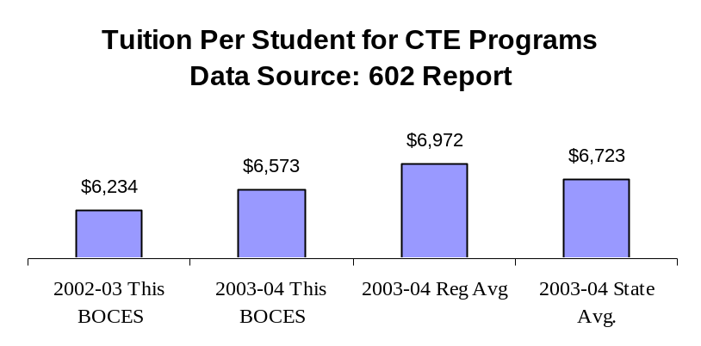
*Number Enrolled in CTE Programs as a Percent of all Juniors and Seniors in Component District High Schools
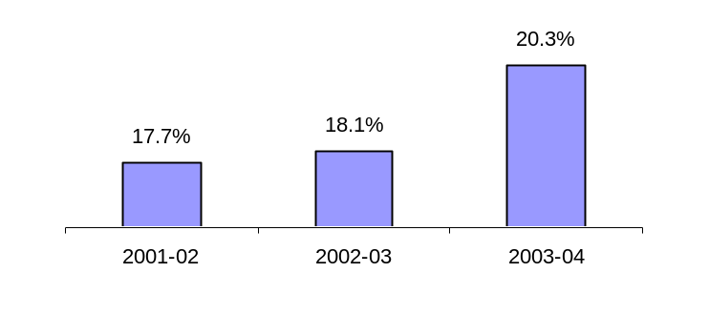
*Data Include General Education and Students with Disabilities. Data Source: BOCES Survey and Basic Education Data System

Performance of Career & Technical Education (CTE)
Students Who Graduated in 2003
BOCES collects student performance data from component districts for students who participate in CTE BOCES programs. The data in the chart are based upon total program completers (general education and students with disabilities.) Data source: CTEDS-2
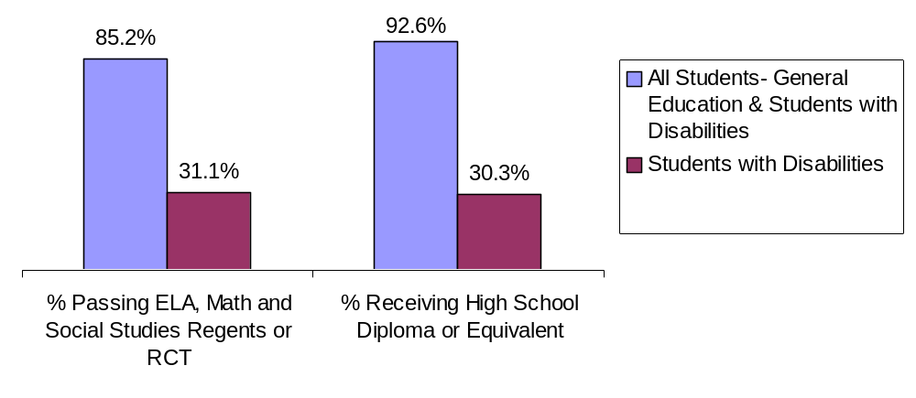

Status of Career and Technical Education (CTE) Students
Who Graduated in 2003
BOCES Surveys CTE graduates within one year after program completion to determine if they are employed or continuing their education. Data source: CTEDS-2 Report
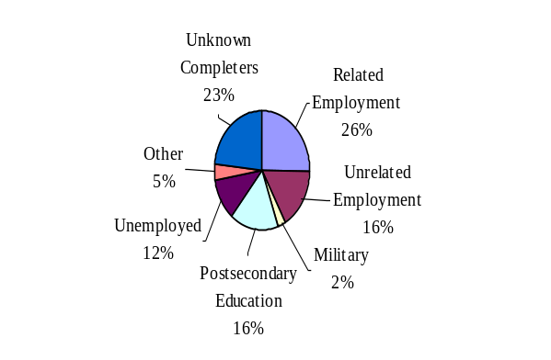
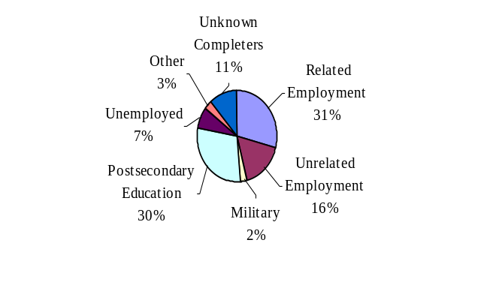
All Graduates
(General Education and
Students with Disabilities)
Students with Disabilities

Alternative Education

BOCES operates full-day and/or half-day programs for general-education students who have been identified as having special needs not being met in school district programs. Programs may include academics, vocational skills, work-study, specialized activities or a combination of these. The BOCES Report Card includes alternative education program enrollment and outcome data for students in grades 5 through 8, as well as students in programs leading to high school diplomas or high school equivalency diplomas. Data source: 2004 BOCES Survey
______________________________________________________________________________
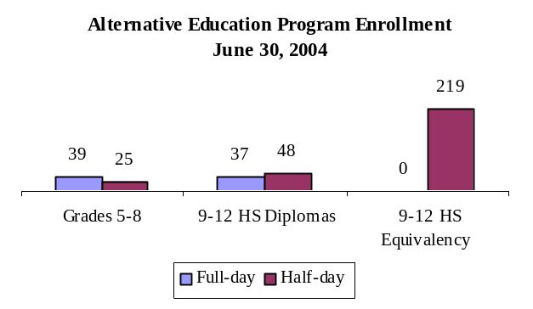
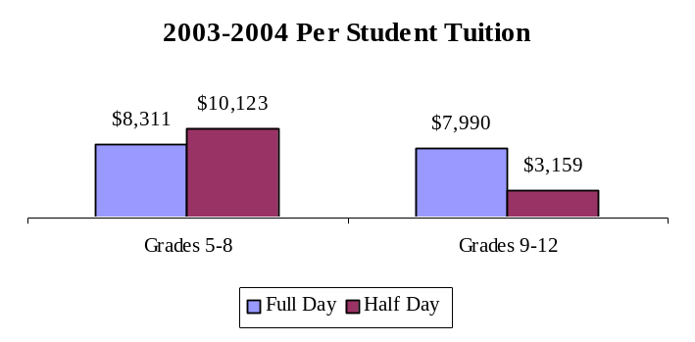

Alternative Education Outcomes

The objective of the alternative education program is to retain students until they graduate or return to a regular school setting. Students counted as leaving programs may have done so for a variety of reasons including relocation, medical problems, childcare, incarceration or entering other education programs. Data source: 2004 BOCES Survey
 | Grades 5-8 |  | Grades 9-12 Programs Leading to HS Diploma |  | Grades 9-12 Programs Leading to HS  Equivalency Diplomas
Number of students who: | Full-day | Half-day | Full-day | Half-day | Full-day | Half-day
returned to a school district program.…………. | 2 | 0 | 2 | 1 | 0 | 7
remained in the BOCES program……………... | 36 | 25 | 28 | 40 | 0 | 41
left the program and did not enter another district or BOCES program (dropouts)………… | 1 | 0 | 6 | 6 | 0 | 60
are waiting for GED exam results……………... |  |  |  |  | 0 | 0
received high school diplomas……………….... |  |  | 1 | 1
received high school equivalency diplomas …... |  |  |  |  | 0 | 79

Adult Basic Education
Adult Career and Technical Education (CTE)
Adult CTE programs enhance academic and workplace skills and enable participants to gain employment or career advancement.
2002-2003 Adult CTE Program Results | This BOCES |  | Statewide  Average
2002-2003 Adult CTE Program Results | Count | Percentage | Statewide  Average
All CTE Programs
Number Enrolled | 195
Number who Left Prior to Completion | 32 | 16.4% | 17.3%
Number who Completed | 114 | 58.5% | 72.7%
Completed and Status Known | 77 | 67.5% | 49.9%
Completed and were Successfully Placed* | 71 | 92.2% | 86.9%
Non-Traditional Programs
Under-Represented Gender Members Enrolled | 11 | 10.5% | 13.1%
Under-Represented Gender Members Who Completed | 6 | 10.9% | 11.9%
* Successfully Placed means placed in employment, the military or in additional education.

Based on data reported for the National Reporting System (NRS) for adult education programs, enrollment in adult basic education programs for 2003-2004 was 217.

Educational Gain

Under the NRS, educational gain is the primary goal for students in adult beginning/ intermediate programs, adult secondary (low) programs, and in English for speakers of other languages programs. Students are counted as achieving educational gain if they exceed established reference points in their standardized test scores between enrollment and re-testing.
Educational Program | Enrollment |  |  | Educational Gain
Educational Program | 2001-02 | 2002-03 | 2003-04 | 2001-02 |  | 2002-03 |  | 2003-2004
Adult Beginning/  Intermediate | 306 | 223 | 194 | 14 | 5% | 20 | 9% | 72 | 37%
Adult Secondary (Low) | 37 | 36 | 15 | 2 | 5% | 4 | 11% | 3 | 20%
ESOL | 0 | 0 | 0 | 0 | 0 | 0 | N/A | 0 | N/A

Other Outcomes (2001-02 through 2003-04)
The following outcome measures are consistent with the National Reporting System (NRS) for adult education. Students in adult secondary (high) programs are considered to have a primary goal of obtaining a secondary or high school equivalency diploma. For all other outcomes, the student achievements correlate to the students indicating those goals at intake.
Other Outcomes | Students with Goal |  |  | Students Achieving Goal
Other Outcomes | 2001-02 | 2002-03 | 2003-04 | 2001-02 |  | 2002-03 |  | 2003-04
Entered employment | 17 | 8 | 19 | 5 | 29% | 4 | 50% | 17 | 89%
Retained employment | 2 | 0 | 1 | 1 | 50% | 0 | NA | 0 | 0%
Obtained a secondary or high school equivalency diploma | 173 | 24 | 21 | 56 | 32% | 10 | 42% | 16 | 76%
Entered post-secondary education or training | 27 | 6 | 16 | 15 | 56% | 6 | 100% | 15 | 94%

Special Education Enrollment and Tuition

When placing students, districts select among classrooms with different student/staff ratios consistent with each student’s Individualized Education Program (IEP). The following are four of the alternatives:
- 12 students per teacher plus one paraprofessional (12:1:1)
- 6 students per teacher plus one paraprofessional (6:1:1)
- 12 students per teacher plus four paraprofessionals (12:1+1:3)
- 8 students per teacher plus 1 paraprofessional (8:1:1)

An addendum of enrollment and tuition information will be attached to this report if this BOCES provides other options of student/staff ratios.

Tuition rates exclude the costs of related services, preschool and summer school programs. BOCES with multiple tuition rates for a program have calculated an average rate. Data source for enrollment and tuition: 602 Report.
Enrollment Trends

 | 2001-02 | 2002-03 | 2003-04
8:1:1 | 106 | 106 | 107
12:1+1:3 | 0 | 0 | 0
6:1:1 | 0 | 0 | 0
12:1:1 | 131 | 139 | 148

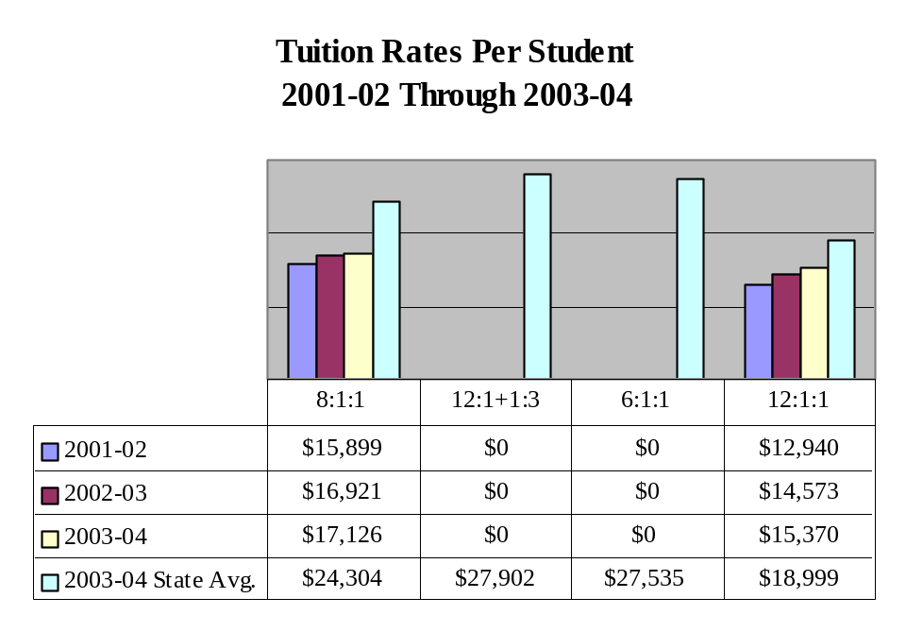

Tuition rates are unavailable for 2001-02 for the 12:1+1:3 student/staff ratio.
State Testing Program

These data are results of State assessments for students enrolled in BOCES programs.
State Assessment | Counts of Students Tested |  |  |  |  | Percentage of Students Tested |  | No Valid Score
State Assessment | Level 1 | Level 2 | Level 3 | Level 4 | Total | Level 2-4 | Level 3-4
Elementary-level English Language Arts  February 2004 | # | # | # | # | 2 | # | # | 0
Elementary-level Mathematics  May 2004 | # | # | # | # | 2 | # | # | 0
Middle-level English Language Arts  January 2004 | # | # | # | # | 2 | # | # | 0
Middle-level Mathematics  May 2004 | # | # | # | # | 2 | # | # | 0

Performance of Students with Severe Disabilities on the
New York State Alternate Assessment (NYSAA)

 | Counts of Students Tested |  |  |  |  | Percentage of Students Tested |  | No Valid Score
 | Level 1 | Level 2 | Level 3 | Level 4 | Total | Level 2-4 | Level 3-4
Elementary-level English Language Arts | 0 | 0 | 0 | 0 | 0 | 0 | 0 | 0
Elementary-level Mathematics | 0 | 0 | 0 | 0 | 0 | 0 | 0 | 0
Middle-level English Language Arts | 0 | 0 | 0 | 0 | 0 | 0 | 0 | 0
Middle-level Mathematics | 0 | 0 | 0 | 0 | 0 | 0 | 0 | 0

Level 4 | These students exceed the standards and are moving toward high performance on the Regents examination.
Level 3 | These students meet the standards and, with continued steady growth, should pass the Regents examination.
Level 2 | These students need extra help to meet the standards and pass the Regents examination.
Level 1 | These students have serious academic deficiencies.

Note: To protect student confidentiality, the pound character (#) appears when fewer than five students in a group are tested.
Professional Development
2003-2004 School Year

BOCES provided training for a minimum of one or more full instructional days in the following areas: | Number of Participants:
 | Districts | Teachers | Principals | Paraprofessionals | Other
Site Based Educational Planning | 10 | 84 | 3 | 0 | 0
District Based Educational Planning | 1 | 14 | 9 | 0 | 0
High School Graduation Requirements | 0 | 0 | 0 | 0 | 0
Learning Standards (ELA, MST etc.) | 0 | 0 | 0 | 0 | 0
Data Management and Analysis | 9 | 272 | 2 | 18 | 19
Integrating Technology into Curricula & Instruction | 3 | 69 | 5 | 0 | 0
Interdisciplinary Teaching (including integration of career technology & academics) | 0 | 0 | 0 | 0 | 0
Middle Level Education Academic and Youth Development | 9 | 25 | 4 | 0 | 0
Career and Technical Education | 0 | 0 | 0 | 0 | 0
Instructional Strategies | 9 | 490 | 0 | 0 | 0
Parent Training | 0 | 0 | 0 | 0 | 0
Special Education Issues | 10 | 682 | 42 | 277 | 46
Leadership Training | 10 | 116 | 27 | 7 | 0
Special Education Training Resource Center (SETRC) | 10 | 480 | 35 | 110 | 15
Other | 0 | 0 | 0 | 0 | 0


Technology Services
2003-2004 School Year

BOCES provides technology services to district and BOCES staff and students. | Districts | Professionals Teachers  Administrators | Students
Distance Learning | 8 | 8 | 162
Instructional Computing | 8 | 500 | 15,975
Computer/Audio Visual Repair | 9 | 600
Library Automation/Software | 7 | 26 | 14,900
LAN Installation/Support | 1 | 104 | 1,020
Distributed Process Technicians | 0 | 0 | 0
Guidance Information | 4 | 16 | 3,000
Administrative Computer Services | 0 | 0
Administrative Training | 0 | 0

School Library System Services


School Library System Services, a state-aided program sponsored by each BOCES, provide vital library and information resources to public and nonpublic schools throughout the State. Each system operates under an approved plan of service and provides leadership and training through professional development activities; facilitates resource-sharing among its member school libraries; promotes advances in technology for information storage and retrieval; focuses on cooperative collection development of school library materials; addresses the information needs of special client groups and participates in regional library issues with public, academic and special libraries. Students, teachers and administrators in each BOCES service area benefit from the activities of the program. The charts below depict selected school library system services.
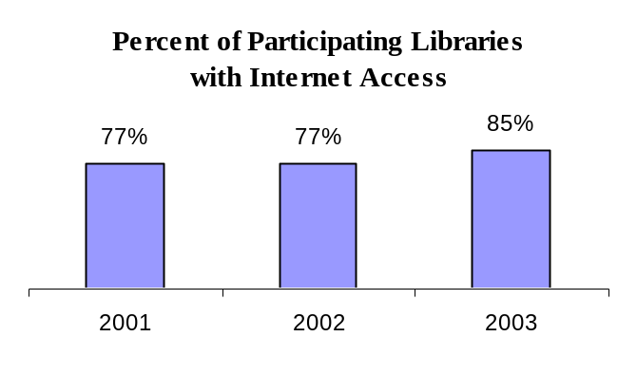
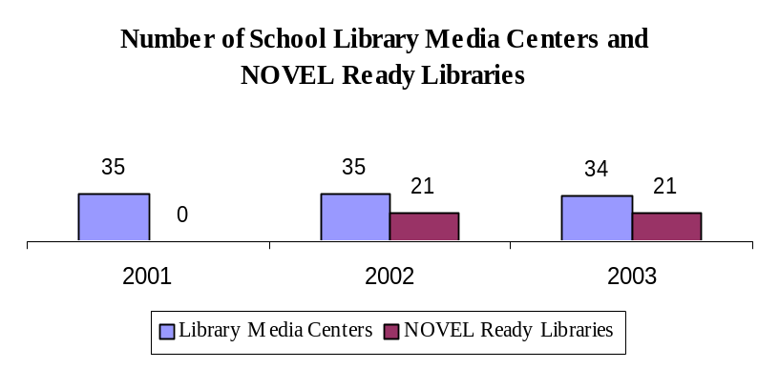
NOVEL (New York Online Virtual Electronic Library) Ready Libraries provide access via the Internet to their own information resources and to information resources outside the library, in addition to providing technology training.
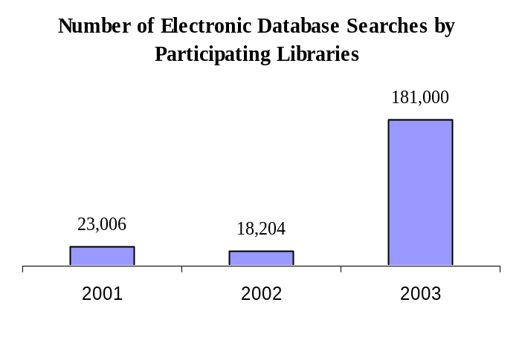
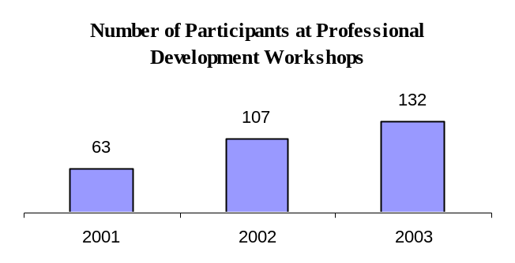

State Testing Program for All Component Districts

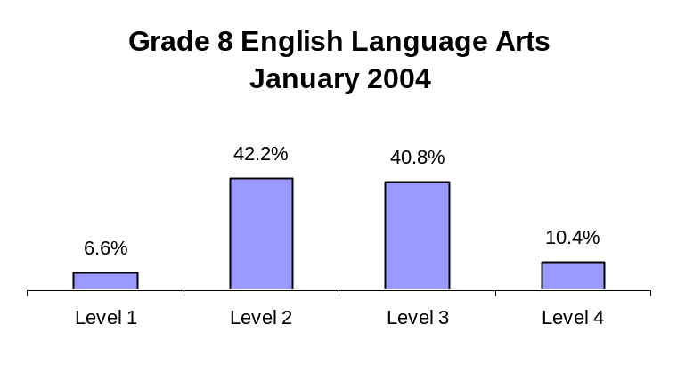
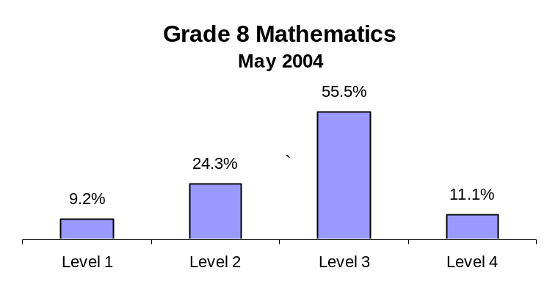
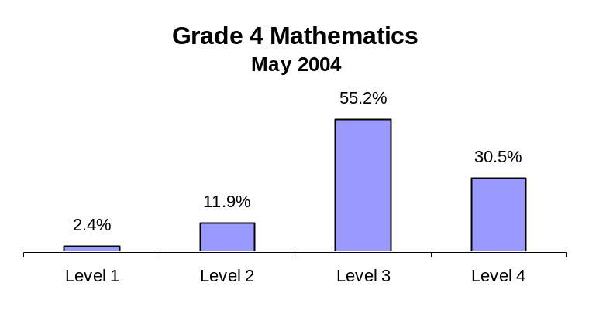
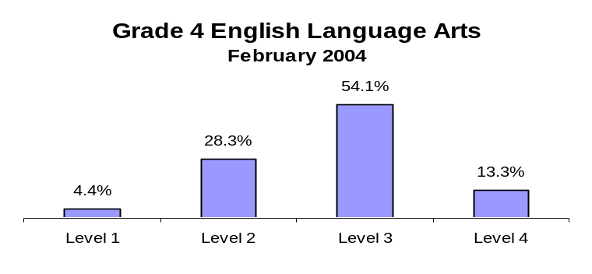
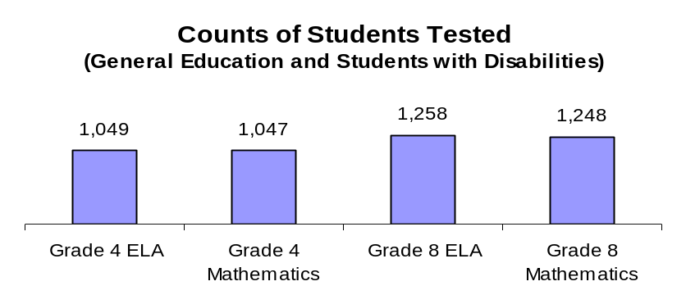
The State testing program provides data to the State Education Department and local school districts for use in planning, managing, and evaluating educational programs. The 4th and 8th grade English language arts (ELA) and mathematics tests measure student performance on the State standards for the elementary and middle grades, while the Regents examinations are key indicators of student progress in the secondary grades. These data are calculated by aggregating district-level results for general education students and pupils with disabilities for all component districts.
Percent of Student Scoring at Each Performance Level
Level 4 | These students exceed the standards and are moving toward high performance on the Regents examination.
Level 3 | These students meet the standards and, with continued steady growth, should pass the Regents examination.
Level 2 | These students need extra help to meet the standards and pass the Regents examination.
Level 1 | These students have serious academic deficiencies.
Further descriptions for each level by exam are available on the School Report Cards at the New York State Education Department Web site at www.emsc.nysed.gov/irts/.

Regents Examinations

In 1996, the Regents acted to raise learning standards by requiring future students to demonstrate competence for graduation using Regents examinations, rather than the lower-level Regents competency tests (RCTs). All general-education students who entered ninth grade in the fall of 1996 were required to score 65 or higher (55 if approved by the local school board) on the Regents examination in comprehensive English to earn a local diploma. General-education students who entered ninth grade in the fall of 1997 are required to score 65 or higher (55 if approved by the local school board) on the Regents examination in comprehensive English and on a Regents examination in mathematics. The number of Regents examinations required for graduation has increased with each succeeding freshman class. Added requirements for the freshman class of 1998 were the Regents examinations in global history and geography and U.S. history & government. The freshman class of 1999 has to also pass a Regents examination in science.

Data were collected to assess the progress that students are making toward meeting new graduation requirements for their cohort. The following charts show the percentage of cohort members in component districts who scored 55-100 and 65-100 on each Regents examination after four years. The data include results for students with disabilities.
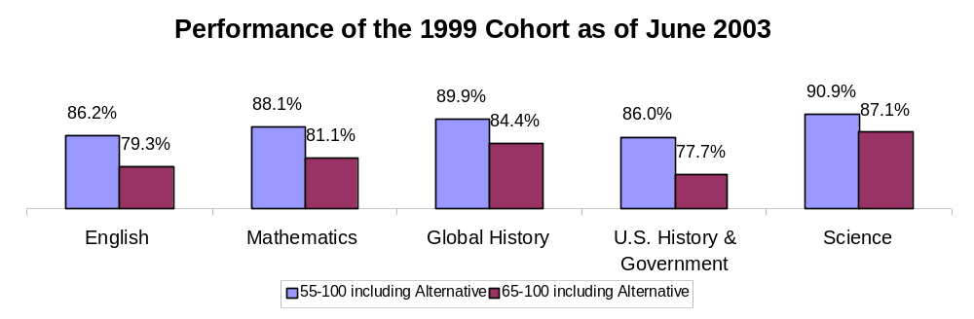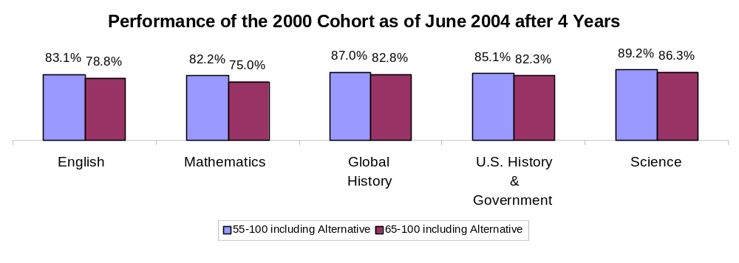
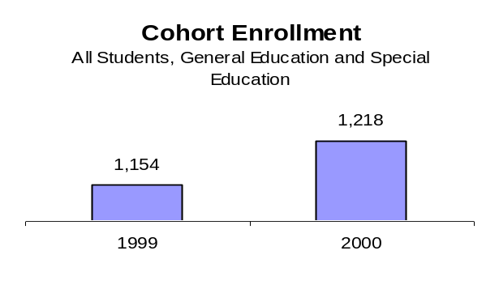
Graduation Results
1999-2000 through 2003-04 School Years

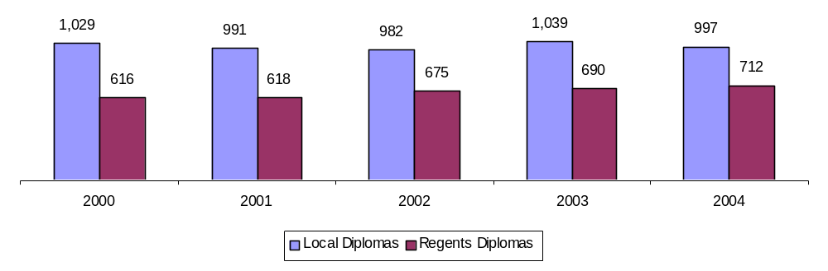
Displayed below are the number of graduates in component districts who received local diplomas with or without Regents endorsement and local diplomas with Regents endorsement during the 1999-2000 through 2003-04 school years. Before the 2001-02 school year, counts include January, June and August graduates. In the 2001-02 school year, counts include January and June graduates. Data for the 2002-03 and 2003-04 school year include August, January and June graduates. In 2003-04, 71.4% of the high school graduates in this BOCES region component districts earned a Regents diploma verses 69.2% of the graduates in component districts statewide.

Distribution of Graduates

2001-2002 through 2003-2004 School Years

The chart provides the percentage of graduates in component districts who specified the postsecondary intentions listed during the 2001-2002 through 2003-2004 school years. Other postsecondary includes trade and proprietary schools.

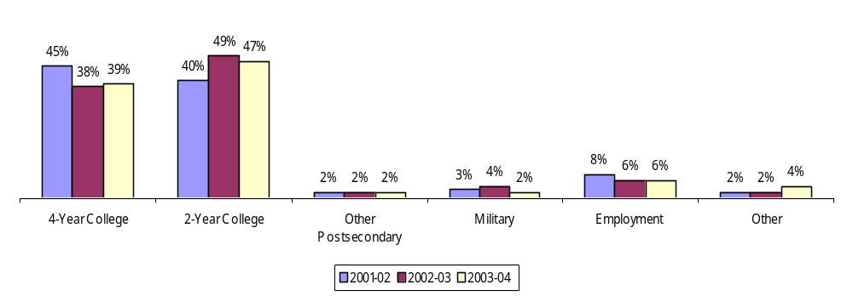
2002-2003 Expenses

Administrative Expenses (Excluding Supplemental

& Other Post Retirement Benefits) $ 749,518
Supplemental Retirement & Other Post Retiree Benefits $ 85,586
Capital Expenses $ 330,683
Total Program Expenses $ 15,683,481
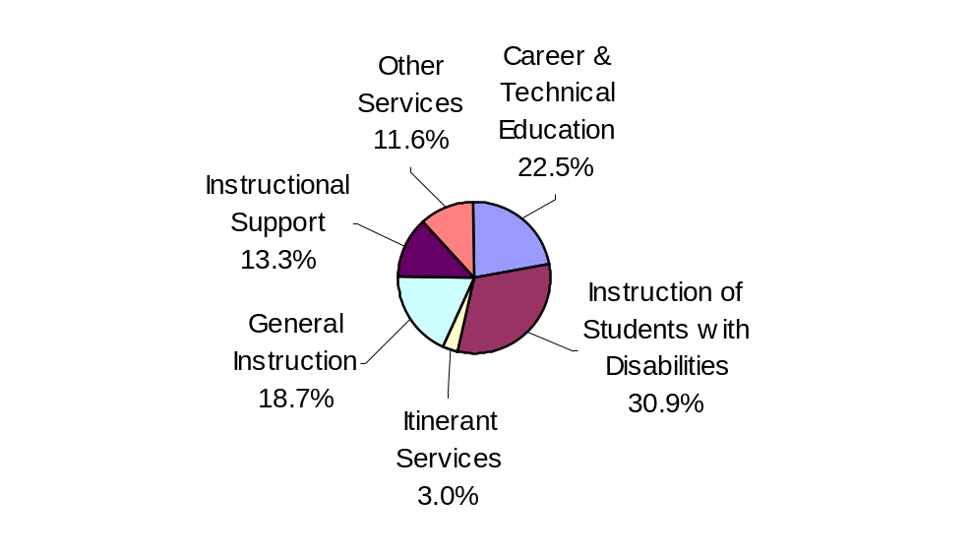
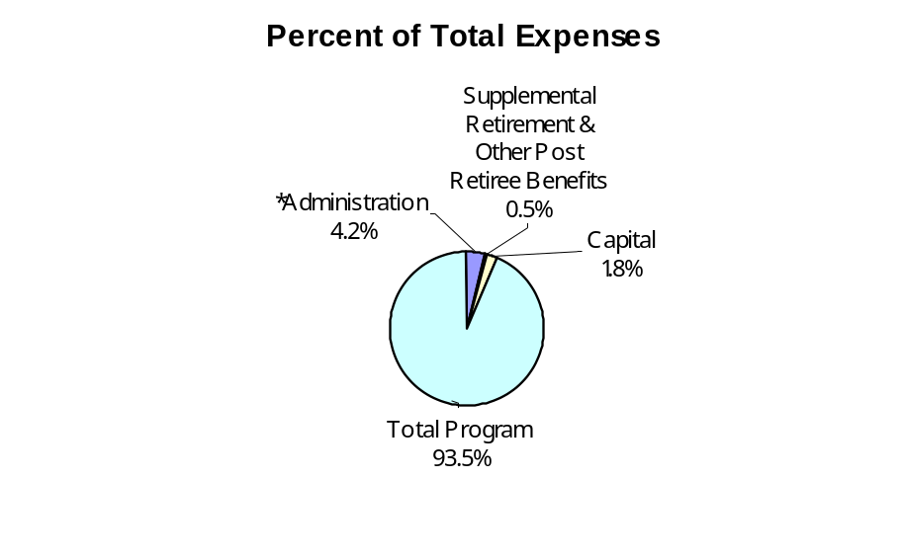
Total Expenses $ 16,849,268

*Excludes Supplemental & Other Post Retirement Benefits

