September 2021
NYSSD School Newsletter

Welcome Back!

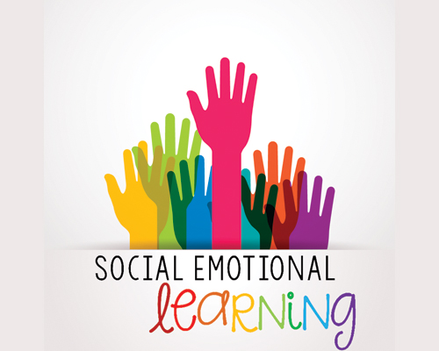

Hello NYSSD friends and family. We hope you had an enjoyable summer and welcome you to the beginning of the 2021-22 school year! We have some wonderful changes that will be taking place during the 2021-22 school year to enhance the social emotional learning for our students. Our school psychologist, Ashlee Feldman-Alguire, and school counselor, Chris Kimball, will be providing consistent SEL (social emotional learning) instruction throughout the school year. For our middle school and high school students we have this labeled SEL lab in their class schedules. For our elementary students we will be scheduling times with their classroom teacher and teaching assistant(s) to provide SEL instruction.

Social emotional learning is always a crucial part of instruction at any school level. With the changes that have occurred since the COVID-19 pandemic it is arguably more crucial than ever. Socialization has been minimized in order to ensure the safety of our staff and students. Our goal with our SEL labs is to instill age appropriate social skills in a variety of settings. In addition, assist our students in developing the social skills needed now and in the future.

We look forward to providing monthly updates and pictures of our activities with your child or children. If there are additional ideas or topics you’d like us to address with your child or children please feel free to reach out to Ashlee Feldman-Alguire and/or Chris Kimball. We are a team and the goal is for your child or children to be successful now and into the future. We look forward to working with you and supporting your child or children to have a successful 2021-22 school year. We hope you have a wonderful September.
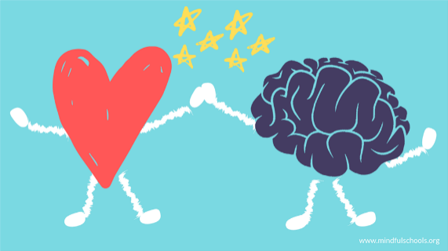

This summer our students had the opportunity to “Camp Out Under the Stars”.

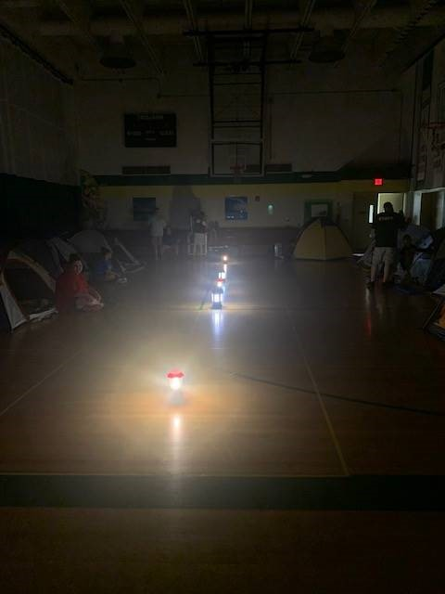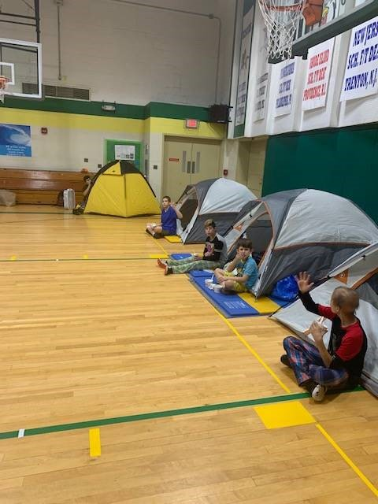

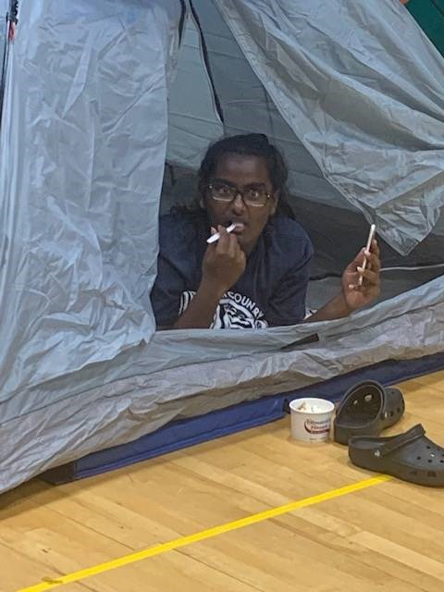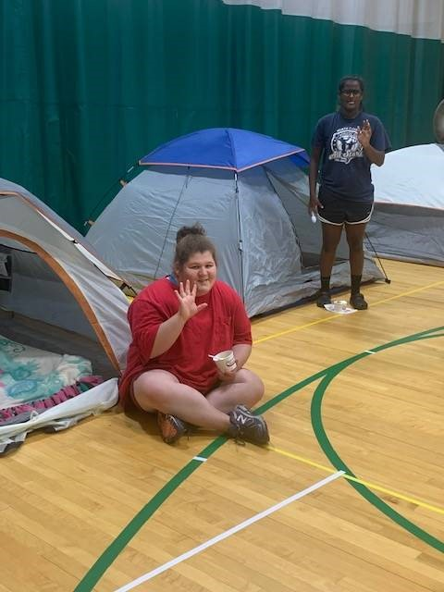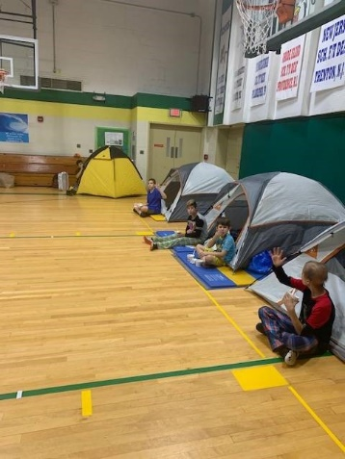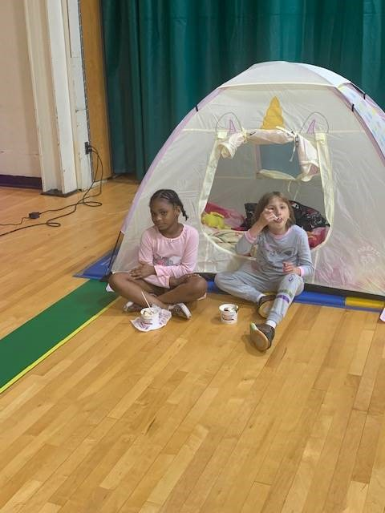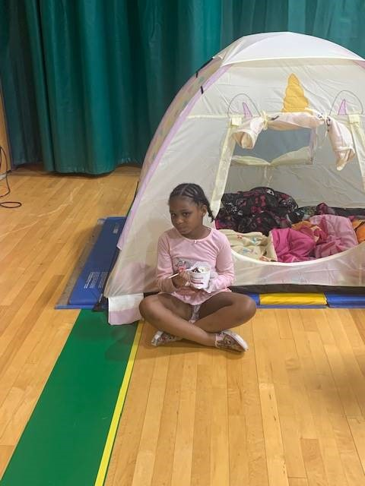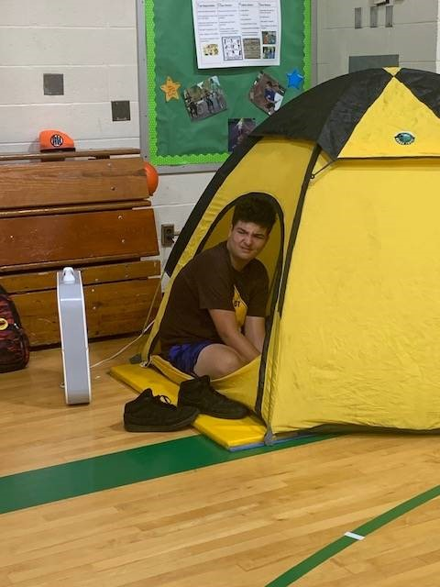

Deaf Infant Program News

The students and families in the Deaf Infant Program have been learning All About Me for the month of September. They have been learning about their bodies and identifying body parts. We have been using stories, crafts, toys, Play-Doh, stickers and dolls to help learn this vocabulary. The students have also been working on matching and identifying vocabulary during their sessions. Here are pictures of Andrew working on identifying body parts using Mr. Potato Head, and using his listening to matching objects to pictures.

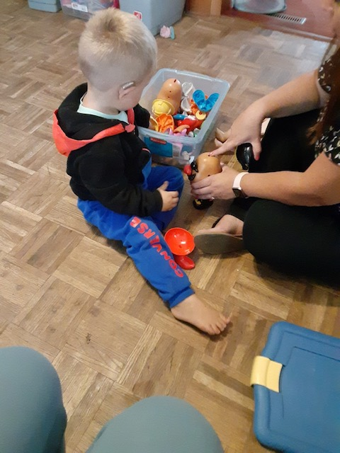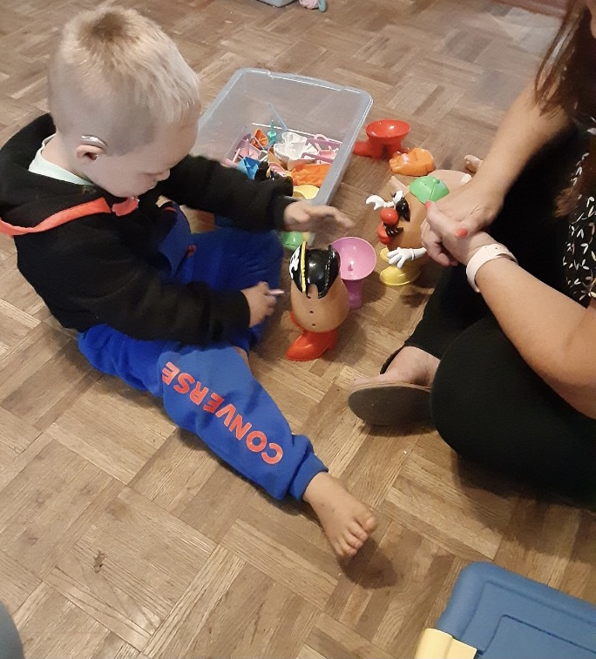
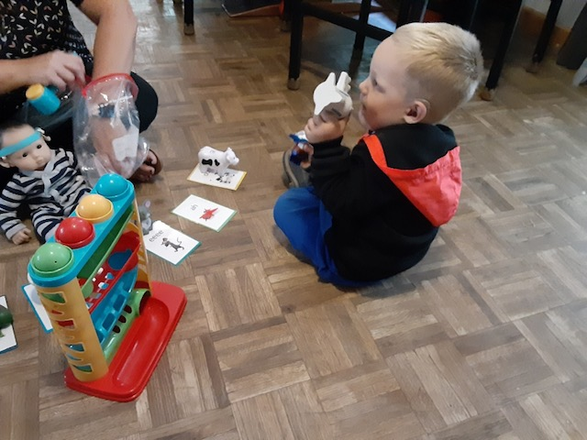

Pre-K News

In Pre-K, we have successfully started school! We have been working on finding out who we are. Also, the students are learning colors. So far, they have discovered many objects and foods that are red.
We are looking forward to learning more colors and ways to be kind in and outside of school. Thank you for helping us start our school year as part of a strong community!
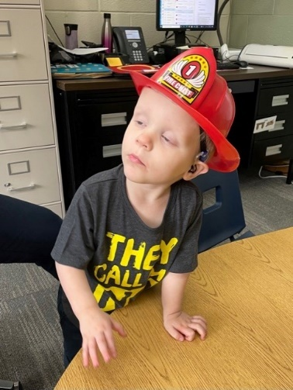
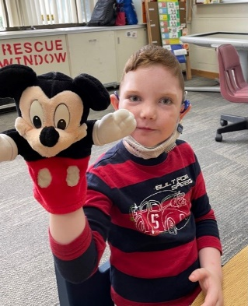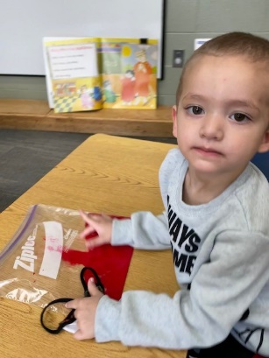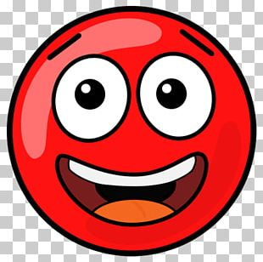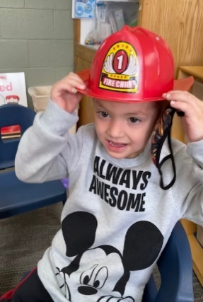
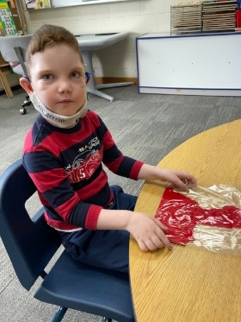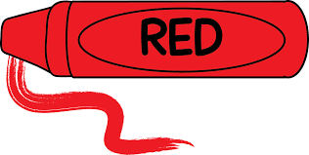

Kindergarten News

It has been a great start for Kindergarten! In math, we are learning how to sort items into categories and how to count objects using one-to-one correspondence. In reading, we are focusing on our letters and following words top to bottom, from left to right, and page to page. We are also working very hard at writing our names and numbers from memory!

Sheryl Whipple
Instructor
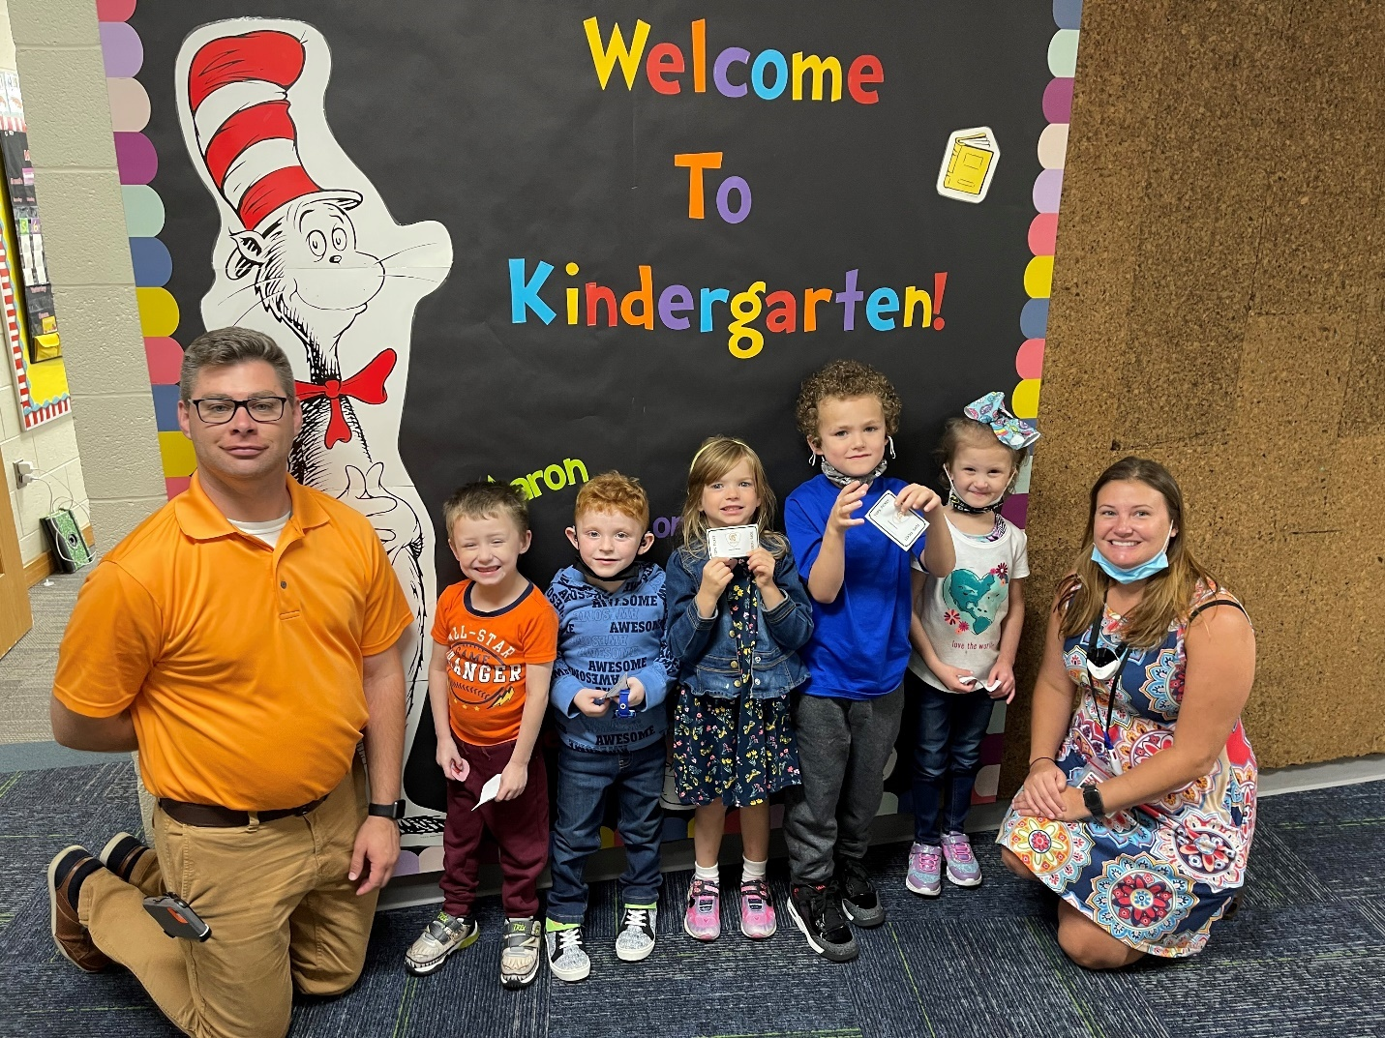

Ms. Wheelock’s Classroom
In the 1st/2nd grade classroom we spent the first couple of weeks getting to know each other, our classroom expectations and the new routines. On the first day of school we read a story titled “The Night Before First Grade” by Natasha Wing. After reading the story, each student wrote down one wish they have for this year (as modeled by the characters in our story). We placed our wishes on the bulletin board for everyone to enjoy!
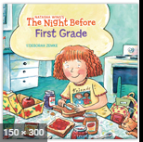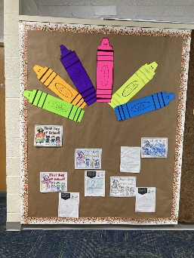
Our class also spent some time creating a classroom community complete with a set of rules that follow our school-wide TOPS program. We read “Do Unto Otters” by Laurie Keller to help us think about how to treat others. We have been working hard to follow the rules and earn TOPS tickets!
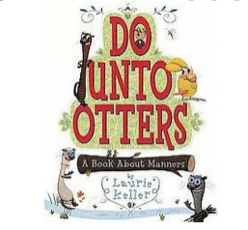
Students participated in an “Owl About Me” project the second week of school. Students brought in a few items special to them, and shared the items in a Show-and-Tell way. It was really fun to get to learn about our friends! We found out we have A LOT of things in common.
Now that we are in our third week of school, we are settled in and beginning the academic units for the school year! What an EXCITING start to 1st/2nd Grade!
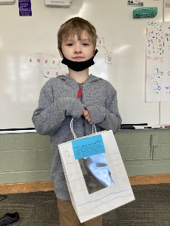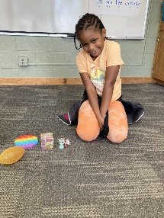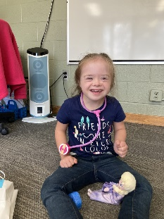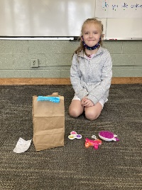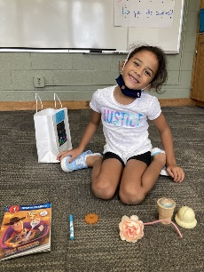

In Jessica and Morgan’s class we are working on building relationships, making friends, learning the rules, and working together as a class. Our students had a wonderful first day of school. They have created many paintings, personal/academic goals, and an About Me poster. Thank you for your support within the past few weeks. Students have been coming to school and ready to learn! We couldn’t do this without your support!

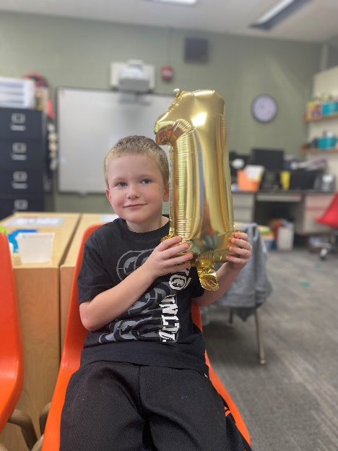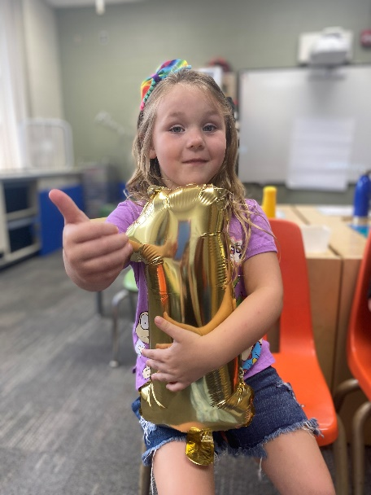
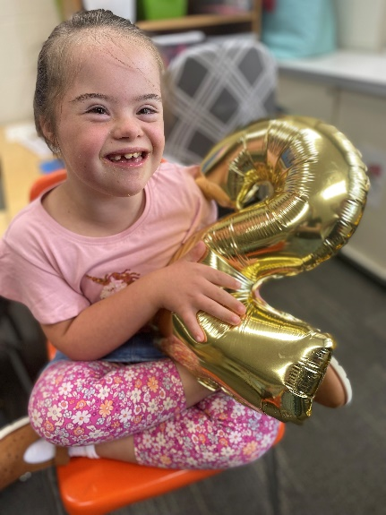
All About Me!!

3rd Grade News

Math - We are learning how multiplication can be represented in many ways by adding, using words equal groups of, and pictures like arrays.
ELA - The students are learning how to build their reading stamina through independent read. They are learning new words in spelling and vocabulary. The students wrote a goal for the first term.
Social Studies - The students created a class constitution and compared it to the U.S. Constitution.
Science - The students are starting to learn about Force and Motion.

We are practicing the routines and procedures, too. 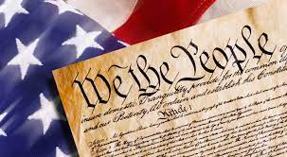

6th Grade News

We are starting the days with working on grammar and sprucing up on our sight words. Afterwards we move on to ELA class, where the students are identifying the 5Ws (who, what, where, when, and why) in their weekly reading. They then go on to learn several vocab words pulled from the reading and create a comic strip of the story adding how they think the story started and ended. We then finish with test based on the reading and vocab. Math we are on hot pursuit of learning about ratios and ratio equalities. Science and Social Studies are slowly starting up by looking at the 50 states and the continents. This will then transition to early civilizations and the formation of the continents.

Living Environment

The last few weeks, we have been learning all about cells, the most basic unit of life. We have learned the structure and function of cells as well as the different types of cells that make up living organisms, such as plant vs. animal and eukaryotic vs. prokaryotic. The next few weeks we will discuss the chemical processes that occur inside cells, such as photosynthesis and respiration and why these are important for proper functioning. Ask your children about the Cell Rap! It’s a class favorite!

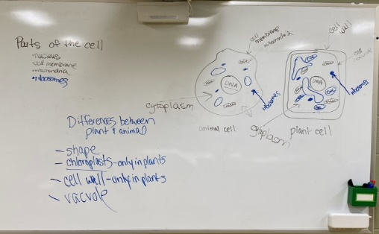

Transition to Adulthood

The students in Transition to Adulthood are in the process of researching scholarships. They are learning how to use specific search engines to locate scholarships when given specific criteria. The students will be deciding which scholarships they are interested in applying for and we will then complete the application process together.

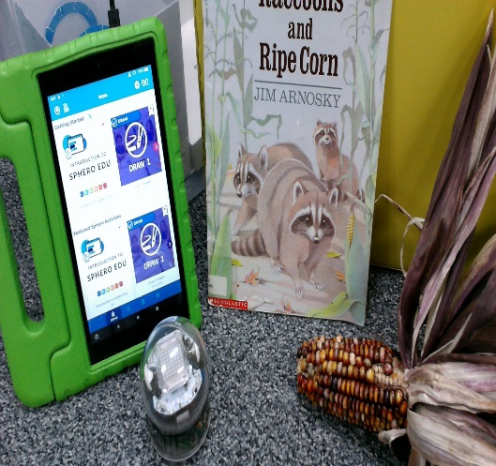
ELA News
ELA 9 & 10 Unit on identity

*Editing: correction marks *Main Idea - reading and selecting

ELA 11& 12 Unit on survival
*Editing: correction marks *Main Idea - reading and selecting

Pre-algebra Refresher on signed numbers, calculator, absolute value, fractions

Library News

Welcome back to school! When the Library re-opens, there will be a nice new carpet and maker place for hands-on learning. Until then, we have been getting used to story times and library activities in a different space.
Pre-K through 2nd grade is practicing whole body listening and listening to stories that promote the letter sounds A,B and C! Stories included books by authors Todd Parr, Bill Martin and Lois Ehlert.
Elementary students are using story sticks to identify story elements, learning about how to locate books using the library catalog, and creating a character as authors of their own story.
Middle school classes are reviewing library resources, and at the end of the month learned how to use Bolt robots using Sphero Play and Edu apps. These techies are quick learners!

In ELA the 7th graders have started a Survival Unit. We are learning about water and its importance. We have constructed thinking maps about “Why is water important?”, “Where do we get water?”, and “What do we need water for?”. We then started learning about the water crisis in our world and how some people do not have access to clean water. Many of these people also have to walk very far to reach water. Soon, we will be reading the story “The Long Walk to Water”.

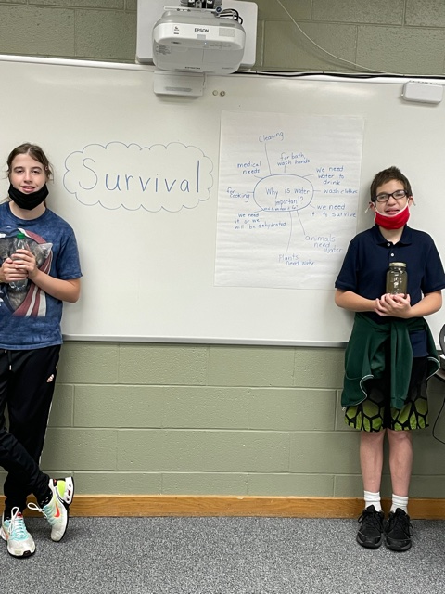
Speech News

Speech and language is off to a great start! In our program-driven Language Lab classes, our middle school students have been discussing different social circles, and appropriate ways to interact with people in each group. The high school students have been working on keeping journals and discussing different strategies to advocate for themselves in public. The elementary classes have been focusing on literacy skills, such as sight word identification and story retell!
Lower elementary has been learning about apples and practicing the concepts of "same" and "different." We also practiced answering yes and no questions by discussed what foods and drinks we can make with apples.

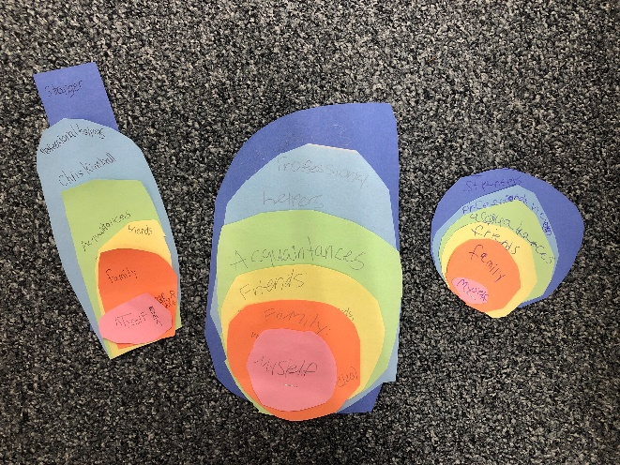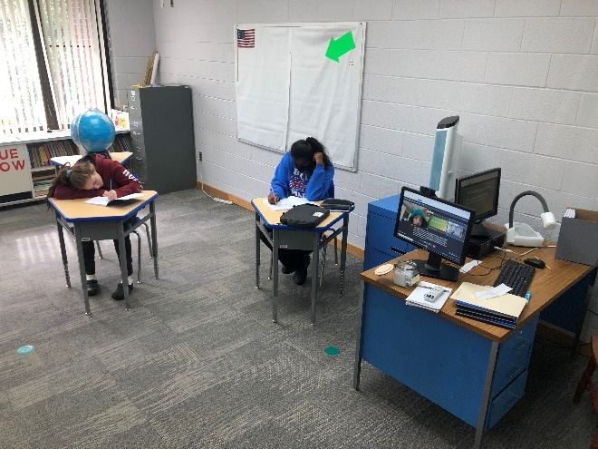

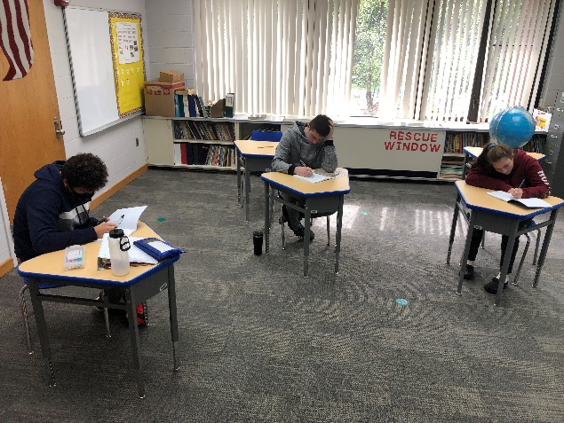

The 7th Grade Social Studies students are learning about migration and the Native Americans. During the last Ice Age (75,000 years ago), students learned about the Bering Strait Land Bridge from Russia to Alaska. They recognized all continents and discussed of the prehistoric people from Asia migrated to North and South America. In the photo the students are creating a map of the continents and will illustrate the great human migrations.
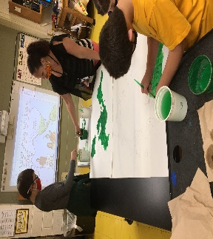
News From Vicky 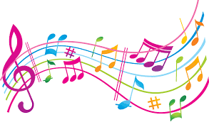 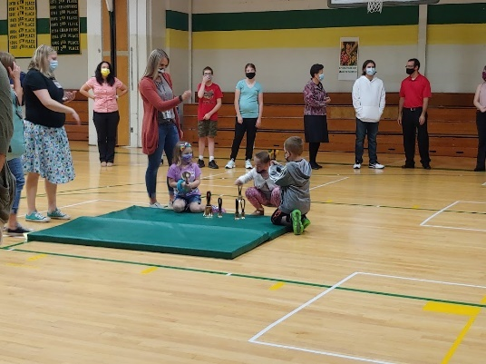 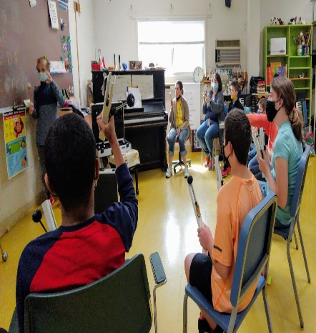 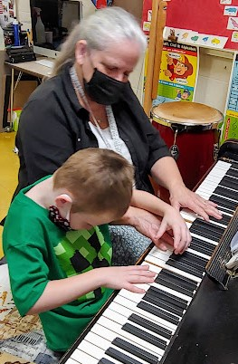
Opening day students RING THE BELL!
Jon directs his classmates in playing chords in the Key of C.

Josh explores the piano keyboard for the first time!

September October
17th Kathleen 7th Anvita
24th Jahtavious 16th Damerious
29th Amran

