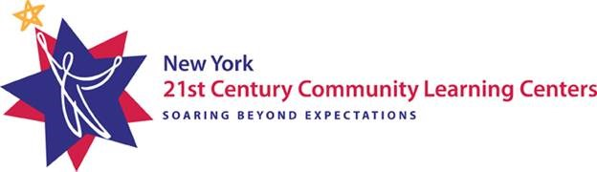
ACTION PLAN FOLLOW-UP
☐ Action Plan sent to Resource
Center within 30 days
☐ All areas compliant within 6 months

ACTION PLAN

Lead Agency: | Project Number1: 0187-XX-XXXX | Program Reviewer(s):
Date of SMV: | Date SMV Report Received: | Date Plan Submitted to Resource Center:
Name of person(s) and role(s) completing Action Plan:
Recently your agency received a Site Monitoring Visit (SMV) by the Resource Center and the following indicators were found to be partially and/or not compliant. Please outline an action plan describing how your program will address the indicator(s) and bring them into compliance. Submit the action plan, along with any supporting documentation, to the Resource Center within 30 days of receiving the report. Additionally, let the Resource Center know if you need any technical assistance in completing work towards the indicator(s).

Indicator of Success | Description of Indicator | Improvement Action Steps and Strategies | Person(s) Responsible | Timeline for Improvement  (Month/Year) | Date Completed  (Month/Day/Year)

1 Project number example: 0187-20-7150; 0187 indicates to NYSED that it is a 21st CCLC program; 20 indicates the program year (July 1, 2019-June 30, 2020 and after June 30, 2020, the year changes to 21; 7150 (last four digits) indicates the grant’s project number.

