The University of the State of New York
The State Education Department



OVERVIEW OF PERFORMANCE IN

ENGLISH LANGUAGE ARTS, MATHEMATICS, AND SCIENCE

AND

ANALYSIS OF STUDENT SUBGROUP PERFORMANCE

for

Public Schools in New York State

February 2005
THE UNIVERSITY OF THE STATE OF NEW YORK

Regents of The University

Robert M. Bennett, Chancellor, B.A., M.S. Tonawanda
Adelaide L. Sanford, Vice Chancellor, B.A., M.A., P.D. Hollis
Diane O’Neill McGivern, B.S.N., M.A., Ph.D. . Staten Island
Saul B. Cohen, B.A., M.A., Ph.D. New Rochelle
James C. Dawson, A.A., B.A., M.S., Ph.D. Peru
Anthony S. Bottar, B.A., J.D. North Syracuse
Merryl H. Tisch, B.A., M.A. New York
Geraldine D. Chapey, B.A., M.A., Ed.D. Belle Harbor
Arnold B. Gardner, B.A., LL.B. Buffalo
Harry Phillips, 3rd, B.A., M.S.F.S. Hartsdale
Joseph E. Bowman, Jr., B.A., M.L.S., M.A., M.Ed., Ed.D Albany
Lorraine A. CortÉs-VÁzquez, B.A., M.P.A. Bronx
James R. Tallon, jr., B.A., M.A. Binghamton
Milton L. Cofield, B.S., M.B.A., Ph.D. Rochester
John Brademas, B.A., Ph.D. New York

President of The University and Commissioner of Education
Richard P. Mills

Deputy Commissioner for Elementary, Middle, Secondary and Continuing Education
James A. Kadamus

Assistant Commissioner for Standards, Assessment and Reporting
David M. Abrams

Coordinator, Information and Reporting Services
Martha P. Musser

The State Education Department does not discriminate on the basis of age, color, religion, creed, disability, marital status, veteran status, national origin, race, gender, genetic predisposition or carrier status, or sexual orientation in its educational programs, services and activities. Portions of this publication can be made available in a variety of formats, including braille, large print or audio tape, upon request. Inquiries concerning this policy of nondiscrimination should be directed to the Department’s Office for Diversity, Ethics, and Access, Room 530, Education Building, Albany, NY 12234. Requests for additional copies of this publication may be made by contacting the Publications Sales Desk, Room 309, Education Building, Albany, NY 12234.

Please address all correspondence about this report that is not related to data corrections to:

School Report Card Coordinator
Information and Reporting Services Team
New York State Education Department

Room 863 EBA
89 Washington Avenue
Albany, NY 12234
E-mail: RPTCARD@mail.nysed.gov
The New York State Report Card is an important part of the Board of Regents effort to raise learning standards for all students. It provides information to the public on student performance and other measures of statewide performance. Knowledge gained from the report card can be used to improve instruction and services to students.
The New York State Report Card consists of three parts: the Overview of Performance in English Language Arts, Mathematics, and Science and Analysis of Student Subgroup Performance, the Comprehensive Information Report, and the Accountability Status Report. The Overview and Analysis presents performance data on measures required by the federal No Child Left Behind Act: English, mathematics, science, and graduation rate. Performance data on other State assessments can be found in the Comprehensive Information Report. The Accountability Status Report provides information as to whether the State is making adequate progress toward enabling all students to achieve proficiency in English and mathematics.
State assessments are designed to help ensure that all students reach high learning standards. They show whether students are getting the foundation knowledge they need to succeed at the elementary, middle, and commencement levels and beyond. The State requires that students who are not making appropriate progress toward the standards receive academic intervention services.
In the Overview, performance on the elementary- and middle-level assessments in English language arts, mathematics, and science is reported in terms of mean scores and the percentage of students scoring at each of the four levels. These levels indicate performance on the standards from seriously deficient to advanced proficiency. Regents examination scores are reported in four score ranges. Scores of 65 to 100 are passing; scores of 55 to 64 earn credit toward a local diploma (with the approval of the local board of education). Though each elementary- and middle-level assessment is administered to students in a specific grade, secondary-level assessments are taken by students when they complete the coursework for the core curriculum. Therefore, the performance of students at the secondary level is measured for a student cohort rather than a group of students at a particular grade level. Students are grouped in cohorts according to the year in which they first entered grade 9.
The assessment data in the Overview and Analysis are for all tested students statewide, including general-education students and students with disabilities. In the Analysis, performance is disaggregated by race/ethnicity, disability status, gender, LEP status, income level, and migrant status.
Explanations of terms referred to or symbols used in this part of the report card may be found in the glossary on the last page. Further information on the report card may be found in the guide, Understanding Your School Report Card: February 2005, available on the Information and Reporting Services Web site at www.emsc.nysed.gov/irts.

Overview of Statewide Performance
in English Language Arts, Mathematics, and Science

Statewide Profile

Organization  2003–04 | Grade Range | Student Enrollment
Organization  2003–04 | K–12 | 2,806,436

2002–03 NYS Public Schools Total Expenditure per Pupil | $13,085

2003–04 Core Classes Taught by Highly Qualified Teachers*
Total Number of Core Classes | Percent Taught by Highly Qualified Teachers
459,402 | 94%
*To meet the federal definition of “highly qualified,” public school teachers of core academic subjects must have at least a bachelor’s degree and be State certified for and demonstrate subject matter competency in the core academic subject(s) they teach.

2003–04 Teachers with No Valid Teaching Certificate*
Total Number of Teachers | Percent with No Valid Teaching Certificate
214,861 | 3%
*Includes teachers with a modified temporary license.
Elementary Level
English Language Arts

Grade 4 English Language Arts Performance
(All Students: General Education and Students with Disabilities)
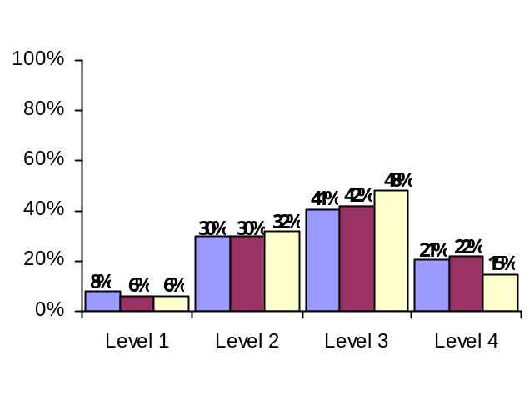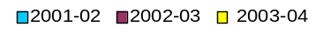

Statwide Performance | Counts of Students |  |  |  |  | Mean Score
Statwide Performance | Level 1  455–602 | Level 2  603–644 | Level 3  645–691 | Level 4  692–800 | Total Tested | Mean Score
Jan–Feb 2002 | 17,347 | 64,714 | 87,030 | 43,729 | 212,820 | 659
Feb 2003 | 12,394 | 62,455 | 89,069 | 45,987 | 209,905 | 660
Feb 2004 | 12,109 | 65,680 | 98,097 | 30,360 | 206,246 | 656

Elementary-Level English Language Arts Levels — Listening, Reading, and Writing Standards
Level 4 | These students exceed the standards and are moving toward high performance on the Regents examination.
Level 3 | These students meet the standards and, with continued steady growth, should pass the Regents examination.
Level 2 | These students need extra help to meet the standards and pass the Regents examination.
Level 1 | These students have serious academic deficiencies.
Performance of Limited English Proficient Students Taking the New York State English as a Second Language Achievement Test (NYSESLAT) as the Measure of English Language Arts Achievement
Grade 4 | Level 1 | Level 2 | Level 3 | Level 4 | Total Tested
2004 | 2,253 | 1,330 | 1,120 | 3,536 | 8,239
Performance of Students with Severe Disabilities on the New York State Alternate Assessment (NYSAA) in English
Elementary Level | AA–Level 1 | AA–Level 2 | AA–Level 3 | AA–Level 4 | Total Tested
2003–04 | 30 | 107 | 270 | 1,022 | 1,429

Elementary Level
Mathematics
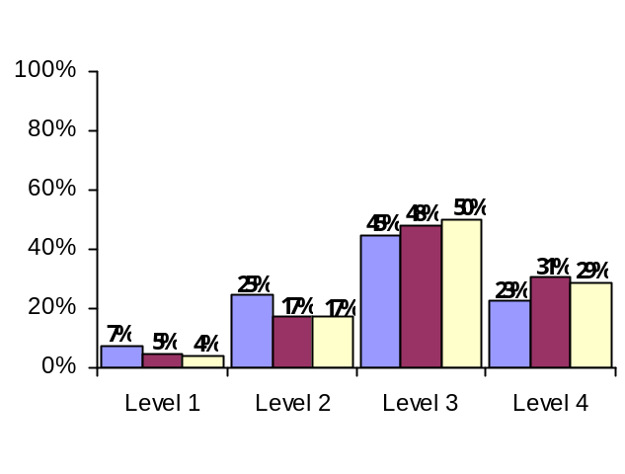
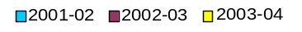
Grade 4 Mathematics Performance
(All Students: General Education and Students with Disabilities)

Statewide Performance | Counts of Students |  |  |  |  | Mean Score
Statewide Performance | Level 1  448–601 | Level 2  602–636 | Level 3  637–677 | Level 4  678–810 | Total Tested | Mean Score
May 2002 | 15,737 | 54,686 | 96,999 | 49,099 | 216,521 | 651
May 2003 | 10,342 | 36,918 | 103,645 | 67,274 | 218,179 | 661
May 2004 | 8,352 | 36,455 | 108,183 | 61,706 | 214,696 | 661

Elementary-Level Mathematics Levels —

Knowledge, Reasoning, and Problem-Solving Standards
Level 4 | These students exceed the standards and are moving toward high performance on the Regents examination.
Level 3 | These students meet the standards and, with continued steady growth, should pass the Regents examination.
Level 2 | These students need extra help to meet the standards and pass the Regents examination.
Level 1 | These students have serious academic deficiencies.
Performance of Students with Severe Disabilities on the New York State Alternate Assessment (NYSAA) in Mathematics
Elementary Level | AA–Level 1 | AA–Level 2 | AA–Level 3 | AA–Level 4 | Total Tested
2003–04 | 57 | 154 | 238 | 986 | 1,435

Elementary Level
Science*
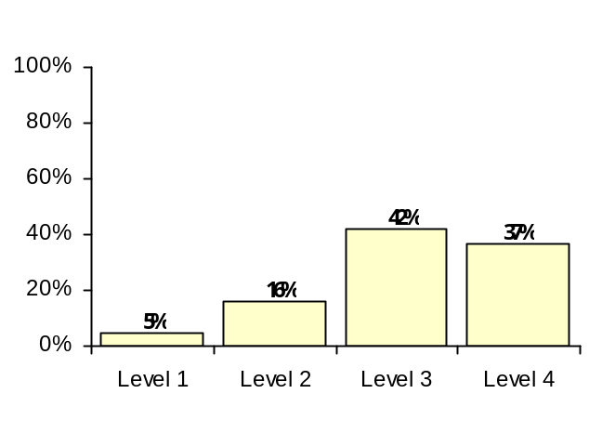
Grade 4 Science
(All Students: General Education and Students with Disabilities)


Statewide Performance | Counts of Students |  |  |  |  | Mean Score
Statewide Performance | Level 1  0–44 | Level 2  45–64 | Level 3  65–84 | Level 4  85–100 | Total Tested | Mean Score
May 2004 | 10,864 | 34,220 | 89,088 | 78,044 | 212,216 | 76

Elementary-Level Science Levels —

Knowledge, Reasoning, and Problem-Solving Standards
Level 4 | These students exceed the standards and are moving toward high performance on the Regents examination.
Level 3 | These students meet the standards and, with continued steady growth, should pass the Regents examination.
Level 2 | These students need extra help to meet the standards and pass the Regents examination.
Level 1 | These students have serious academic deficiencies.
Performance of Students with Severe Disabilities on the New York State Alternate Assessment (NYSAA) in Science
Elementary Level | AA–Level 1 | AA–Level 2 | AA–Level 3 | AA–Level 4 | Total Tested
2003–04 | 30 | 135 | 229 | 848 | 1,242

*Only one year of data is shown because a new assessment in elementary-level science was administered for the first time in 2003–04.
Middle Level
English Language Arts
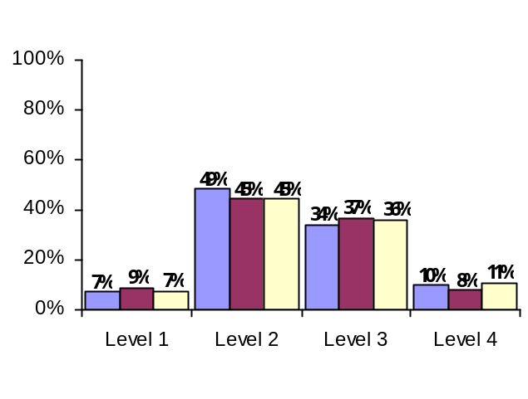
Grade 8 English Language Arts Performance
(All Students: General Education and Students with Disabilities)
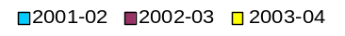

Statewide Performance | Counts of Students |  |  |  |  | Mean Score
Statewide Performance | Level 1  527–659 | Level 2  660–698 | Level 3  699-737 | Level 4  738-830 | Total Tested | Mean Score
March 2002 | 14,738 | 100,200 | 70,432 | 21,048 | 206,418 | 697
 | Level 1  527–657 | Level 2  658–696 | Level 3  697–736 | Level 4  737–830 | Total Tested
January 2003 | 20,130 | 96,533 | 79,747 | 16,296 | 212,706 | 694
January 2004 | 15,994 | 98,949 | 79,256 | 23,893 | 218,092 | 699

Middle-Level English Language Arts Levels — Listening, Reading, and Writing Standards
Level 4 | These students exceed the standards and are moving toward high performance on the Regents examination.
Level 3 | These students meet the standards and, with continued steady growth, should pass the Regents examination.
Level 2 | These students need extra help to meet the standards and pass the Regents examination.
Level 1 | These students have serious academic deficiencies.
Performance of Limited English Proficient Students Taking the New York State English as a Second Language Achievement Test (NYSESLAT) as the Measure of English Language Arts Achievement
Grade 8 | Level 1 | Level 2 | Level 3 | Level 4 | Total Tested
2004 | 1,615 | 940 | 1,033 | 3,359 | 6,947
Performance of Students with Severe Disabilities on the New York State Alternate Assessment (NYSAA) in English
Grade 8 | AA–Level 1 | AA–Level 2 | AA–Level 3 | AA–Level 4 | Total Tested
2003–04 | 21 | 122 | 251 | 1,061 | 1,455

Middle Level
Mathematics
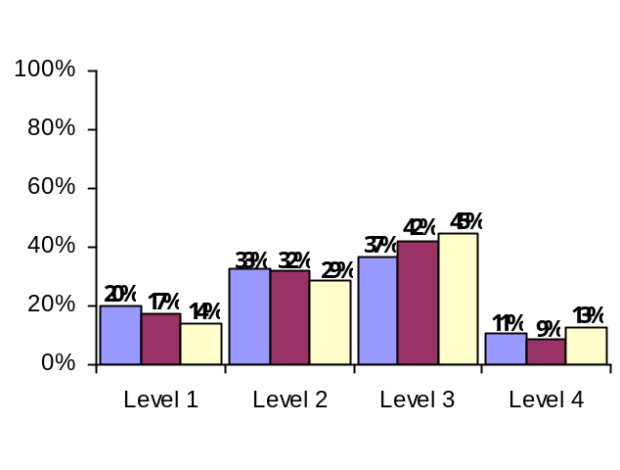
Grade 8 Mathematics Performance
(All Students: General Education and Students with Disabilities)
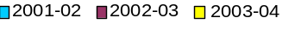

Statwide Performance | Counts of Students |  |  |  |  | Mean Score
Statwide Performance | Level 1  517–680 | Level 2  681–715 | Level 3  716–759 | Level 4  760–882 | Total Tested | Mean Score
May 2002 | 52,663 | 68,403 | 62,884 | 16,034 | 199,984 | 703
May 2003 | 36,209 | 70,196 | 91,864 | 20,733 | 219,002 | 713
May 2004 | 30,937 | 63,654 | 100,371 | 28,322 | 223,284 | 718

Middle-Level Mathematics Levels — Knowledge, Reasoning, and Problem-Solving Standards
Level 4 | These students exceed the standards and are moving toward high performance on the Regents examination.
Level 3 | These students meet the standards and, with continued steady growth, should pass the Regents examination.
Level 2 | These students need extra help to meet the standards and pass the Regents examination.
Level 1 | These students have serious academic deficiencies.

Performance of Students with Severe Disabilities on the New York State Alternate Assessment (NYSAA) in Mathematics
Middle Level | AA–Level 1 | AA–Level 2 | AA–Level 3 | AA–Level 4 | Total Tested
2003–04 | 46 | 144 | 232 | 987 | 1,409

Middle Level
Science

Middle-Level Science and Regents Science Performance
of Middle-Level Students
(All Students: General Education and Students with Disabilities)

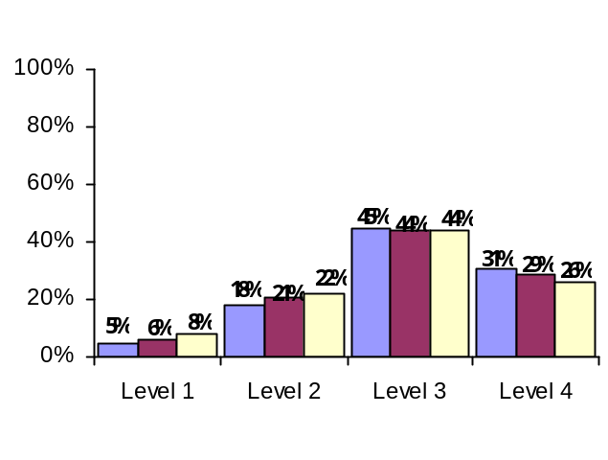
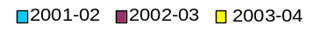

Statewide Performance |  | Counts of Students Tested |  |  |  |  | Mean Score
 |  | Level 1 | Level 2 | Level 3 | Level 4 | Total Tested | Mean Score
June 2002 | Middle-Level Science | 10,180 | 34,773 | 82,014 | 51,400 | 178,367 | 73
June 2002 | Regents Science | 299 | 399 | 5,195 | 8,734 | 14,627 | 84
January/  June 2003 | Middle-Level Science | 11,097 | 40,901 | 84,529 | 48,950 | 185,477 | 73
January/  June 2003 | Regents Science | 53 | 100 | 2,676 | 8,346 | 11,175 | 88
January/  June 2004 | Middle-Level Science | 16,276 | 46,357 | 86,921 | 45,307 | 194,861 | 71
January/  June 2004 | Regents Science | 353 | 398 | 5,885 | 10,498 | 17,134 | 85

Middle-Level Science Levels — Knowledge, Reasoning, and Problem-Solving Standards*
Level 4 | These students exceed the standards on the middle-level science test and are moving toward high performance on the Regents examinations or score 85–100 on a Regents science examination.
Level 3 | These students meet the standards on the middle-level science test and, with continued steady growth, should pass the Regents examinations or score 65–84 on a Regents science examination.
Level 2 | These students need extra help to meet the standards for middle-level science and to pass the Regents examinations or score 55–64 on a Regents science examination.
Level 1 | These students have serious academic deficiencies as evidenced in the middle-level science test or score 0–54 on a Regents science examination.

*Students may demonstrate proficiency in middle-level science by scoring at Level 3 or above on the middle-level science test or by scoring 65 or above on a Regents examination in science.

Performance of Students with Severe Disabilities on the New York State Alternate Assessment (NYSAA) in Science
Middle-Level | AA–Level 1 | AA–Level 2 | AA–Level 3 | AA–Level 4 | Total Tested
2003–04 | 42 | 118 | 212 | 935 | 1,307

High School English Achievement after Four Years of Instruction

The graphs and tables below present performance of the 1998, 1999, and 2000 cohort members, four years after entering grade 9, in meeting the graduation assessment requirement in English. In the graph, students passing approved alternatives to this examination are counted as scoring in the 65 to 84 range. RCT results are not included in the graph. The data in these tables and charts show the performance of the cohorts as of June 30th of the fourth year after first entering grade 9. Data for the 1999 and 2000 cohorts include all students in cohorts in the district’s schools, students continuously enrolled in the district who transferred between schools within the district, and students placed outside the district but who are the reporting responsibility of the district. Data for the 1998 cohort include all students in the cohort in the district’s schools.

Achievement on the Regents Examination in Comprehensive English after Four Years
(All Students: General Education and Students with Disabilities)
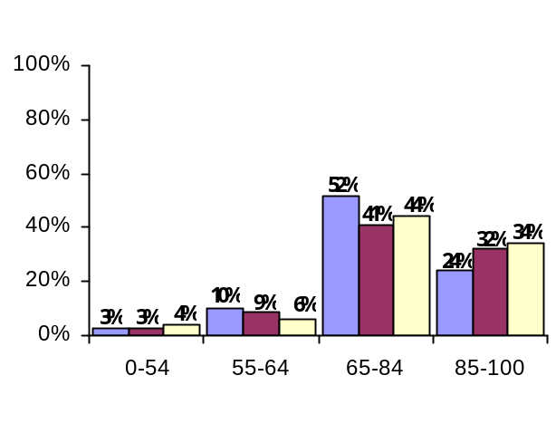

English Graduation Requirement Achievement after Four Years of High School*
 | Cohort Members  All Students | Highest Score Between 0 and 54 | Highest Score Between 55 and 64 | Highest Score Between 65 and 84 | Highest Score Between 85 and 100 | Approved Alternative Credit
1998 Cohort | 157,846 | 4,074 | 15,069 | 82,167 | 38,123 | 146
1999 Cohort | 171,399 | 5,668 | 16,143 | 70,470 | 55,584 | 157
2000 Cohort | 173,058 | 6,324 | 9,698 | 75,518 | 58,942 | 211
*Assessments used to determine counts in this table include the Regents examination in comprehensive English, the component retest in English, and approved alternatives.

Performance of Students Who Took the Regents Competency Tests in Reading and Writing to Meet the Graduation Requirement*
 | Passed the RCTs | Failed RCT in Reading  and/or Writing
1998 Cohort | 1,355 | 1,190
1999 Cohort | 2,570 | 1,776
2000 Cohort | 2,423 | 1,879
*Includes only students eligible for the safety net who did not score 55 or higher on the Regents examination or an approved alternative.
High School Mathematics Achievement after Four Years of Instruction

The graphs and tables below present performance of the 1998, 1999, and 2000 cohort members, four years after entering grade 9, in meeting the graduation assessment requirement in mathematics. In the graph, students passing approved alternatives to these examinations are counted as scoring in the 65 to 84 range. RCT results are not included in the graph. The data in these tables and charts show the performance of the cohorts as of June 30th of the fourth year after first entering grade 9. Data for the 1999 and 2000 cohorts include all students in cohorts in the district’s schools, students continuously enrolled in the district who transferred between schools within the district, and students placed outside the district but who are the reporting responsibility of the district. Data for the 1998 cohort include all students in the cohort in the district’s schools.

Achievement on a Regents Examination in Mathematics after Four Years
(All Students: General Education and Students with Disabilities)

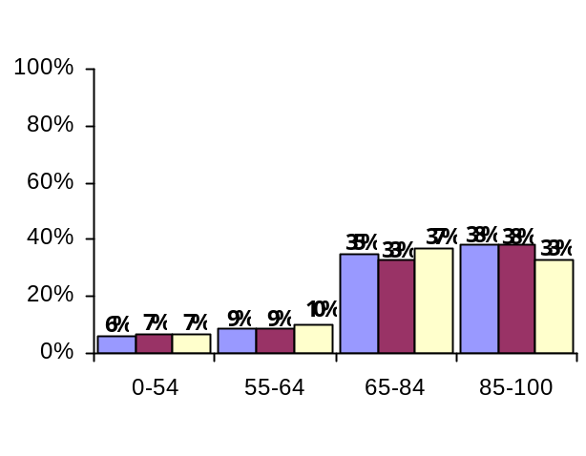

Mathematics Graduation Requirement Achievement after Four Years of High School*
 | Cohort Members  All Students | Highest Score  Between 0 and 54 | Highest Score  Between 55 and 64 | Highest Score Between 65 and 84 | Highest Score  Between 85 and 100 | Approved  Alternative Credit
1998 Cohort | 157,846 | 10,077 | 15,069 | 82,167 | 38,123 | 146
1999 Cohort | 171,399 | 11,787 | 16,187 | 55,808 | 65,108 | 32
2000 Cohort | 173,058 | 11,389 | 17,351 | 64,599 | 56,339 | 30
*Assessments used to determine counts in this table include a Regents examination in mathematics, the component retest in mathematics and approved alternatives.

Performance of Students Who Took the Regents Competency Test in Mathematics to Meet the Graduation Requirement*
 | Passed the RCT | Failed at Least  One RCT
1998 Cohort | 1,355 | 685
1999 Cohort | 4,961 | 714
2000 Cohort | 5,484 | 660
*Includes only students eligible for the safety net who did not score 55 or higher on the Regents examination or an approved alternative.
Cohort Graduation Rates

Students were counted as graduates if they earned a local diploma with or without a Regents endorsement by August 31st of the fourth year after first entering grade 9. The graduation-rate cohort includes students who transferred to general education development (GED) programs. These students were not counted in the 1998 and 1999 school accountability cohort for English and mathematics.

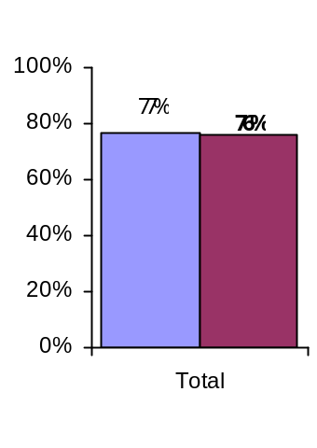
Cohort Graduation Rates

1998 Cohort
1999 Cohort

Cohort Graduation Rates
 | Cohort  Members*  (a) | Transfers to GED  (b) | Graduation Rate Cohort  Members  (a+b) | Number Graduated
1998 Cohort | 159,254 | 5,972 | 165,226 | 127,096
1999 Cohort | 163,316 | 10,662 | 173,978 | 132,245
*Count as of August 31st of the fourth year after first entering grade 9.

Analysis of Student Subgroup Performance

Historically, on State assessments the average performance of Black, Hispanic, and Native American students has been lower than that of White and Asian students. Similarly, students from low-income families have not performed as well as those from higher income families. A high priority of the Board of Regents is to eliminate these gaps in student performance. In addition, Title I of the federal Elementary and Secondary Education Act includes explicit requirements “to ensure that students served by Title I are given the same opportunity to achieve to high standards and are held to the same high expectations as all students in each State.”

This section of the report card provides performance data for two years by racial/ethnic group, disability status, gender, English proficiency status, income level, and migrant status. The purpose of the student subgroup analyses is to determine if students who perform below the standards statewide tend to fall into particular groups, such as minority students, limited English proficient students, or economically disadvantaged students.
Elementary Level
English Language Arts
Student Subgroup | 2002–03 |  |  |  | 2003–04
Student Subgroup | Total  Tested | Percentages of Tested Students Scoring at Levels |  |  | Total  Tested | Percentages of Tested Students Scoring at Levels
Student Subgroup | Total  Tested | 2–4 | 3–4 | 4 | Total  Tested | 2–4 | 3–4 | 4

Results by Race/Ethnicity
American Indian/Alaskan Native | 1,071 | 91 | 55 | 14 | 1,070 | 90 | 46 | 6
Black | 43,727 | 90 | 48 | 12 | 42,424 | 89 | 44 | 7
Hispanic | 37,938 | 90 | 48 | 11 | 37,441 | 91 | 46 | 6
Asian or Pacific Islander | 12,053 | 98 | 78 | 33 | 12,326 | 98 | 78 | 26
White | 115,027 | 97 | 75 | 28 | 112,985 | 97 | 73 | 20
Total | 209,905 | 94 | 64 | 22 | 206,246 | 94 | 62 | 15
Small Group Totals (s) | 0 | 0 | 0 | 0 | 0 | 0 | 0 | 0

Results by Disability Status
General-education students | 183,322 | 97 | 70 | 25 | 179,362 | 98 | 68 | 17
Students with disabilities | 26,583 | 71 | 23 | 3 | 26,884 | 72 | 22 | 2
Total | 209,905 | 94 | 64 | 22 | 206,246 | 94 | 62 | 15

Results by Gender
Female | 102,038 | 96 | 68 | 26 | 100,927 | 96 | 66 | 18
Male | 107,867 | 93 | 61 | 18 | 105,319 | 93 | 59 | 12
Total | 209,905 | 94 | 64 | 22 | 206,246 | 94 | 62 | 15

Results by English Proficiency Status
English proficient | 206,064 | 95 | 65 | 22 | 201,924 | 95 | 63 | 15
Limited English proficient | 3,841 | 62 | 12 | 2 | 4,322 | 71 | 21 | 2
Total | 209,905 | 94 | 64 | 22 | 206,246 | 94 | 62 | 15

Results by Income Level
Economically disadvantaged | 71,832 | 91 | 52 | 12 | 84,659 | 90 | 46 | 7
Not disadvantaged | 106,653 | 98 | 79 | 31 | 121,587 | 97 | 74 | 21
Total | 209,905 | 94 | 64 | 22 | 206,246 | 94 | 62 | 15

Results by Migrant Status
Migrant family | 107 | 80 | 42 | 5 | 117 | 87 | 33 | 3
Not migrant family | 134,004 | 96 | 71 | 26 | 206,129 | 94 | 62 | 15
Total | 209,905 | 94 | 64 | 22 | 206,246 | 94 | 62 | 15

Elementary Level
Mathematics
Student Subgroup | 2002–03 |  |  |  | 2003–04
Student Subgroup | Total  Tested | Percentages of Tested Students Scoring at Levels |  |  | Total  Tested | Percentages of Tested Students Scoring at Levels
Student Subgroup | Total  Tested | 2–4 | 3–4 | 4 | Total  Tested | 2–4 | 3–4 | 4

Results by Race/Ethnicity
American Indian/Alaskan Native | 1,095 | 93 | 70 | 19 | 1,087 | 93 | 72 | 18
Black | 44,211 | 91 | 62 | 16 | 42,758 | 93 | 63 | 13
Hispanic | 43,330 | 91 | 66 | 17 | 43,250 | 93 | 66 | 15
Asian or Pacific Islander | 13,434 | 97 | 88 | 50 | 13,774 | 98 | 90 | 48
White | 116,000 | 98 | 88 | 40 | 113,827 | 99 | 89 | 38
Total | 218,179 | 95 | 78 | 31 | 214,696 | 96 | 79 | 29
Small Group Totals (s) | 0 | 0 | 0 | 0 | 0 | 0 | 0 | 0

Results by Disability Status
General-education students | 190,963 | 97 | 83 | 34 | 186,908 | 98 | 84 | 32
Students with disabilities | 27,216 | 80 | 48 | 9 | 27,788 | 83 | 49 | 8
Total | 218,179 | 95 | 78 | 31 | 214,696 | 96 | 79 | 29

Results by Gender
Female | 105,963 | 96 | 79 | 30 | 104,875 | 97 | 80 | 28
Male | 112,216 | 95 | 78 | 31 | 109,821 | 95 | 79 | 30
Total | 218,179 | 95 | 78 | 31 | 214,696 | 96 | 79 | 29

Results by English Proficiency Status
English proficient | 206,973 | 96 | 80 | 32 | 202,248 | 97 | 81 | 30
Limited English proficient | 11,206 | 80 | 44 | 9 | 12,448 | 84 | 48 | 8
Total | 218,179 | 95 | 78 | 31 | 214,696 | 96 | 79 | 29

Results by Income Level
Economically disadvantaged | 77,173 | 93 | 69 | 19 | 90,151 | 94 | 68 | 16
Not disadvantaged | 108,139 | 99 | 90 | 43 | 124,545 | 98 | 88 | 38
Total | 218,179 | 95 | 78 | 31 | 214,696 | 96 | 79 | 29

Results by Migrant Status
Migrant family | 170 | 88 | 55 | 13 | 170 | 92 | 62 | 7
Not migrant family | 137,169 | 98 | 85 | 36 | 214,526 | 96 | 79 | 29
Total | 218,179 | 95 | 78 | 31 | 214,696 | 96 | 79 | 29

Elementary Level
Science*
Student Subgroup | 2003–04
Student Subgroup | Total Tested | Percentages of Tested Students Scoring at Levels
Student Subgroup | Total Tested | 2–4 | 3–4 | 4

Results by Race/Ethnicity
American Indian/Alaskan Native | 1,057 | 92 | 70 | 25
Black | 41,894 | 90 | 62 | 17
Hispanic | 42,520 | 89 | 59 | 16
Asian or Pacific Islander | 13,646 | 97 | 84 | 42
White | 113,099 | 99 | 92 | 51
Total | 212,216 | 95 | 79 | 37
Small Group Totals (s) | 0 | 0 | 0 | 0

Results by Disability Status
General-education students | 185,176 | 96 | 82 | 40
Students with disabilities | 27,040 | 85 | 57 | 16
Total | 212,216 | 95 | 79 | 37

Results by Gender
Female | 103,838 | 95 | 78 | 35
Male | 108,378 | 95 | 80 | 39
Total | 212,216 | 95 | 79 | 37

Results by English Proficiency Status
English proficient | 199,967 | 96 | 81 | 39
Limited English proficient | 12,249 | 74 | 38 | 8
Total | 212,216 | 95 | 79 | 37

Results by Income Level
Economically disadvantaged | 88,641 | 91 | 65 | 19
Not disadvantaged | 123,569 | 98 | 89 | 49
Total | 212,216 | 95 | 79 | 37

Results by Migrant Status
Migrant family | 164 | 93 | 65 | 15
Not migrant family | 212,052 | 95 | 79 | 37
Total | 212,216 | 95 | 79 | 37
*Only one year of data is shown because a new assessment in elementary-level science was administered for the first time in 2003–04.

Middle Level
English Language Arts
Student Subgroup | 2002–03 |  |  |  | 2003–04
Student Subgroup | Total  Tested | Percentages of Tested Students Scoring at Levels |  |  | Total  Tested | Percentages of Tested Students Scoring at Levels
Student Subgroup | Total  Tested | 2–4 | 3–4 | 4 | Total  Tested | 2–4 | 3–4 | 4

Results by Race/Ethnicity
American Indian/Alaskan Native | 840 | 86 | 30 | 3 | 929 | 88 | 32 | 4
Black | 42,478 | 82 | 26 | 2 | 43,170 | 86 | 27 | 4
Hispanic | 34,981 | 83 | 26 | 2 | 37,093 | 88 | 30 | 4
Asian or Pacific Islander | 11,457 | 95 | 59 | 15 | 11,837 | 97 | 64 | 21
White | 122,877 | 95 | 56 | 10 | 125,063 | 96 | 58 | 15
Total | 212,706 | 91 | 45 | 8 | 218,092 | 93 | 47 | 11
Small Group Totals (s) | 0 | 0 | 0 | 0 | 0 | 0 | 0 | 0

Results by Disability Status
General-education students | 182,534 | 95 | 51 | 9 | 187,068 | 97 | 54 | 13
Students with disabilities | 30,172 | 62 | 8 | 0 | 31,024 | 67 | 8 | 1
Total | 212,706 | 91 | 45 | 8 | 218,092 | 93 | 47 | 11

Results by Gender
Female | 103,834 | 93 | 50 | 10 | 106,376 | 95 | 53 | 14
Male | 108,872 | 88 | 40 | 6 | 111,716 | 91 | 42 | 8
Total | 212,706 | 91 | 45 | 8 | 218,092 | 93 | 47 | 11

Results by English Proficiency Status
English proficient | 207,954 | 92 | 46 | 8 | 212,161 | 94 | 49 | 11
Limited English proficient | 4,752 | 45 | 2 | 0 | 5,931 | 59 | 5 | 1
Total | 212,706 | 91 | 45 | 8 | 218,092 | 93 | 47 | 11

Results by Income Level
Economically disadvantaged | 63,596 | 85 | 29 | 3 | 78,675 | 87 | 29 | 4
Not disadvantaged | 117,175 | 96 | 59 | 12 | 139,416 | 96 | 58 | 15
Total | 212,706 | 91 | 45 | 8 | 218,092 | 93 | 47 | 11

Results by Migrant Status
Migrant family | 68 | 66 | 19 | 3 | 118 | 81 | 23 | 2
Not migrant family | 140,369 | 93 | 52 | 9 | 217,973 | 93 | 47 | 11
Total | 212,706 | 91 | 45 | 8 | 218,092 | 93 | 47 | 11

Middle Level
Mathematics
Student Subgroup | 2002–03 |  |  |  | 2003–04
Student Subgroup | Total  Tested | Percentages of Tested Students Scoring at Levels |  |  | Total  Tested | Percentages of Tested Students Scoring at Levels
Student Subgroup | Total  Tested | 2–4 | 3–4 | 4 | Total  Tested | 2–4 | 3–4 | 4

Results by Race/Ethnicity
American Indian/Alaskan Native | 841 | 81 | 39 | 4 | 914 | 82 | 47 | 5
Black | 42,532 | 68 | 26 | 2 | 42,967 | 73 | 33 | 3
Hispanic | 38,772 | 69 | 28 | 2 | 40,769 | 75 | 37 | 4
Asian or Pacific Islander | 13,320 | 91 | 69 | 24 | 13,622 | 94 | 77 | 31
White | 123,393 | 93 | 65 | 13 | 125,012 | 94 | 71 | 17
Total | 219,002 | 83 | 51 | 9 | 223,284 | 86 | 58 | 13
Small Group Totals (s) | 0 | 0 | 0 | 0 | 0 | 0 | 0 | 0

Results by Disability Status
General-education students | 189,081 | 89 | 57 | 11 | 192,718 | 91 | 64 | 15
Students with disabilities | 29,921 | 51 | 16 | 1 | 30,566 | 55 | 19 | 1
Total | 219,002 | 83 | 51 | 9 | 223,284 | 86 | 58 | 13

Results by Gender
Female | 106,813 | 86 | 53 | 9 | 108,878 | 88 | 59 | 13
Male | 112,188 | 81 | 50 | 10 | 114,406 | 85 | 56 | 12
Total | 219,002 | 83 | 51 | 9 | 223,284 | 86 | 58 | 13

Results by English Proficiency Status
English proficient | 207,733 | 85 | 53 | 10 | 210,643 | 88 | 60 | 13
Limited English proficient | 11,269 | 50 | 17 | 2 | 12,641 | 59 | 24 | 4
Total | 219,002 | 83 | 51 | 9 | 223,284 | 86 | 58 | 13

Results by Income Level
Economically disadvantaged | 67,999 | 74 | 34 | 4 | 81,837 | 77 | 39 | 6
Not disadvantaged | 118,234 | 93 | 68 | 14 | 141,446 | 92 | 68 | 17
Total | 219,002 | 83 | 51 | 9 | 223,284 | 86 | 58 | 13

Results by Migrant Status
Migrant family | 95 | 47 | 24 | 3 | 155 | 67 | 30 | 3
Not migrant family | 141,829 | 90 | 61 | 11 | 223,128 | 86 | 58 | 13
Total | 219,002 | 83 | 51 | 9 | 223,284 | 86 | 58 | 13

Middle Level
Science
Student Subgroup | 2002–03 |  |  |  |  |  |  |  |  |  |  |  | 2003–04
Student Subgroup | Total  Tested |  |  | Percentages of Tested Students Scoring at Levels |  |  |  |  |  |  |  |  | Total  Tested |  |  | Percentages of Tested Students Scoring at Levels
Student Subgroup |  |  |  | 2–4 |  |  |  | 3–4 |  |  |  | 4 |  |  |  | 2–4 |  |  | 3–4 |  |  | 4

Results by Race/Ethnicity
American Indian/Alaskan Native |  | 746 |  |  | 94 |  | 70 |  |  | 17 |  |  |  | 816 |  |  | 91 |  |  | 64 |  |  | 16
Black |  | 36,218 |  |  | 86 |  | 46 |  |  | 7 |  |  |  | 37,666 |  |  | 82 |  |  | 40 |  |  | 5
Hispanic |  | 32,333 |  |  | 87 |  | 45 |  |  | 7 |  |  |  | 36,131 |  |  | 82 |  |  | 41 |  |  | 6
Asian or Pacific Islander |  | 10,513 |  |  | 96 |  | 77 |  |  | 30 |  |  |  | 11,414 |  |  | 93 |  |  | 72 |  |  | 26
White |  | 105,565 |  |  | 99 |  | 89 |  |  | 39 |  |  |  | 108,834 |  |  | 98 |  |  | 86 |  |  | 35
Total |  | 185,477 |  |  | 94 |  | 72 |  |  | 26 |  |  |  | 194,861 |  |  | 92 |  |  | 68 |  |  | 23
Small Group Totals (s) |  | 0 |  |  | 0 |  | 0 |  |  | 0 |  |  |  | 0 |  |  | 0 |  |  | 0 |  |  | 0

Results by Disability Status
General-education students |  | 159,744 |  |  | 96 |  | 76 |  |  | 29 |  |  |  | 167,747 |  |  | 94 |  |  | 72 |  |  | 26
Students with disabilities |  | 25,733 |  |  | 82 |  | 45 |  |  | 7 |  |  |  | 27,114 |  |  | 77 |  |  | 41 |  |  | 6
Total |  | 185,477 |  |  | 94 |  | 72 |  |  | 26 |  |  |  | 194,861 |  |  | 92 |  |  | 68 |  |  | 23

Results by Gender
Female |  | 90,576 |  |  | 95 |  | 72 |  |  | 24 |  |  |  | 95,012 |  |  | 93 |  |  | 67 |  |  | 21
Male |  | 94,901 |  |  | 93 |  | 72 |  |  | 29 |  |  |  | 99,849 |  |  | 91 |  |  | 69 |  |  | 25
Total |  | 185,477 |  |  | 94 |  | 72 |  |  | 26 |  |  |  | 194,861 |  |  | 92 |  |  | 68 |  |  | 23

Results by English Proficiency Status
English proficient |  |  | 177,068 |  |  | 95 |  |  | 74 |  | 28 |  |  |  | 183,616 |  |  | 93 |  |  | 71 |  |  | 25
Limited English proficient |  |  | 8,409 |  |  | 71 |  |  | 22 |  | 2 |  |  |  | 11,245 |  |  | 63 |  |  | 19 |  |  | 2
Total |  |  | 185,477 |  |  | 94 |  |  | 72 |  | 26 |  |  |  | 194,861 |  |  | 92 |  |  | 68 |  |  | 23

Results by Income Level
Economically disadvantaged |  |  | 59,075 |  |  | 91 |  |  | 57 |  | 12 |  |  |  | 73,469 |  |  | 85 |  |  | 48 |  |  | 9
Not disadvantaged |  |  | 99,702 |  |  | 99 |  |  | 89 |  | 40 |  |  |  | 121,391 |  |  | 96 |  |  | 80 |  |  | 32
Total |  |  | 185,477 |  |  | 94 |  |  | 72 |  | 26 |  |  |  | 194,861 |  |  | 92 |  |  | 68 |  |  | 23

Results by Migrant Status
Migrant family |  |  | 89 |  |  | 89 |  |  | 39 |  | 6 |  |  |  | 137 |  |  | 84 |  |  | 47 |  |  | 5
Not migrant family |  |  | 121,422 |  |  | 98 |  |  | 85 |  | 35 |  |  |  | 194,723 |  |  | 92 |  |  | 68 |  |  | 23
Total |  |  | 185,477 |  |  | 94 |  |  | 72 |  | 26 |  |  |  | 194,861 |  |  | 92 |  |  | 68 |  |  | 23

1999 and 2000 High School Cohorts
General-education students who first entered ninth grade in 1999 or 2000 must score 55 or higher on Regents English and mathematics examinations to graduate. During the phase-in of the Regents examination graduation requirements, all students (with district board of education approval) may qualify for a local diploma by earning a score of 55–64 on the required Regents examinations; a score of 65 or higher is required for a Regents diploma. Students with disabilities and certain students with a Section 504 Accomodation Plan may qualify for a local diploma by passing Regents competency tests. The data in these tables show the performance of the cohorts as of June 30th of the fourth year after first entering grade 9.
Performance on the English Assessment Requirement for Graduation
after Four Years of High School
Student Subgroup | 1999 Cohort |  |  |  |  | 2000 Cohort
Student Subgroup | Students in Cohort | Count of Students by Score |  |  | Percent Meeting Gradu-ation Require-ment | Students in Cohort | Count of Students by Score |  |  |  | Percent Meeting Gradua-tion Require-ment
Student Subgroup | Students in Cohort | Regents |  | Pass-ed RCTs | Percent Meeting Gradu-ation Require-ment | Students in Cohort | Regents |  | Pass-ed RCTs |  | Percent Meeting Gradua-tion Require-ment
Student Subgroup | Students in Cohort | 55–64 | 65–100 | Pass-ed RCTs | Percent Meeting Gradu-ation Require-ment | Students in Cohort | 55–64 | 65–100 |  |  | Percent Meeting Gradua-tion Require-ment

Results by Race/Ethnicity
American Indian/Alaskan Native | 570 | 73 | 364 | 16 | 79 | 571 | 53 | 372 | 15 | 77
Black | 28,591 | 4,985 | 15,210 | 494 | 72 | 28,097 | 2,732 | 17,613 | 434 | 74
Hispanic | 23,682 | 3,656 | 12,422 | 370 | 69 | 23,662 | 2,139 | 14,516 | 302 | 72
Asian or Pacific Islander | 11,656 | 1,029 | 8,937 | 55 | 86 | 12,108 | 631 | 9,633 | 35 | 85
White | 106,900 | 6,400 | 89,278 | 1,635 | 91 | 108,621 | 4,143 | 92,537 | 1,637 | 91
Total | 171,399 | 16,143 | 126,211 | 2,570 | 85 | 173,059 | 9,698 | 134,671 | 2,423 | 85
Small Group Totals (s) | 0 | 0 | 0 | 0 | 0 | 0 | 0 | 0 | 0 | 0

Results by Disability Status
General-education students | 154,521 | 13,938 | 120,441 | 249 | 87 | 154,993 | 7,883 | 128,049 | 262 | 88
Students with disabilities | 16,878 | 2,205 | 5,770 | 2,321 | 61 | 18,066 | 1,815 | 6,622 | 2,161 | 59
Total | 171,399 | 16,143 | 126,211 | 2,570 | 85 | 173,059 | 9,698 | 134,671 | 2,423 | 85

Results by Gender
Female | 85,955 | 7,842 | 66,188 | 943 | 87 | 86,820 | 4,514 | 70,799 | 907 | 88
Male | 85,444 | 8,301 | 60,023 | 1,627 | 82 | 86,239 | 5,184 | 63,872 | 1,516 | 82
Total | 171,399 | 16,143 | 126,211 | 2,570 | 85 | 173,059 | 9,698 | 134,671 | 2,423 | 85

Results by English Proficiency Status
English proficient | 165,358 | 14,861 | 124,201 | 2,532 | 86 | 164,337 | 8,498 | 131,270 | 2,346 | 86
Limited English proficient | 6,041 | 1,282 | 2,010 | 38 | 55 | 8,722 | 1,200 | 3,401 | 77 | 54
Total | 171,399 | 16,143 | 126,211 | 2,570 | 85 | 173,059 | 9,698 | 134,671 | 2,423 | 85

Results by Income Level
Economically disadvantaged | 39,505 | 6,552 | 22,617 | 699 | 76 | 38,732 | 3,552 | 24,587 | 731 | 75
Not disadvantaged | 131,894 | 9,591 | 103,594 | 1,871 | 87 | 134,327 | 6,146 | 110,084 | 1,692 | 88
Total | 171,399 | 16,143 | 126,211 | 2,570 | 85 | 173,059 | 9,698 | 134,671 | 2,423 | 85

Results by Migrant Status
Migrant family | 33 | 3 | 17 | 1 | 64 | 54 | 4 | 21 | 1 | 48
Not migrant family | 171,366 | 16,140 | 126,194 | 2,569 | 85 | 173,005 | 9,694 | 134,650 | 2,422 | 85
Total | 171,399 | 16,143 | 126,211 | 2,570 | 85 | 173,059 | 9,698 | 134,671 | 2,423 | 85

Performance on the Mathematics Assessment Requirement for Graduation
after Four Years of High School
Student Subgroup | 1999 Cohort |  |  |  |  | 2000 Cohort
Student Subgroup | Students in Cohort | Count of Students by Score |  |  | Percent Meeting Gradu-ation Require-ment | Students in Cohort | Count of Students by Score |  |  |  | Percent Meeting Gradua-tion Require-ment
Student Subgroup | Students in Cohort | Regents |  | Pass-ed RCTs | Percent Meeting Gradu-ation Require-ment | Students in Cohort | Regents |  | Pass-ed RCTs |  | Percent Meeting Gradua-tion Require-ment
Student Subgroup | Students in Cohort | 55–64 | 65–100 | Pass-ed RCTs | Percent Meeting Gradu-ation Require-ment | Students in Cohort | 55–64 | 65–100 |  |  | Percent Meeting Gradua-tion Require-ment

Results by Race/Ethnicity
American Indian/Alaskan Native | 570 | 66 | 369 | 23 | 80 | 571 | 63 | 350 | 19 | 76
Black | 28,591 | 4,764 | 12,818 | 1,069 | 65 | 28,097 | 5,000 | 12,958 | 1,055 | 68
Hispanic | 23,682 | 3,816 | 10,714 | 742 | 64 | 23,662 | 3,975 | 11,406 | 682 | 68
Asian or Pacific Islander | 11,656 | 801 | 9,423 | 107 | 89 | 12,108 | 807 | 9,728 | 86 | 88
White | 106,900 | 6,740 | 87,624 | 3,020 | 91 | 108,621 | 7,506 | 86,527 | 3,642 | 90
Total | 171,399 | 16,187 | 120,948 | 4,961 | 83 | 173,059 | 17,351 | 120,969 | 5,484 | 83
Small Group Totals (s) | 0 | 0 | 0 | 0 | 0 | 0 | 0 | 0 | 0 | 0

Results by Disability Status
General-education students | 154,521 | 14,712 | 115,777 | 565 | 85 | 154,993 | 15,695 | 115,680 | 688 | 85
Students with disabilities | 16,878 | 1,475 | 5,171 | 4,396 | 65 | 18,066 | 1,656 | 5,289 | 4,796 | 65
Total | 171,399 | 16,187 | 120,948 | 4,961 | 83 | 173,059 | 17,351 | 120,969 | 5,484 | 83

Results by Gender
Female | 85,955 | 8,495 | 62,304 | 1,913 | 85 | 86,820 | 9,197 | 62,261 | 2,085 | 85
Male | 85,444 | 7,692 | 58,644 | 3,048 | 81 | 86,239 | 8,154 | 58,708 | 3,399 | 81
Total | 171,399 | 16,187 | 120,948 | 4,961 | 83 | 173,059 | 17,351 | 120,969 | 5,484 | 83

Results by English Proficiency Status
English proficient | 165,358 | 15,232 | 118,289 | 4,890 | 84 | 164,337 | 16,080 | 117,017 | 5,362 | 84
Limited English proficient | 6,041 | 955 | 2,659 | 71 | 61 | 8,722 | 1,271 | 3,952 | 122 | 61
Total | 171,399 | 16,187 | 120,948 | 4,961 | 83 | 173,059 | 17,351 | 120,969 | 5,484 | 83

Results by Income Level
Economically disadvantaged | 39,505 | 6,379 | 20,431 | 1,454 | 72 | 38,732 | 6,000 | 20,385 | 1,552 | 72
Not disadvantaged | 131,894 | 9,808 | 100,517 | 3,507 | 86 | 134,327 | 11,351 | 100,584 | 3,932 | 86
Total | 171,399 | 16,187 | 120,948 | 4,961 | 83 | 173,059 | 17,351 | 120,969 | 5,484 | 83

Results by Migrant Status
Migrant family | 33 | 5 | 18 | 1 | 73 | 54 | 12 | 18 | 3 | 61
Not migrant family | 171,366 | 16,182 | 120,930 | 4,960 | 83 | 173,005 | 17,339 | 120,951 | 5,481 | 83
Total | 171,399 | 16,187 | 120,948 | 4,961 | 83 | 173,059 | 17,351 | 120,969 | 5,484 | 83

Cohort Graduation Rates

Students were counted as graduates if they earned a local diploma with or without a Regents endorsement by August 31st of the fourth year after first entering grade 9. The graduation-rate cohort includes students who transferred to general education development (GED) programs. These students were not counted in the district accountability cohort for English and mathematics.

 | 1998 Cohort as of  August 31, 2002 |  |  | 1999 Cohort as of  August 31, 2003
Student Subgroup | Graduation Rate Cohort | Graduation Rate |  | Graduation Rate Cohort |  | Graduation Rate
Results by Race/Ethnicity
American Indian/Alaskan Native | 570 |  | 68 |  | 574 |  | 69
Black | 27,924 |  | 57 |  | 28,725 |  | 58
Hispanic | 22,674 |  | 53 |  | 24,327 |  | 53
Asian or Pacific Islander | 11,106 |  | 78 |  | 11,750 |  | 79
White | 102,952 |  | 88 |  | 108,602 |  | 86
Total | 165,226 |  | 77 |  | 173,978 |  | 76
Small Group Totals (s) | 0 |  | 0 |  | 0 |  | 0

Results by Disability Status
General-education students | 150,920 |  | 79 |  | 158,922 |  | 78
Students with disabilities | 14,306 |  | 55 |  | 15,056 |  | 58
Total | 165,226 |  | 77 |  | 173,978 |  | 76

Results by Gender
Female | 83,331 |  | 80 |  | 86,921 |  | 80
Male | 81,895 |  | 73 |  | 87,057 |  | 72
Total | 165,226 |  | 77 |  | 173,978 |  | 76

Results by English Proficiency Status
English proficient | 160,983 |  | 78 |  | 167,089 |  | 77
Limited English proficient | 4,243 |  | 49 |  | 6,889 |  | 43
Total | 165,226 |  | 77 |  | 173,978 |  | 76

Results by Income Level
Economically disadvantaged | 17,180 |  | 54 |  | 38,374 |  | 62
Not disadvantaged | 148,046 |  | 80 |  | 135,604 |  | 80
Total | 165,226 |  | 77 |  | 173,978 |  | 76

Results by Migrant Status
Migrant family | 16 |  | 81 |  | 39 |  | 67
Not migrant family | 165,210 |  | 77 |  | 173,939 |  | 76
Total | 165,226 |  | 77 |  | 173,978 |  | 76

Glossary

Accountability Cohort: An accountability cohort is all students, regardless of grade status, who were enrolled in school on BEDS day two years after the year in which they first entered grade 9, or, in the case of ungraded students with disabilities, the year in which they reached their seventeenth birthday. (For example, the 1999 accountability cohort consists of all students who first entered grade 9 in the fall of 1999 who were enrolled on October 3, 2001). Certain students are not included in the school accountability cohort. Cohort is defined in Section 100.2 (p) (8) of the Commissioner’s Regulations.

Component Retests: Component retests were offered in Regents English and Mathematics A to certain students who were at risk of not meeting the State learning standards. Component retesting is the process by which a student who has failed a Regents examination in English or Mathematics A twice is retested only on the areas of the learning standards in which the student has been proven deficient. Component retesting eliminates the need for the student to retake the full Regents examination multiple times. Students who earn credit through component retesting are counted as if they scored in the 55–64 range or in the 65–84 range on the Regents examination, as determined by the component retest results.

Counts of Students Tested: “Counts of Students Tested” includes only students who completed sufficient test questions to receive a score.

Graduation-Rate Cohort: Graduation-rate cohort for each year includes all students in the accountability cohort in the previous year plus all students excluded from that accountability cohort solely because they transferred to a general education development (GED) program.

Limited English Proficient (LEP) Students: Schools provide special English instruction to students for whom English is a second language so they can participate effectively in the academic program. In 2002–03 and in previous years, students were considered LEP if, by reason of foreign birth or ancestry, they spoke a language other than English and (1) either understood and spoke little or no English or (2) scored at or below the 40th percentile on an English language assessment instrument. Beginning in 2003–04, students are considered LEP if, by reason of foreign birth or ancestry, they speak a language other than English and (1) either understand and speak little or no English or (2) score below a state-designated level of proficiency on the Language Assessment Battery-Revised (LAB-R) or the New York State English as a Second Language Achievement Test (NYSESLAT). The United States Department of Education has approved the use of the NYSESLAT as the required measure of language arts proficiency for LEP students in grades 4 and 8 who have attended school in the United States (not including Puerto Rico) for fewer than three consecutive years and for LEP students who have attended for four or five years and have received an exemption from the general assessment requirement.

New York State Alternate Assessment (NYSAA): The district Committee on Special Education designates students with severe disabilities who meet criteria established in Commissioner’s Regulations to take the New York State Alternate Assessment (NYSAA).

Student Confidentiality/Suppressed Data (# and s): To ensure student confidentiality, the Department does not publish data for groups with fewer than five students or data that would allow readers to easily determine the performance of a group with fewer than five students. In the Overview, the pound character (#) appears when fewer than five students in a group were tested. In the Analysis, when fewer than five students in a group (e.g., Hispanic) were tested, percentages of tested students scoring at various levels are suppressed for that group and the next smallest group. Suppressed data are indicated with an (s). However, the performance of tested students in these groups is aggregated and shown in the Small Group Total row.

Validity and Reliability of Small Group Data: It is important that programmatic decisions are based on valid and reliable data. Data for fewer than 30 students in a group may be neither valid nor reliable. If a school does not have 30 students in a grade or a subgroup in a given year, the school should evaluate results for students in this group over a period of years to make programmatic decisions.

