How to Grant PD Data System Entitlements
Effective April 28, 2016, access to the PD Data system will transition to the NYSED Business Portal (http://portal.nysed.gov/portal/page/portal/PortalApp). This means current PD user names and passwords will not work. In order to access the PD system, users must have a State Education Department Delegated Account System (SEDDAS) username and password. Information on SEDDAS can be found at http://www.p12.nysed.gov/seddas/seddashome.html.
Superintendents and Charter School Leaders already have SEDDAS usernames and passwords and will need to set up Delegated/Entitlement Administrator (DA/EA) accounts for Special Education Directors and designated staff in order for these folks to access the PD Data system and submit data. Superintendents and Charter School Leaders are able to create or modify existing delegated accounts for those staff members who are responsible for submitting data.
For the PD Data System, the entitlement is “PD System” and there are up to two specific level of access:
- PD Contact: This delegation allows the user full access within the PD Data System. This user can see all data, drill down to student level data, enter data and certify reports within the system.
- CIO: This delegation allows read only access to all forms within the PD Data System. This user can all data and drill down for student level data. Then cannot enter data or certify reports.
The levels of access available are based on the type of institution. Additional detail on how to set up SEDDAS DA/EA accounts can be found in the current SEDDAS user guide, available at http://www.p12.nysed.gov/seddas/completeuserguide.pdf.
By default all Superintendents and Charter School Leaders will have “PD Contact” access, which entitles them to full access within the PD Data System and the ability to enter data and certify reports.
RICs have been automatically entitled and do not need to take any action.
Accounts can be created or entitled in SEDDAS for the PD Data System beginning on April 21, 2016 in advance of the April 28th effective date for access to PD.

The following screen shots show how Superintendents and Charter School Leaders set up the Delegated/Entitlement Administrator (DA/EA) accounts.
Step 1: Superintendents and Charter School Leaders go to NYSED Business Portal to Log On
http://portal.nysed.gov/portal/page/portal/PortalApp

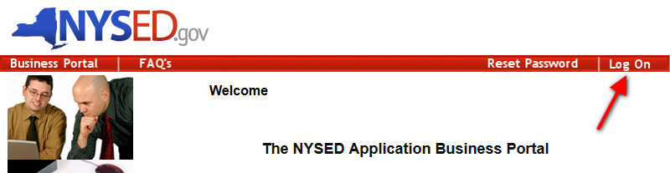

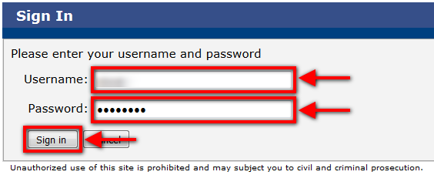

Step 2: Click the Link for State Education Department Delegated Account System (SEDDAS)

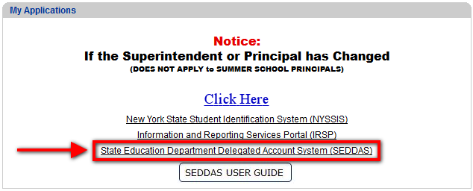

Step 3: Click “Search User” button
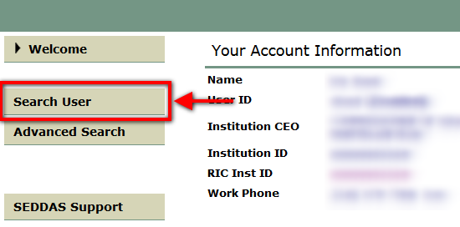
Step 4: Click “Search/Update List” button
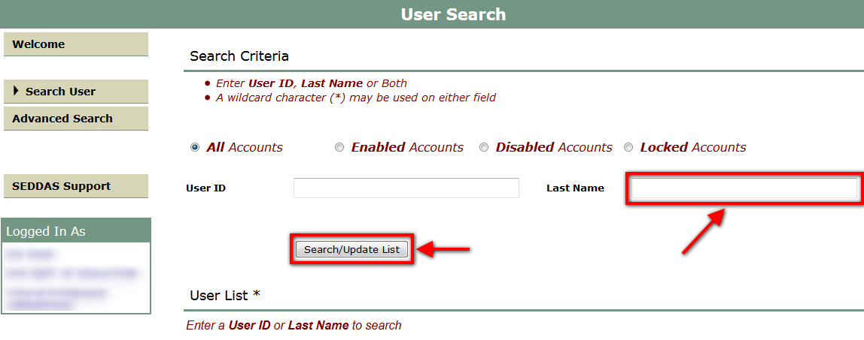

Step 5: Click the “View Selected” button of the user you would like to delegate
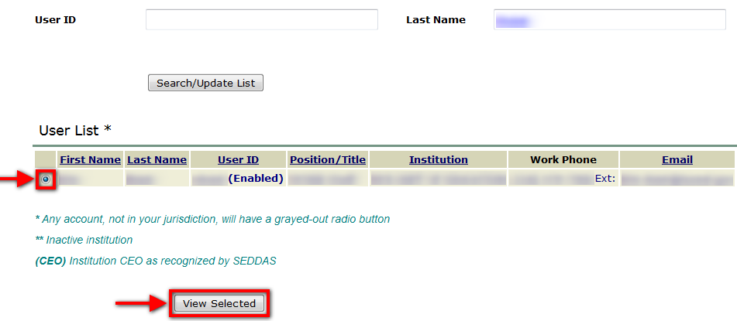

Step 6: Click the “Entitle Applications” button
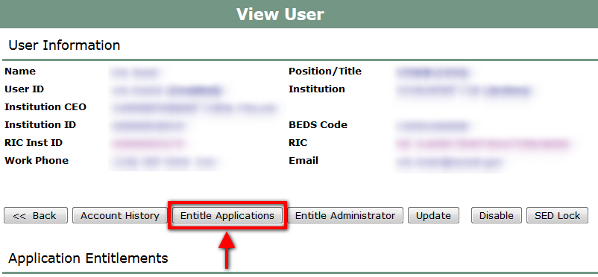

Step 7: Click the box next to “PD System” under “Select applications to change/remove access”
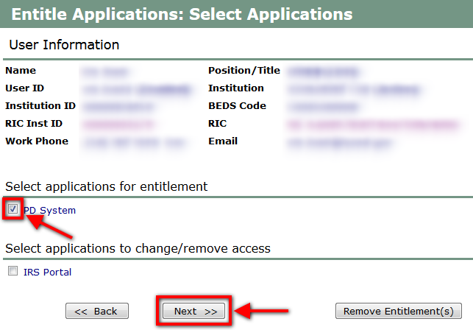

Step 8: Select the type of access to assign the user
- PD Contact: This delegation allows the user full access within the PD Data System. This user can see all data, drill down to student level data, enter data and certify reports within the system.
- CIO: This delegation allows read only access to all forms within the PD Data System. This user can all data and drill down for student level data. Then cannot enter data or certify reports.
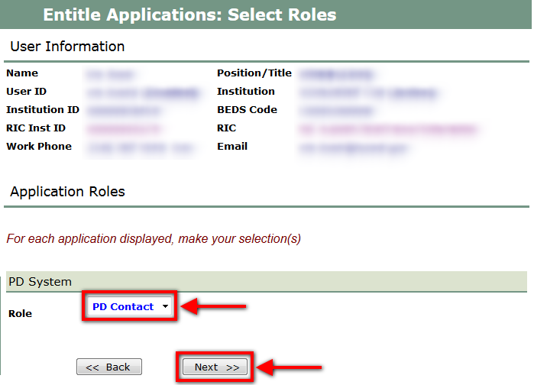

Step 9: Click the “Grant Access” button

