December 2021
NYSSD School Newsletter

Social Emotional Learning Lounge

Students and adults experience a wide range of emotions throughout not only a month or a week, but a day as well. There are several factors that influence our emotions. There are some factors that contribute to positive emotions and some that contribute to negative emotions. Our focus for this month in social emotional learning (SEL) was to help our students in identifying their emotions, what to look for in peers and adults to understand what emotions they are experiencing, and how to appropriately handle certain emotions. Our approach and activities varied per grade level.

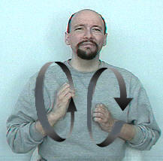

For our lower elementary we focused on identifying and explaining a variety of emotions. We had students, and staff, role play what it looks like to be angry, sad, tired, happy, excited, etc. In addition, we focused on what to look for and what are signs that an individual is feeling a certain way (i.e. smile if happy, eye brows down and frowning when angry). Students were then able to role play and identify these emotions and time was spent discussing what to do if you feel a certain way and aren’t sure why? Who can help them if they are experiencing a negative emotion(s)? What is a negative emotion and why is it negative? We discussed the same with positive emotions and how they make us feel. The goal was to help students understand that we all, students and adults, experience both positive and negative emotions. However, just because we are angry doesn’t me it’s okay to be disrespectful or because we are excited doesn’t mean it’s okay to ignore staff requests/directives. Self-control with all emotions is important.

With our secondary students we went a little deeper in regards to what triggers certain emotions, both positive and negative, for them? Once this was identified we discussed what strategies they utilize to help when they experience a wide range of emotions such as anger, boredom, jealousy, happiness, excitement etc. Students, and staff, were then able to share these strategies with their respective SEL classmates. It was interesting to see the different strategies utilized. In addition, students were able to share strategies and add strategies to cope with certain emotions to their “toolbox.” Once they understand the triggers and supports to utilize they will be able to continue towards their successful SEL development. We discussed how adults of all ages utilize various strategies throughout the day as not every day are we happy and excited. Each day is new regarding emotions.

We are looking forward to having an assembly during our half day in January related to emotions. If you have time, talk with you child about their emotions, how they make them feel, their triggers, and what supports they can utilize in a variety of settings. This will prove beneficial now and as they progress through their respective grade levels.

Deaf-Infant Program
News from Cathy Lee

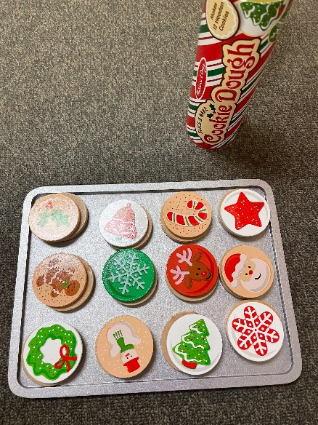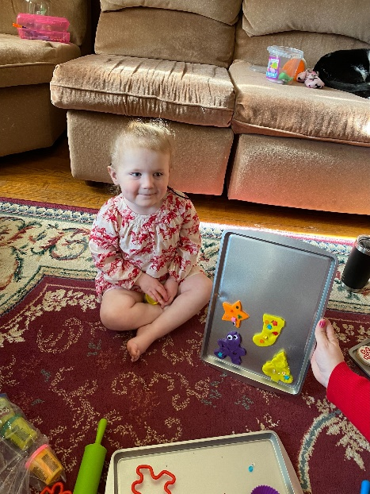

The students and families in the Deaf Infant Program have been doing hands-on activities to reinforce holiday vocabulary. We decorated a miniature Christmas tree, played with Santa and his elf train, and made cookies of course! All while practicing our signing and language skills.

Pre-K
News from Julie Callard

Pre-K has new students this month. Everyone is fitting in well and learning to become great friends. We have had some Social and Emotional Practice that has benefited the way our students share and are kind to each other.
This month, we are preparing for holidays. We learned about Hanukkah and Christmas. Our studies have been focused on decorating trees, presents, snowpeople, stars and lights. The kids loved decorating their individual trees, as well as, the one in the Emerald Hallway for everyone to see! Since holidays are about friends and family, much of our conversations are about who is in our family, where we live, and the children's feeling surrounding so many aspects of their lives.
Pre-K students are learning new skills everyday and we are so fortunate to be a part of it!

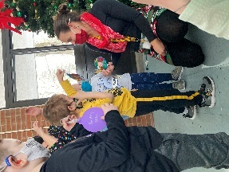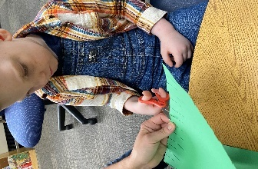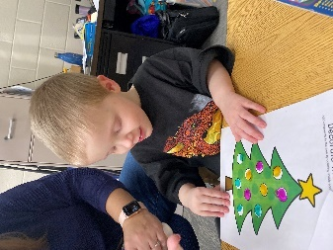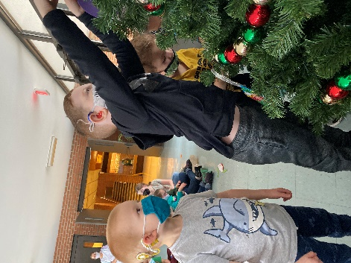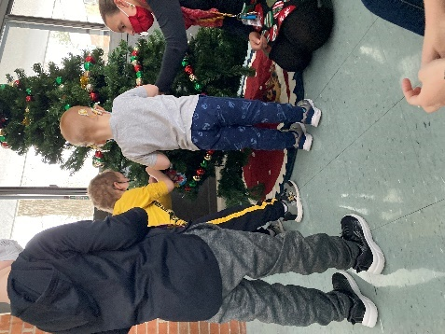

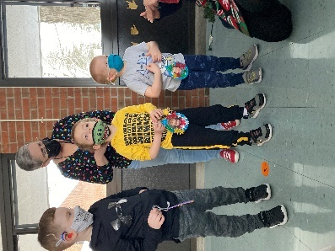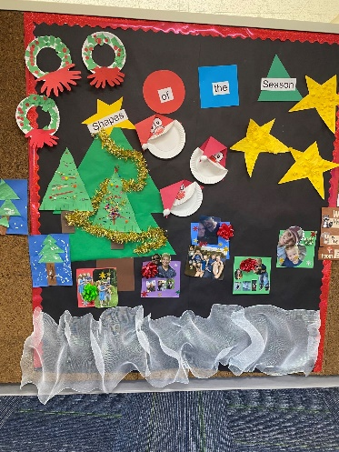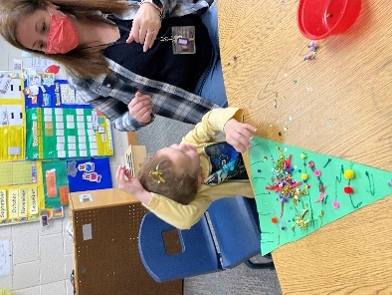

Kindergarten News from Sheryl Whipple

Kindergarten has been working hard to read and sign high frequency words. Learning these words will help your child be able to communicate longer sentences, read, and write. Our current high frequency words are see, can, the, a, like, we, I, and to. Please encourage your child to share and read any books that come home as they will emphasize the high frequency words. In reading, we learned about bugs and how they move through the book I Love Bugs! We just started learning about the theme going places, and read How Do Dinosaurs Go to School? In math, they learned about four 3D shapes (cube, sphere, cone, cylinder). They also learned that 2D shapes are flat and 3D shapes are built out! During social studies we learned about directions, using a compass rose, and even built a map on the floor of the common rooms they see and visit the most! Have a great relaxing break and stay healthy!

Sheryl Whipple

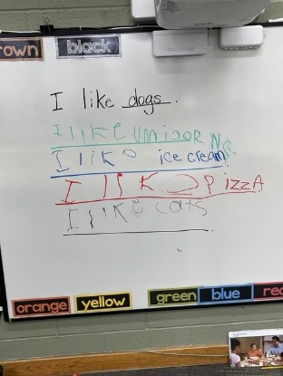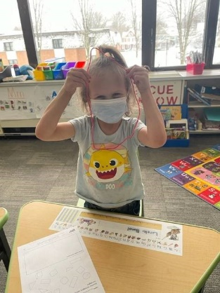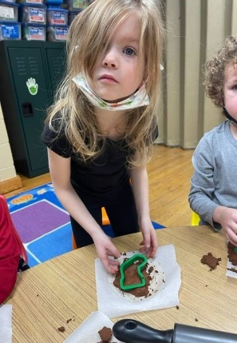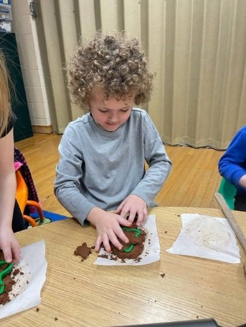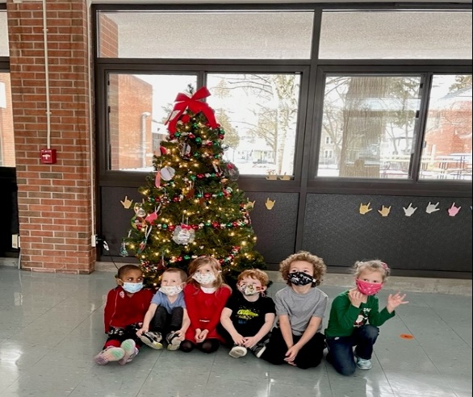

Speech With Katie

We've been celebrating the holidays in speech this month! In lower elementary we've been working on sorting items into categories and listing things in groups. We've also learned about winter and holiday vocabulary.
Middle and high school has been focusing on personal information like addresses, emergency contacts, and phone numbers, as well as literary elements in books and passages. We've been practicing writing in journals and their entries are amazing!

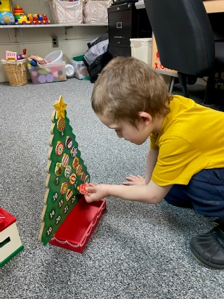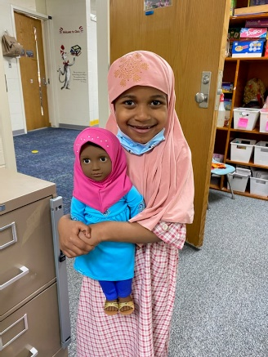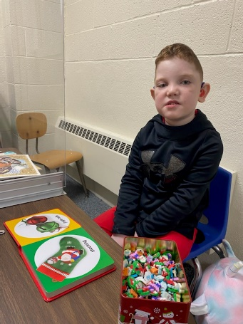

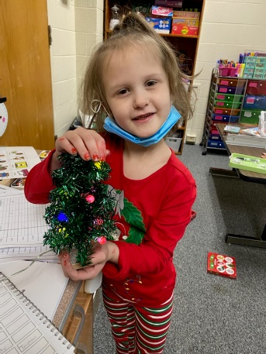

Transition to Adulthood
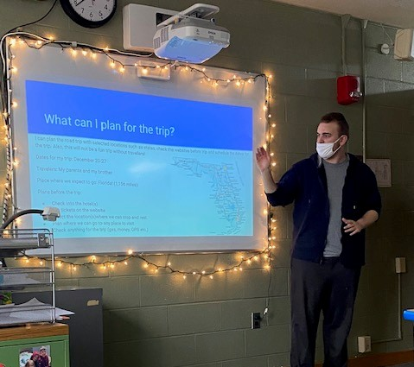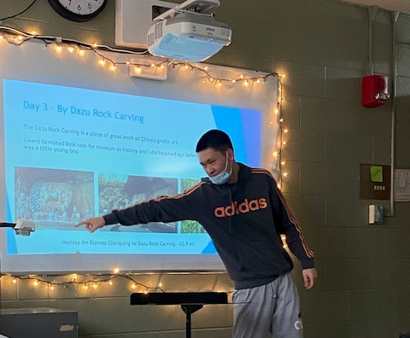

Students wrapped up their “’Planning a Trip” projects by preparing and delivering presentations. We had presentations on traveling to Florida and to China. The students gained some valuable insights from the project. Some “take aways” the students shared:
“Planning a trip is complicated!”
“It is hard to plan a trip traveling to a different county when the money is different and they do not use the American dollar. It’s hard to know how much money the trip will cost.”
“Plane ticket prices can vary.”
“Traveling is EXPENSIVE!”

News from Gloria
Math
Students have been working on solving one and two - step equations using addition, subtraction, multiplication, and division. Students have been solving equations with variables on both sides of the equation and equations containing parentheses.

ELA
Students have been working on reading in class and gathering information from their reading. Students are learning to identify literary elements in their readings. In addition, students are learning how to gather information for their own writing.

Art with Tom Karpe

In Art Class the Pre-Kindergarten students work on matching colors with shapes on their turkey worksheets.

In Art Class with 3rd graders, they created their own images of cornucopias.

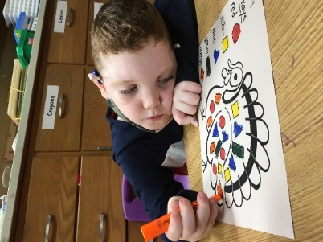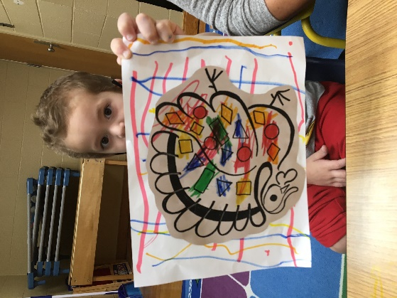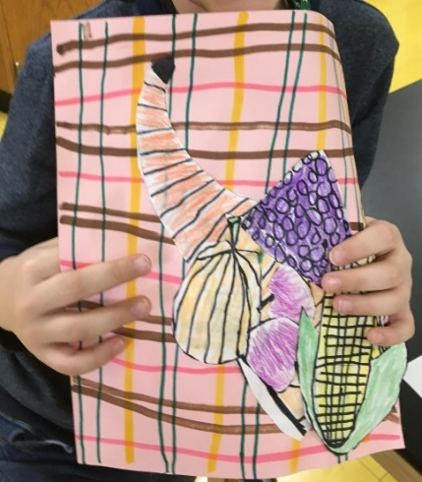

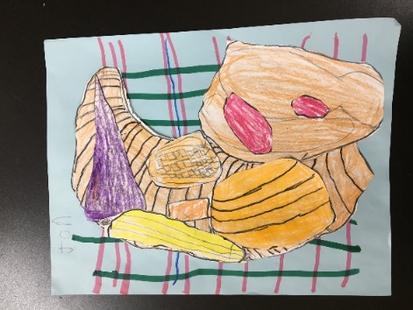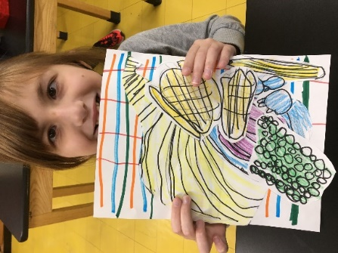

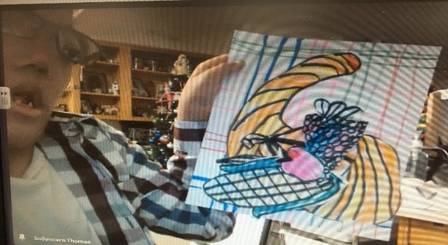

3rd Grade Art Class created the designs of their own Nutcrackers.

1st & 2nd Grade Art Class discussed and created their own collages of POINSETTIAS.

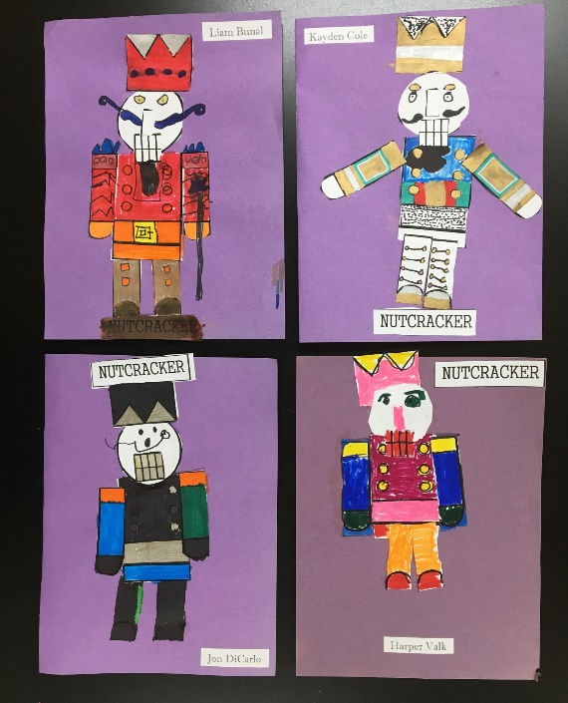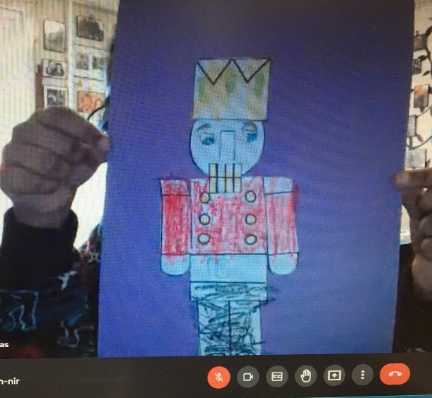

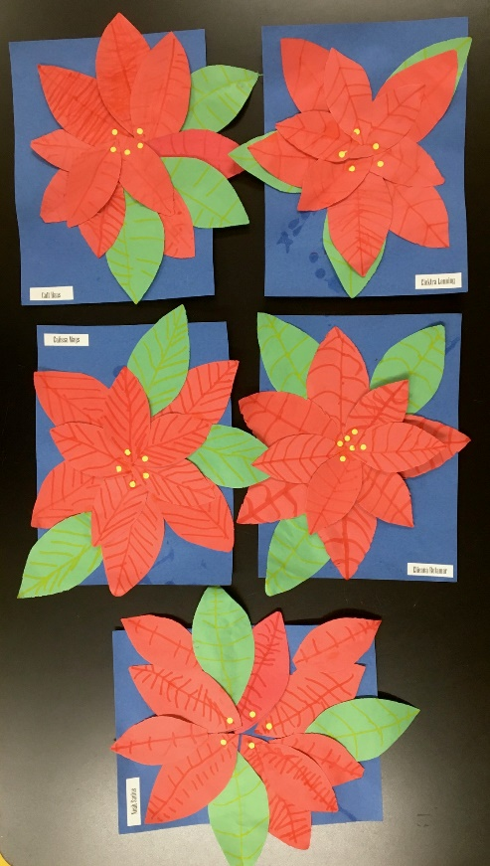

Ms. Wheelock’s and Ms. Parson’s 1st/2nd Grade
This month sure flew by! In ELA, Shari and I put our EDI Training into practice with teaching character, setting, and then main idea. Students enjoyed our new reading routine that includes more partner work, hiding our answers in our desks and a light system to help students understand when to look at the teacher(s) instructing, when to look at and converse with their partner and when to work be working independently.

In Math, we focused on adding and subtracting. We completed subtraction within 10 and began adding by making ten. We learned to make 10 using our number bonds, a drawing or some of us can add mentally! We will continue adding and subtracting within 20 after the break!

With the holidays so close and lots of bundled excitement, we used our Science and Social Studies times to focus on Christmas related crafts and activities. We honed in our ability to follow directions, learned many symbols of Christmas, discussed our family traditions for the holidays and who we spend it with and even tried (and failed) to make snowflake crystals.

Our December Family Project was to decorate a Gingerbread Boy or Girl. Students completed these with their families, then shared their person with the class. Once the presentations were complete, we placed them on our bulletin board, where the Gingerbread House was, of course!

Our Elementary students participated in the annual Tree Lighting Ceremony on December 10th. Each class made an ornament for our tree. Our class up-cycled old Christmas cards and made bulbs for the tree!

In other exciting news, our Classroom Elf left shirts for all the kids for Elf Day, we made Grinch Dust to keep the Grinch away on Christmas Eve, we had a holiday party complete with class gift exchange and we ended the week with a movie, popcorn and matching pajamas!

See you in the New Year!

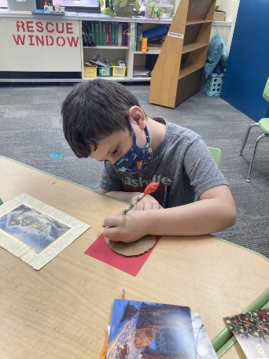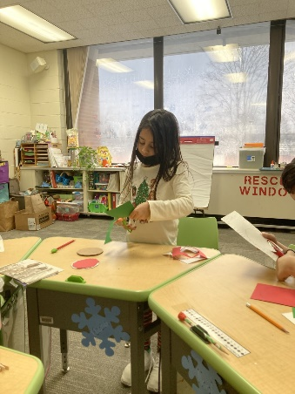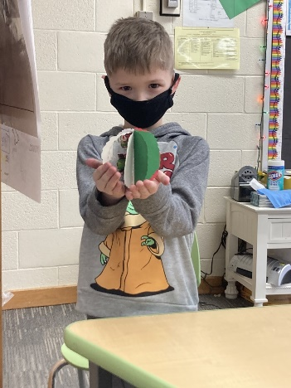

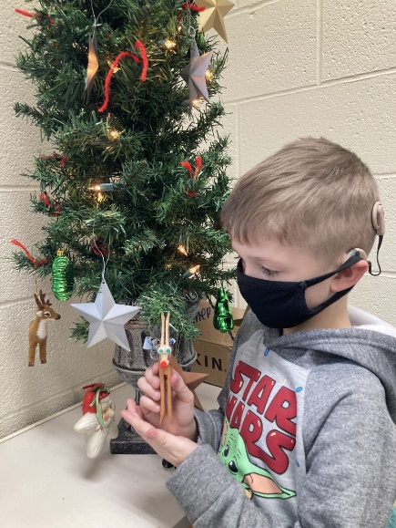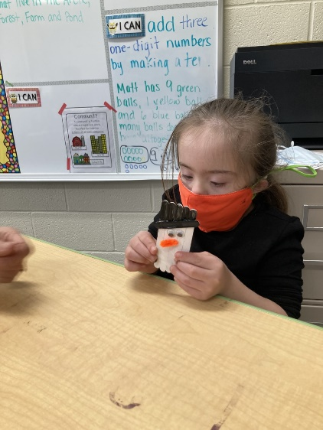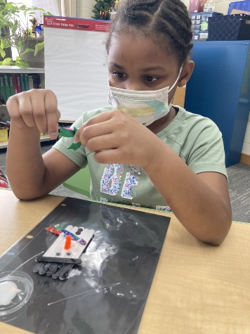

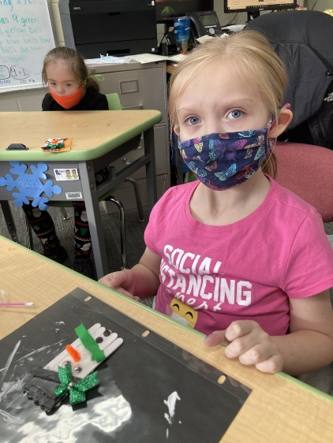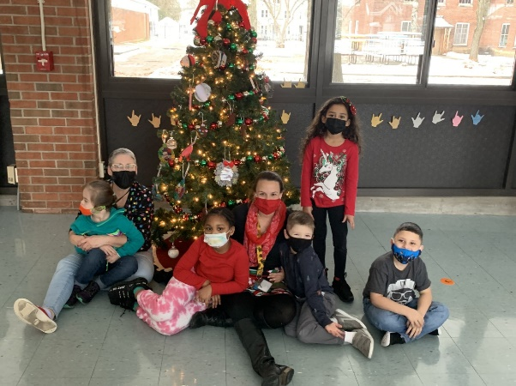

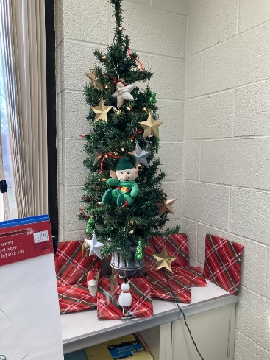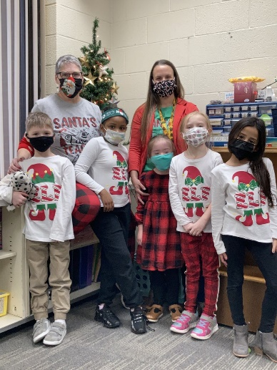

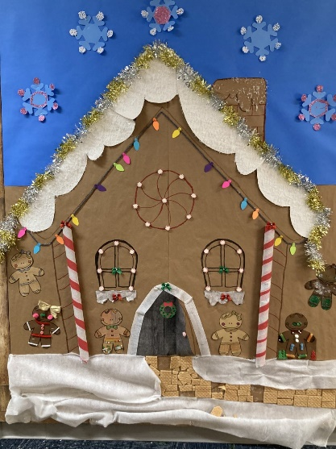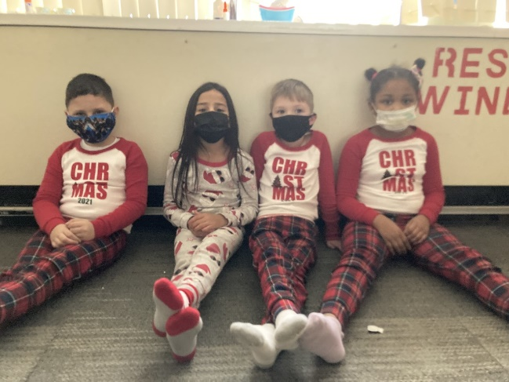

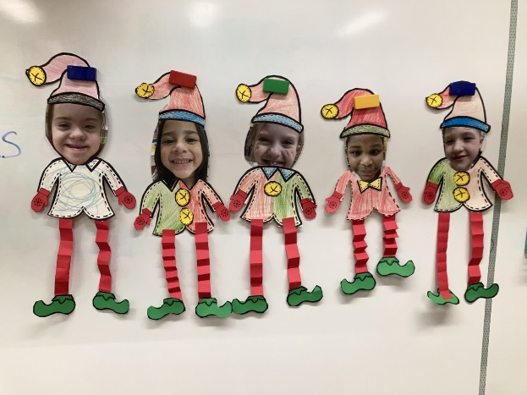

It’s the most Wonderful Time of the Year!

Elementary girls, Calissa, Harper and Natasha decorated the Christmas tree in the elementary girl’s dorm to prepare for the Christmas season. They have also participated in making cookies, doing several arts and crafts projects for the holiday season, and taking a break to enjoy some hot cocoa. The dorms feel so festive and bright thanks to the girls outstanding decorating skills!

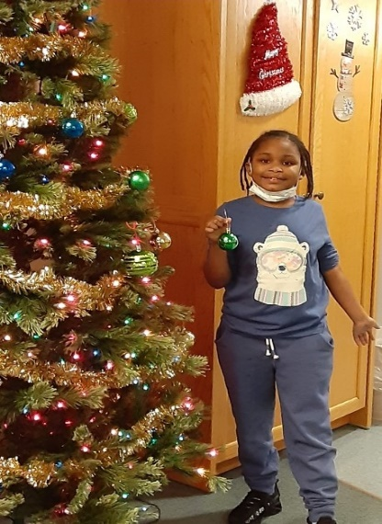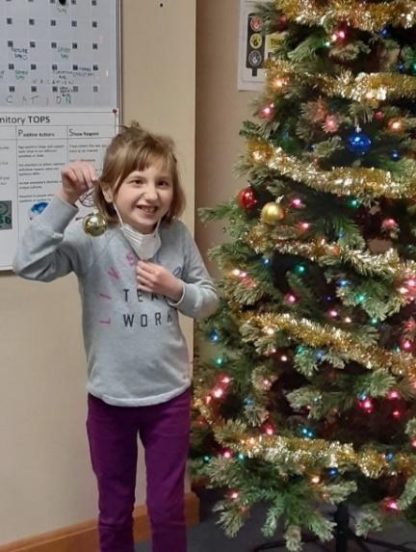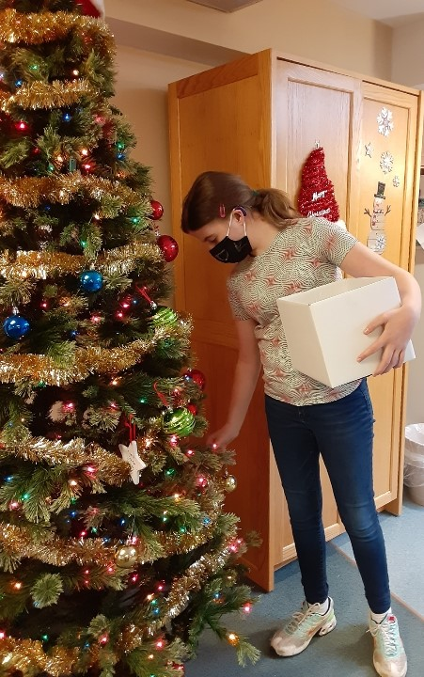

Jingle Jam Light Show

Some of our residential students attended the Jingle Jam Light Show at Mohawk Valley Church in Marcy on Thursday December 2nd. The Jingle Jam is a Christmas production with singing, dancing, and interactive games. Afterwards the students went to the “after party”, where there were pictures with Santa, hot cocoa, crafts, and a kid’s dance party. It was a great night and fun was had by all!

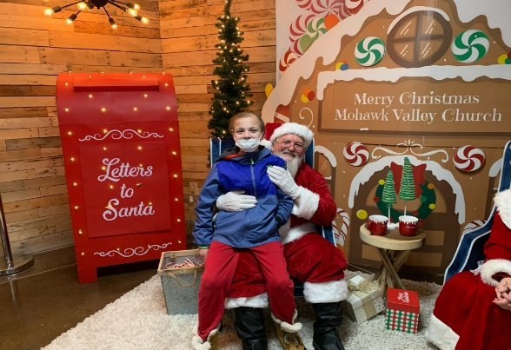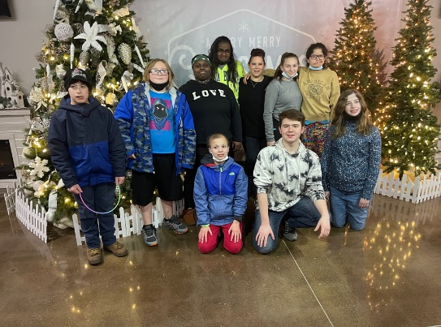

The Season of Giving

The elementary boys along with recreation therapist, Chad LaPlante, spent some time ringing the bell at Tops Supermarket, for the Salvation Army. The money collected in the Red kettle helps feed those that are hungry along with providing countless other services to individuals in our community. Thank you to the boys for taking time to give back to the community, and a thank you to Chad for setting up the volunteer opportunity for our students.

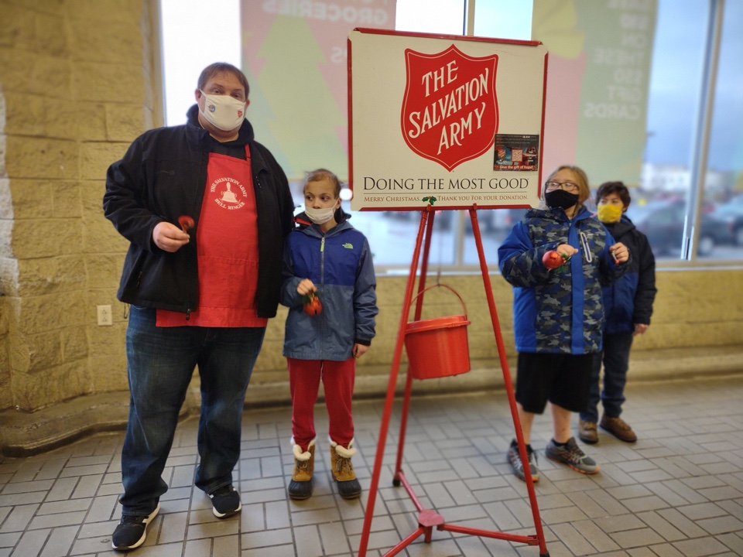

News from Kelly Romanus

The third graders have been working hard this month doing a lot
of great things. In English and Language Arts, students are learning
how to write in sequential order using the words first, then, after,
next, and finally. The class made a snow globe and then wrote the
different steps.
We just finished Module One in Math which focused on
multiplication and division. After December break, our class will be
moving onto Module Two - Place Value and Problem Solving with Units
of Measurement.
The students have been traveling around the world learning about
how holidays are celebrated in other countries in comparison to the
United States. The students have a pretend suitcase, passport, and
airline ticket and we imagine we are traveling to a new country.
We have traveled to many different countries: Israel where we
learned about Hanukkah, Africa in which Kwanzaa is celebrated, and St.
Lucia in Sweden. Finally, we studied Germany decorating with
gingerbread cookies.
We continue to learn about friction and magnetism in science and
how it relates to force and motion. The students are using magnets to
investigate their different properties.
Grade Three would like to wish you and your family a healthy and
happy holiday!

Holiday Fun!
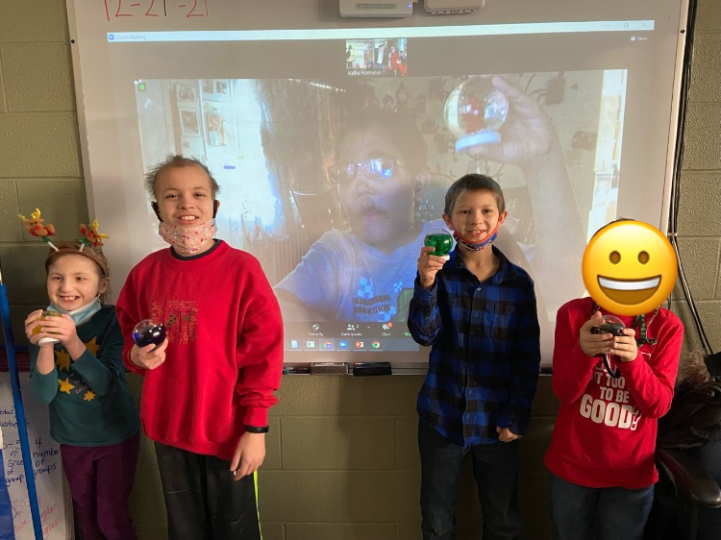

Gym News from Michelle Simmons

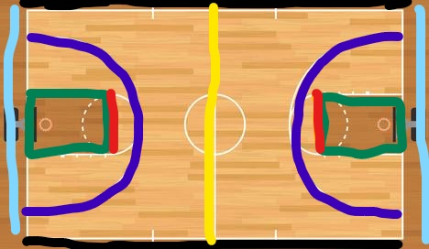
The upper elementary, middle school, and high school have been working on improving their basketball skills this month and learning what different parts of the court are called.
Sideline
Foul line
3-Point line
Baseline
Midline
Key

The lower elementary classes have worked on shapes around us (pizza slices are triangles), basket ball dribbling, and jumping rope.
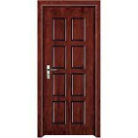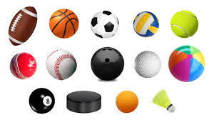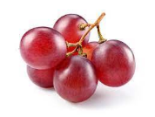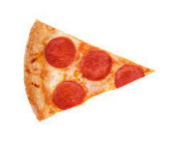
Rectangles Circles Stars Triangle Square

News from Jennifer Cadieux

Theatre Arts
Theatre arts students have been busy learning the art of mime. The class has participated in various theatre warm-ups and class activities related to this theatrical technique. Theatrical mime is a way of suggesting action, character, or emotion without using words. For instance, instead of using words, students have been practicing using gestures, facial expressions, and movement to act out a scene.
Students have also been working on recording a Christmas video, by decorating mini trees with lights and ornaments. The theatre class wishes everyone a Merry Christmas and Happy New year!
Music
Music students Pre-K -7 have been learning about the instruments of the orchestra. Younger students have been exploring different percussion instruments and learning how they make a sound, either by shaking or hitting. Students in grades 3-7 have been learning how to play Orff instruments, such as the xylophone. These students have also have been playing Jingle Bells on the melody chimes. Sixth and seventh grade students have been reviewing basic rhythms and how to read music notes on the treble staff.

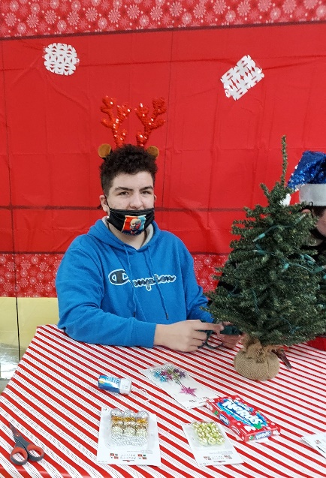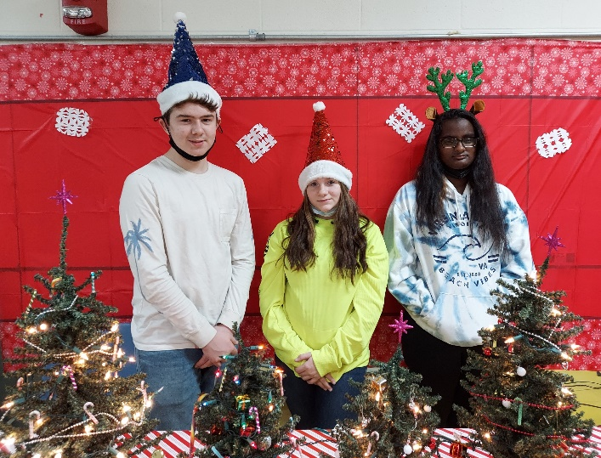

6th Grade Update from Chelsea Mosher

The students have been doing many hands on activities. Starting off with constructing geographical features of river valley civilizations, such as Mesopotamia as a Social Studies project. The boys just finished reading about how the climate affects farming and how Mesopotamians lived off the land. The students used cardboard, paint, markers, and salt dough to create their projects. The students did great designing, creating, and presenting their projects to other staff members (Pictures 1-4). The next big project the students did was make “Bag Ice Cream” fro national ice cream day in December. The students learned how to make and what happens with ice and salt and what that does to the inner bag of cream.
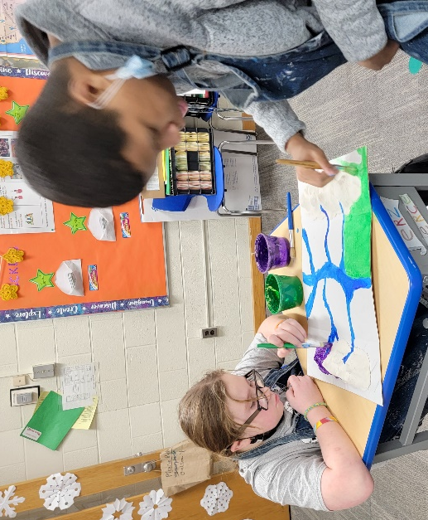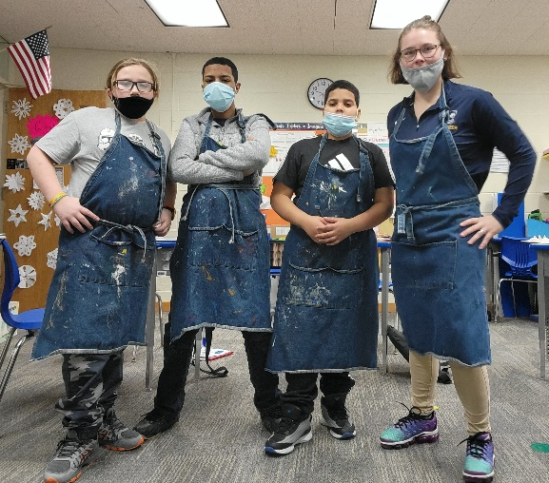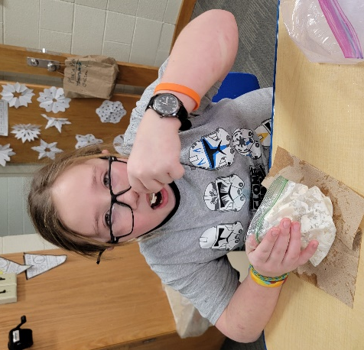

ELA News from Cathy Lee

In ELA the 7th graders have continued to read “A Long Walk to Water”. The theme of the story has shifted from survival to perseverance. The characters in the story show perseverance and working towards and attaining goals. Salva is taught the importance of perseverance, never losing hope, and always continuing to work towards his goals, and attain them, by his uncle as they are crossing the Akobo Desert. Nya and her village work toward installing a well where they can have access to water. We watched a YouTube video showing how a well is installed in Africa and the amount of teamwork it takes to get the job done.

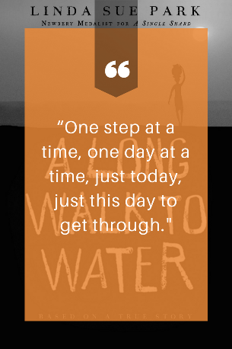

January 1 Evan H.
January 10 Liam B.
January 26 Noah S.

News from Bonnie Bell

In Science 9A we have been working on Paddle boats that could go along with the theme for this year’s science fair – “Combating Global Warming”. Students needed to design their own wooden paddle boat, take measurements for size dimensions LxW in centimeters) and weight (grams). They also got to try the boats outside in a tub containing 4 inches of water. Congratulations goes to Jayden, because his boat was the only one that consistently went from one end of the tub to the other!

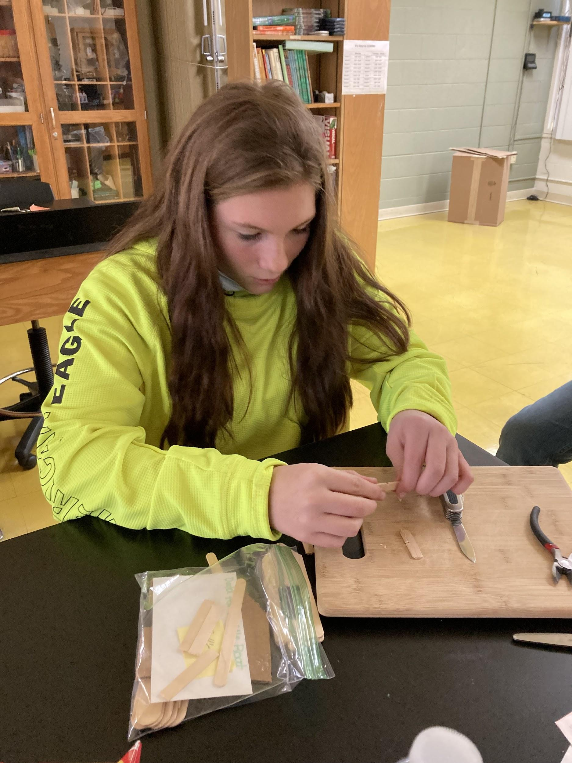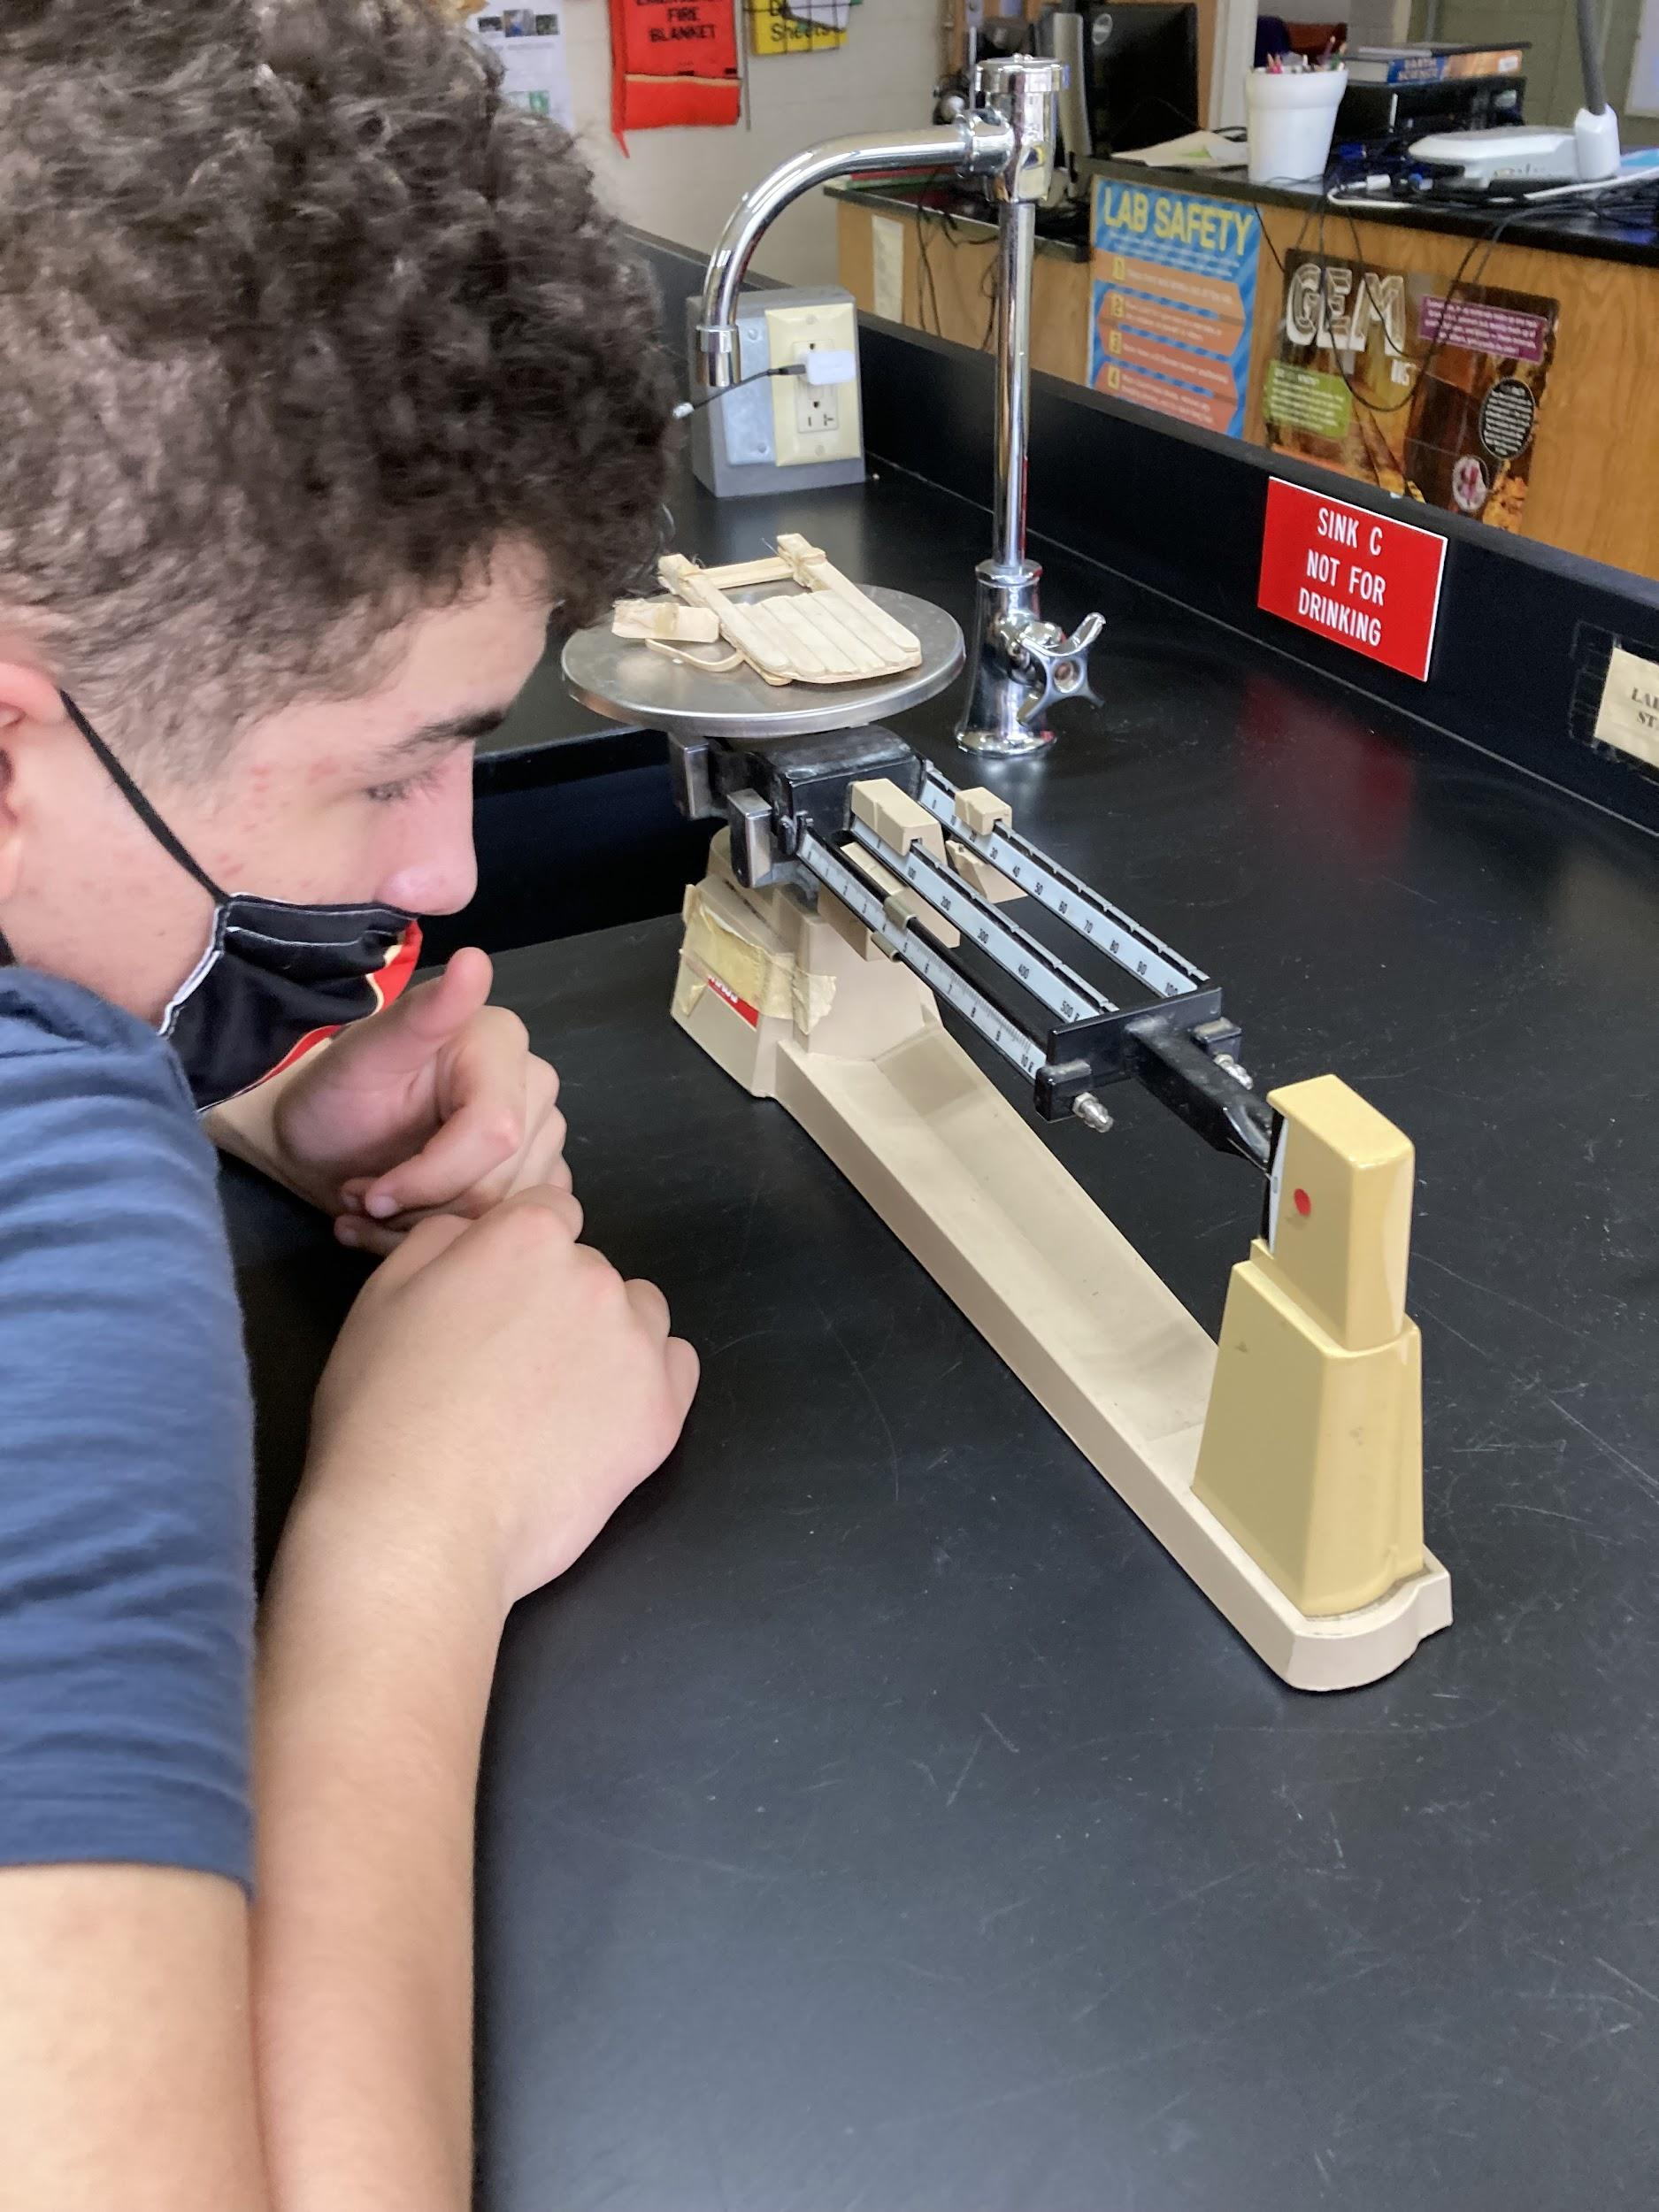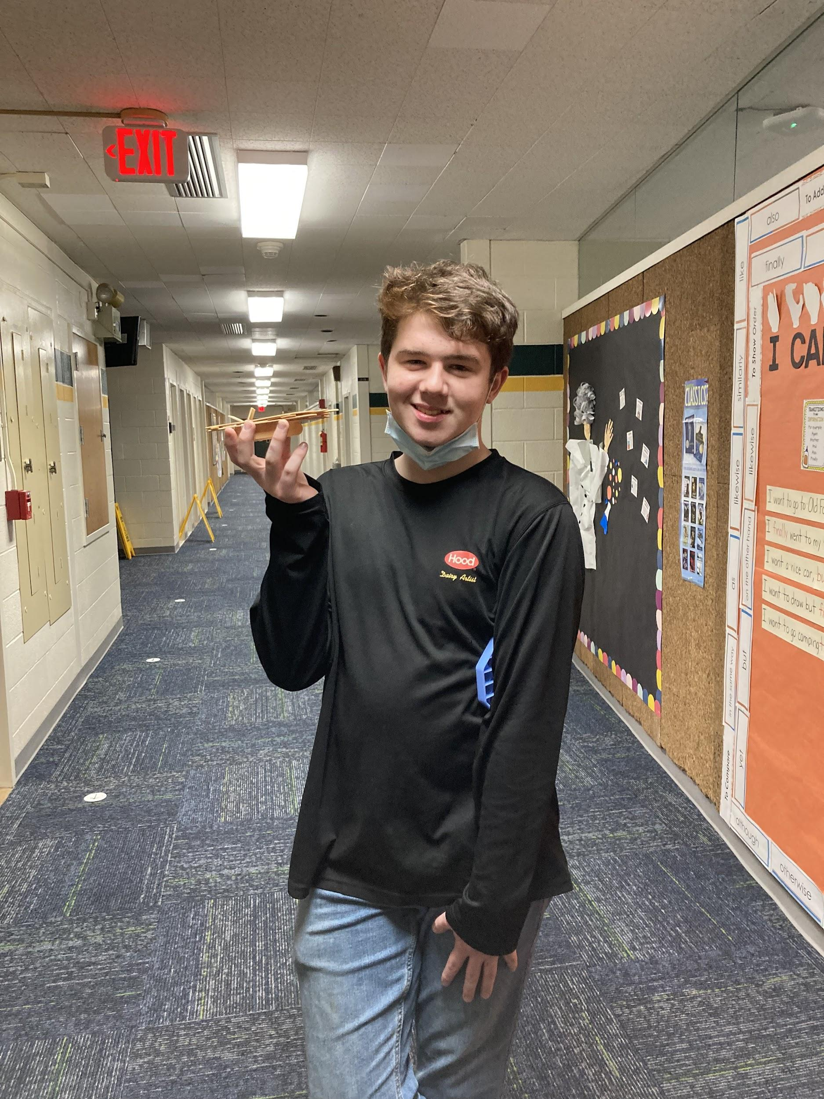

In Science 9B, we have been working on the scientific method and discussing open and closed systems by making Sun Tea. and we will soon be working on building our own terrarium.

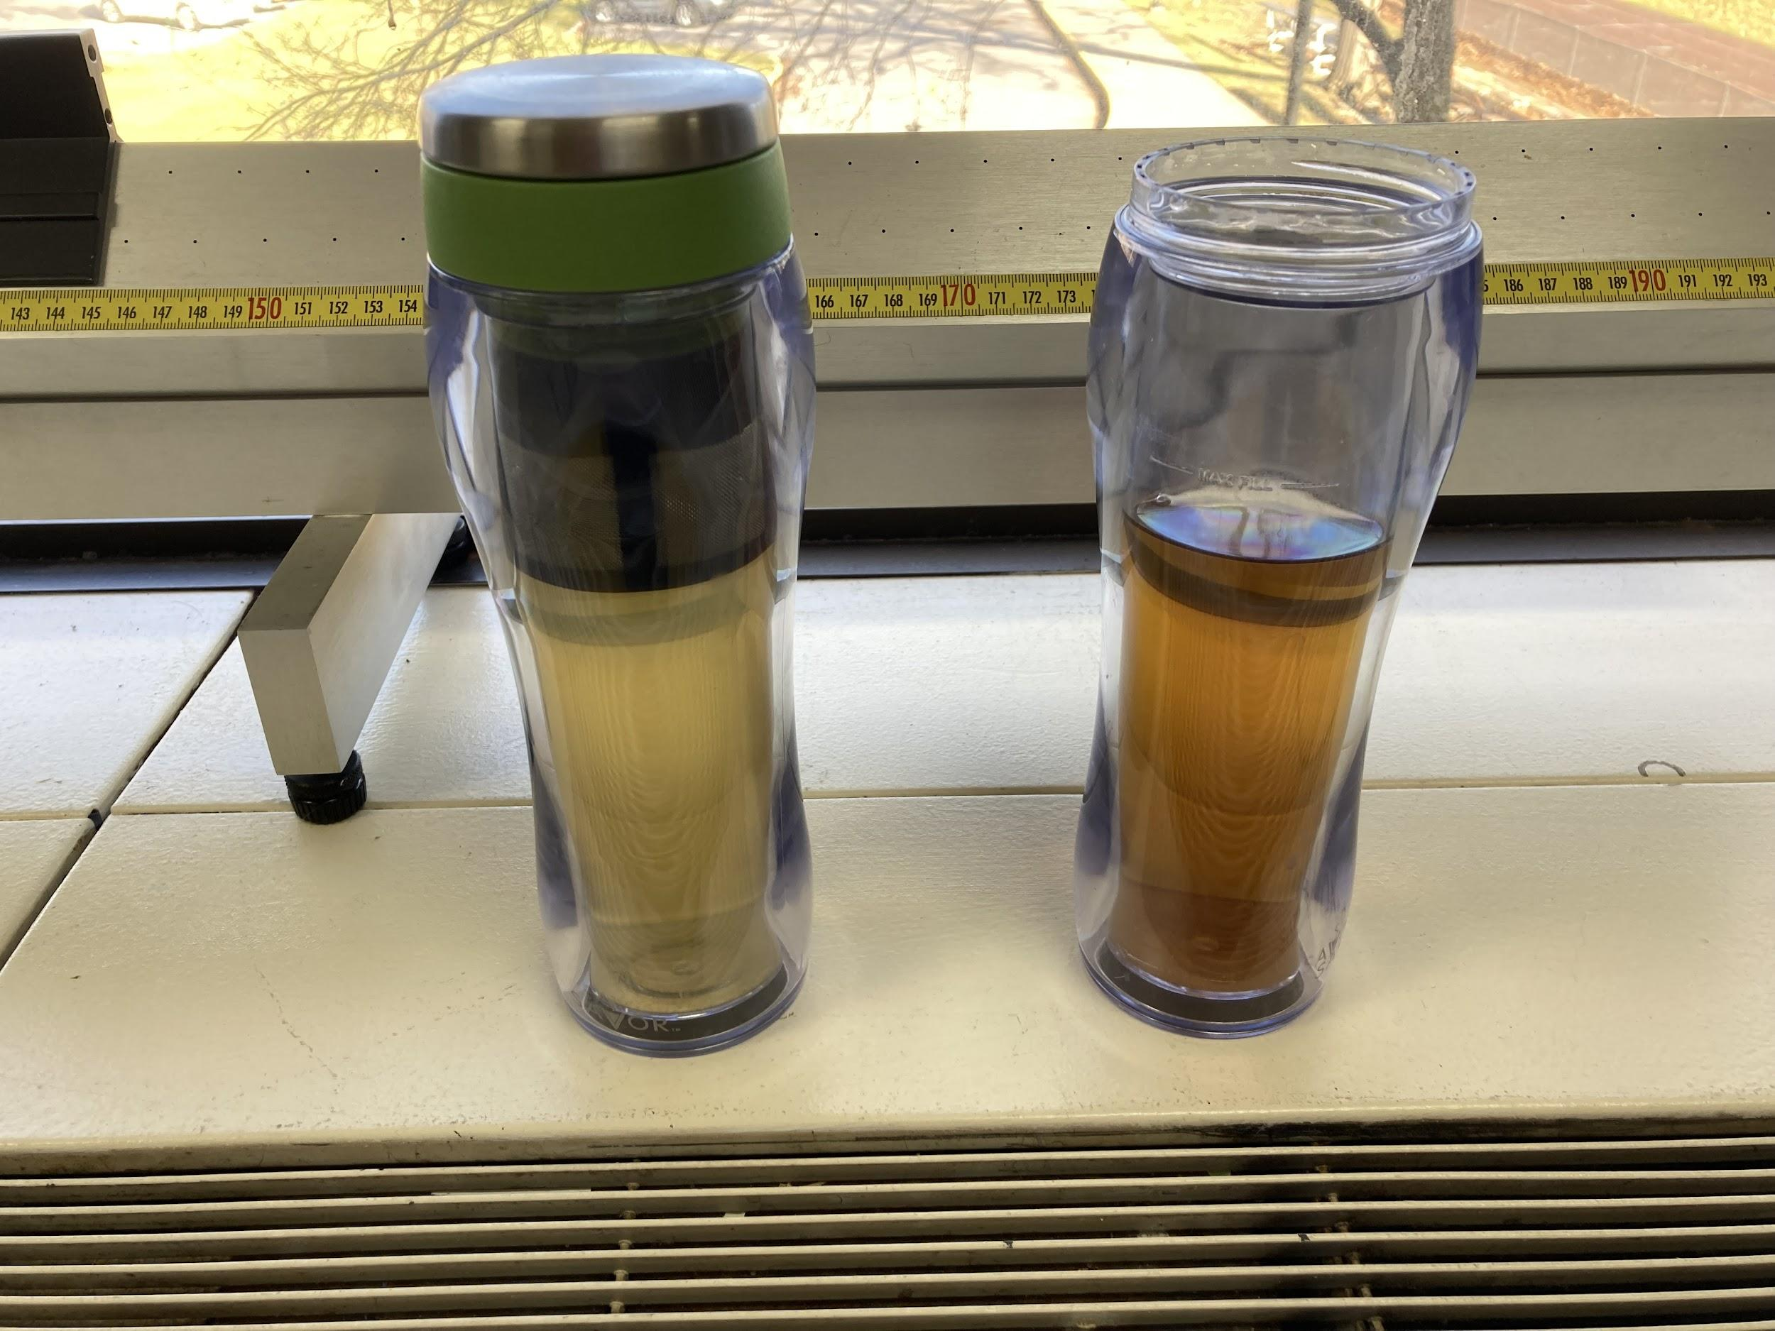

In Life Science, we have been studying concepts such as: diffusion as well as osmosis by conducting lab experiments such as: Naked Egg & Shrinking Egg, Spice Escape and Fluffy Raisins, and Unseen Movement.

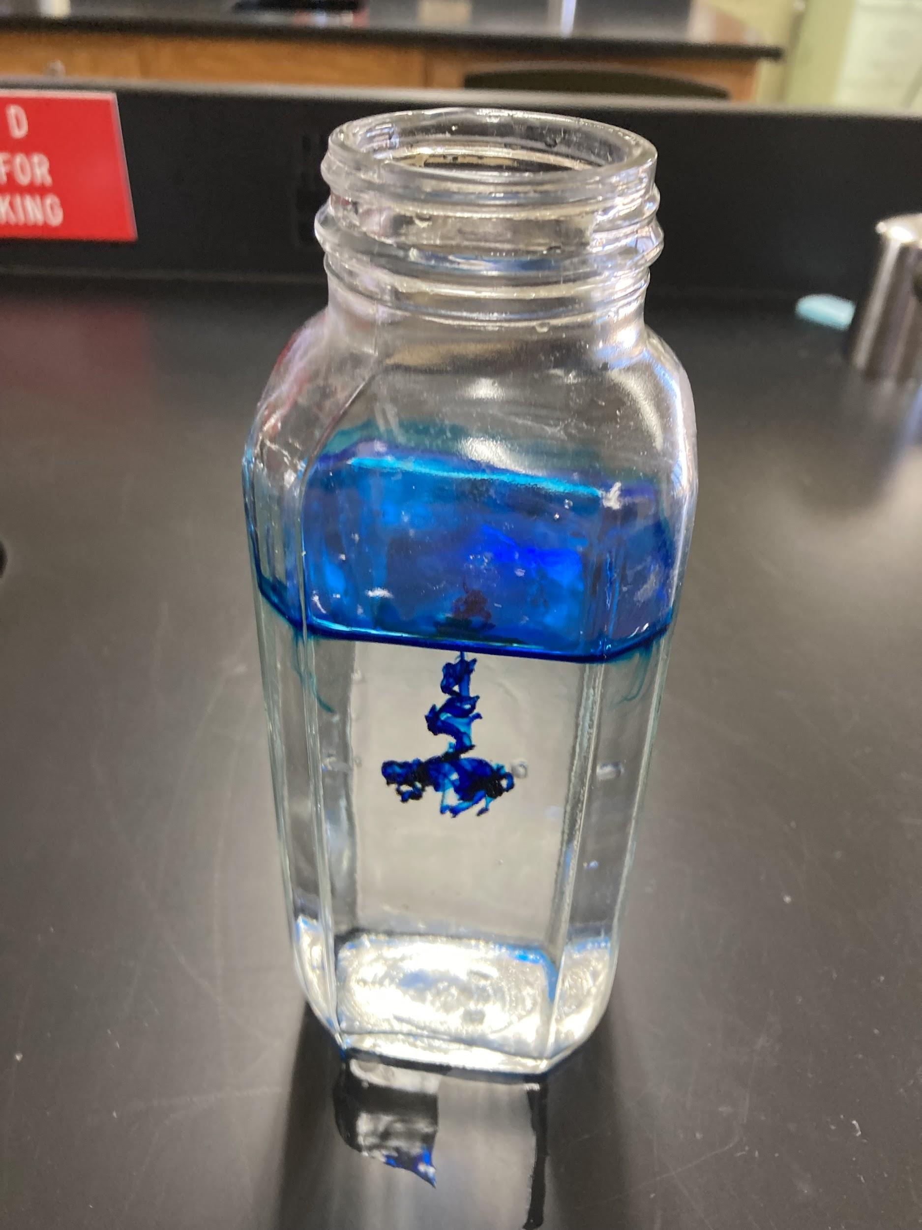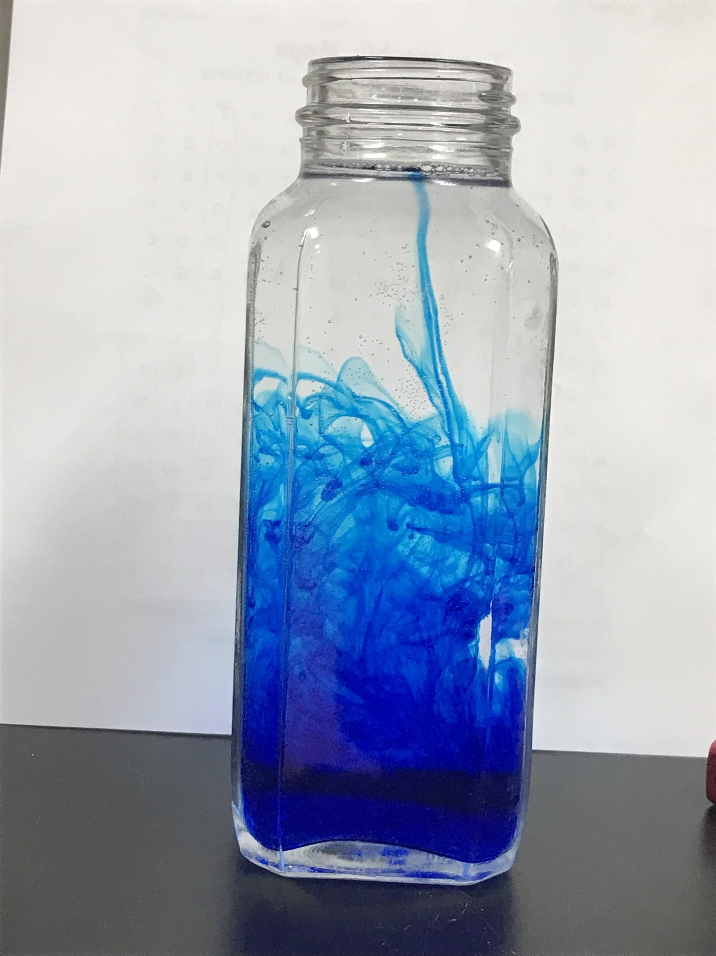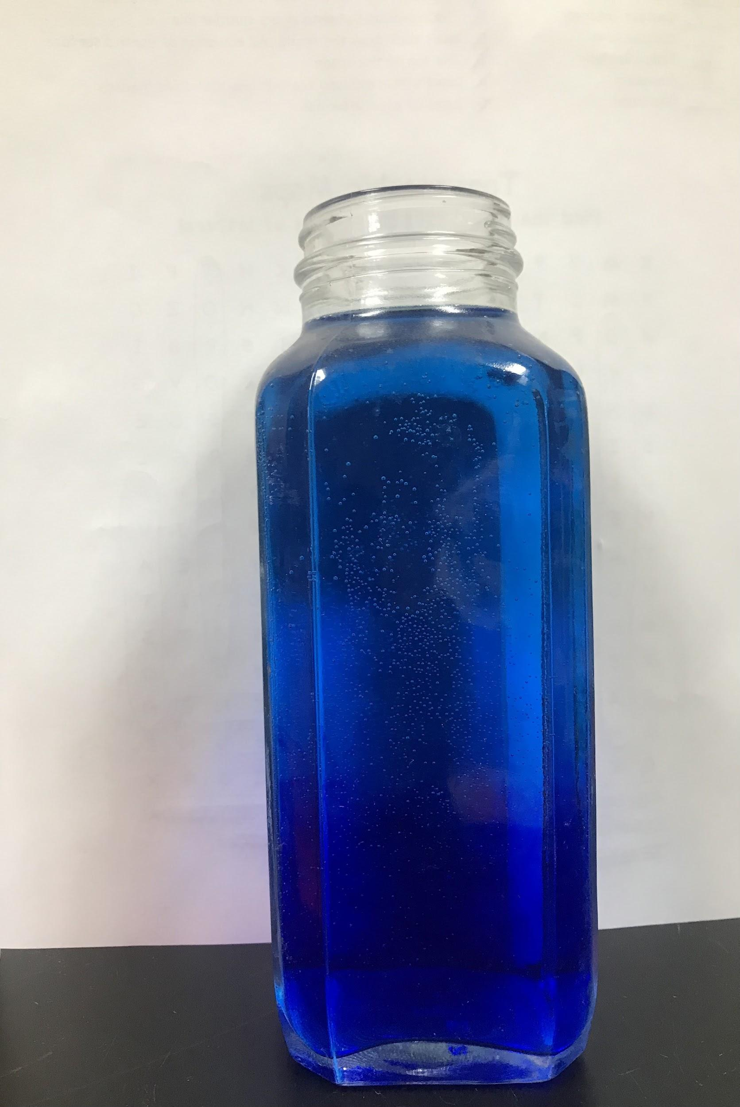

In Science 7, we have been working on the Scientific Method of Inquiry and conducted labs called “The Christmas Surprize” and Baking soda and vinegar experiment.

