January 2022
NYSSD School Newsletter

Hello NYSSD families,

Please read some important information below in regards to current DASA guidelines.

Harassment, discrimination, or bullying are serious incidents and will not be tolerated. If you feel that this is happening to your child please contact NYSSD at 315-337-8400 x6804. Any person (student, parent/caregiver, faculty/staff member, etc.) observing, or being the target of bullying, discrimination, harassment or perceived bullying, discrimination, harassment activity may report the observation. If you feel that this is happening to your child please complete and return the DASA form to the NYSSD Education office. The form can be found on our website at https://www.p12.nysed.gov/specialed/nyssd/

The form will be given to our DASA Coordinator, Chris Kimball. If unsure whether an incident constitutes bullying/harassment/discrimination please contact Interim Superintendent Kara Shore at 315-334-5809 with any questions that you may have.

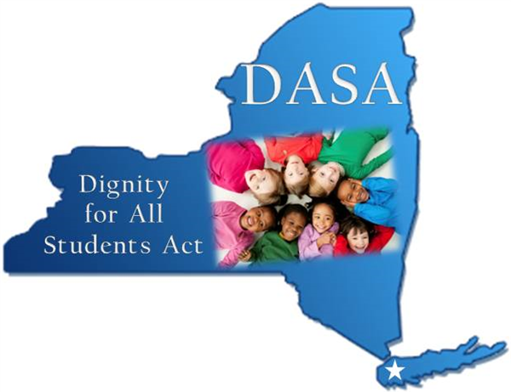

Social Emotional Learning Lounge

Happy New Year and we at NYSSD hope you and your loved ones had a wonderful holiday season! We spent last month reviewing, explaining, and discussing emotions with our students during our SEL (social emotional learning) time. On Friday January 14th we had a half day and were able to hold a successful assembly discussing emotions with our elementary students. In our SEL classes with our secondary students (7th-12th grade) we had our students show their facial expressions when they experience certain emotions. For example, when you’re happy you’ll have a smile, if you’re angry your face will tighten up and eyebrows will be down, and if you’re sad you’ll have a frown etc. A key point was also to show that people have different expressions when they feel different emotions. Once this was done staff and students worked together to develop power points to be shared with our elementary students during our PBIS assembly. The power point presentations had a picture of the student experiencing a certain emotion, what makes them feel that way, and how they/their body feels when they experience that identified emotion.

During our half day on Friday January 14th our elementary teachers (Pre-K-6th grade) along with members of the PBIS team shared these power points developed by our secondary students with their respective classes. In addition, they had a discussion about the different emotions, how they make you feel, why, and what to do when feeling a certain way. It was a great experience as the elementary students were excited to see our secondary students showing the various emotions and what makes them feel that way. Our goal with this was twofold. We wanted to help our elementary students develop a better understanding of the emotions that they experience on a daily basis. In addition, we wanted to further facilitate that feeling of community and rapport with our elementary and secondary students. NYSSD is a family and the more we come together and help each other, staff and students, the more success our students will have as they progress through their respective grade levels. Great job by our staff and students!

It’s hard to believe but we are almost halfway through the 2021-22 school year. MDT/Annual review season will be upon us soon. When a student is 14 or older they are invited, and encouraged, to participate in their MDT/annual review meeting. It can be an overwhelming experience for not only parents, but students as well. There is a lot of information shared in order to develop a plan to ensure the success of your child, or children, as they progress to the next grade level. We are taking time during our SEL lab and speech language lab to review the MDT process with students that are of age to participate. This goes into our next skill of self-advocacy that we will be teaching our students. By supporting our students now and giving them the skills needed to be active participants in their respective MDT/annual review meetings we will be helping them develop the self-advocacy they need to support themselves now and as they progress towards graduation. If you have any questions regarding the MDT/annual review process or if we can support you or your child, or children, in any way please don’t hesitate to reach out to us.

Music News from Jennifer

January News-Theatre Arts and Music

Theatre Arts
Theatre Arts students have been working on reading one-act plays for 2-4 characters. Students have been bringing characters to life vocally and through body language. Students are eager and excited to perform and will be preparing a performance in the near future.

Pre-K-K:
Students have been using Boomwhackers (different size colorful tubes) to learn colors, focus and concentration as they perform in a group. Students are learning the importance of taking turns and waiting for their turn to play. When it is their turn to play, they strike the tube against the floor or the palm of their hand to make a noise. Students are in the beginning stages of making music and learning how to hold and use the instruments properly.

Music 3:
Students are beginning to learn how to read music on the staff. Students have learned that the musical staff is five lines and four spaces. They have learned that notes on the staff make a sound and that there are seven notes in the musical alphabet. Students have been applying this new knowledge to reading music and performing simple songs on the classroom instruments.

Transition to Adulthood
Since 2016, high school students at NYSSD have been chosen to be featured in a magazine, Central New York Deaf/HH Teens. This is a magazine that is developed by students and staff at Center for Instruction, Technology and Innovation (CiTi) BOCES and it features biographies and perspectives of teenagers in NY who are deaf or hard of hearing. During Transition to Adulthood, students are collaborating with the CiTi BOCES team to develop the next edition of Central New York Deaf/HH Teens. As part of our work, students are completing in-depth questionnaires and gathering photographs to best represent their individual perspectives on growing up a student who is deaf. We will share the newest edition of the magazine with the NYSSD community when it is published by CiTi BOCES in spring of 2022.
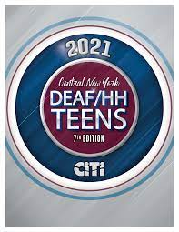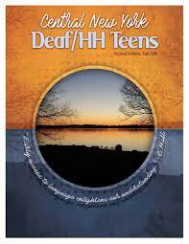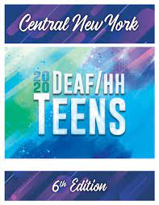

Deaf-Infant Program

Since winter has arrived, the students in the Deaf-Infant Program have been learning about snow, winter, winter clothing and snowmen. The students practiced vocabulary using a winter themed sensory bin, and using real-life items they will be seeing and using this time of the year.

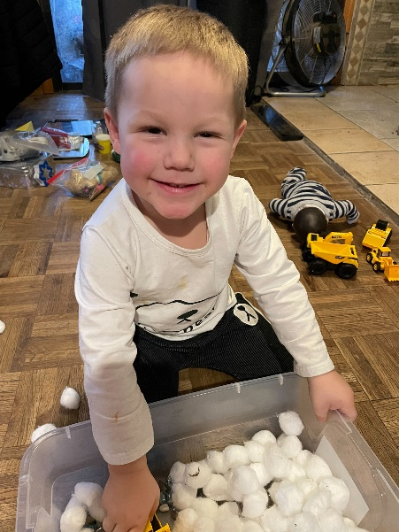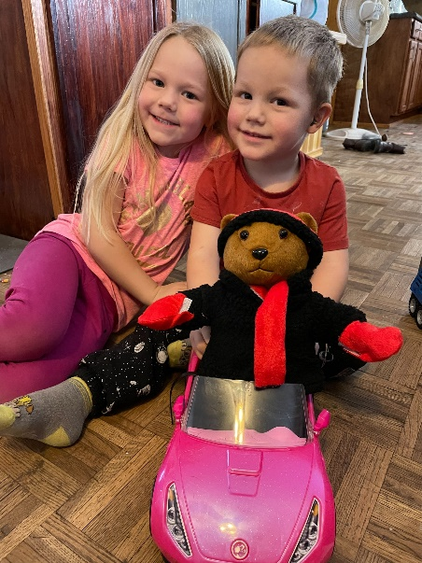

Speech With Katie

In lower elementary speech we've been practicing answering questions! We've been reading fun winter stories like "The Snowy Day" and "Sneezy the Snowman" and answering questions about what we read. There's lots of fun winter vocabulary, too.
In high school, students have been working on writing an essay on a topic of their choice. They've been learning what parts should be included when writing a paper, like an introduction, body, and conclusion. They've also been working on memorizing emergency contact information and writing grammatically correct sentences.

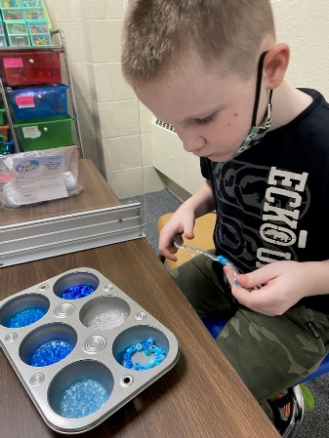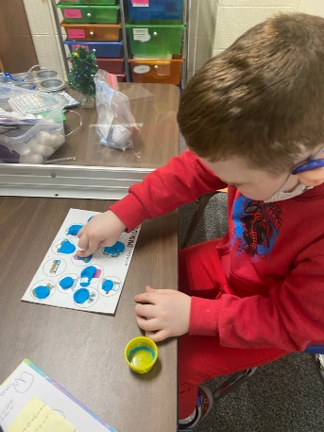

Speech with Rachel

It is a new year in speech and language therapy! Elementary school students did a great job remembering their old routines over the break, and have been reviewing past vocabulary as well as learning new vocabulary. Some students are working on understanding how to answer different types of questions (for example, we answer a "who" question with the name of a person, and a "where" question with the name of a place), others are working on new speech sounds, and yet others are reading social stories to help support positive behaviors throughout the school day. High schoolers are working on identifying "personal information" and essay writing skills.

Kindergarten News from Sheryl
Kindergarten continues to be working hard as we enter the cold winter months! In math, they are learning nonstandard measurement while using tools such as string, popsicle sticks and scale to measure things! In reading, we are beginning to learn about characters, setting, and events. They will will learn how to tell what happened in the beginning, middle, and end using sequencing words such as first, then, and last. Please check out your child's Google Classroom page as there are many great websites and resources that I have posted! Stay warm and healthy!

Physical Education News from Michelle

This month our elementary students pretended to be pirates sailing on a ship. They practiced rolling balls at pins and their friends on the other ship tried to block the balls coming toward their pins.

PT with Mandy

Hello students, parents, and guardians! I am the new Physical Therapist at NYSSD. I am so excited to be a part of the team, and I look forward to getting to know all of you. I will be running PT sessions with students, according to their IEPs, and spending time in gym class to help improve everyone's gross motor skills. This is a really great group of students, and I'm so happy to be here!

Pre-K with Julie

Pre-K Students have been busy learning about winter weather. We have been practicing zipping our coats and changing from our boots to our shoes. Getting them on the right foot is always cause for celebration!
Every one of us have been hard at work to learn new information. Through music, dancing, counting, sorting, pairing, tallying, moving, talking, and listening, we know how to interact with and are beginning to skillfully investigate the world around us.

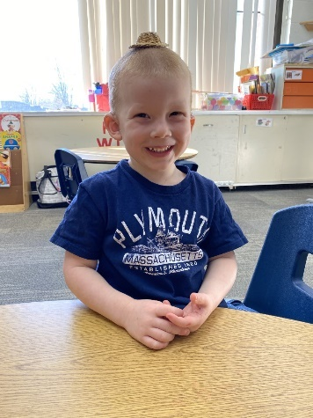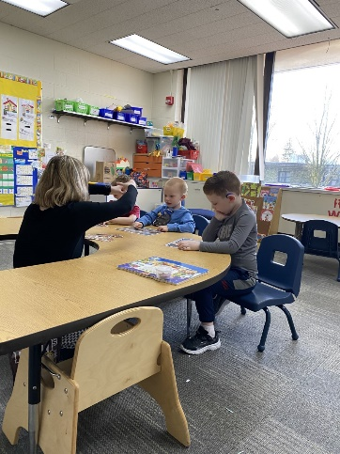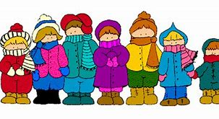

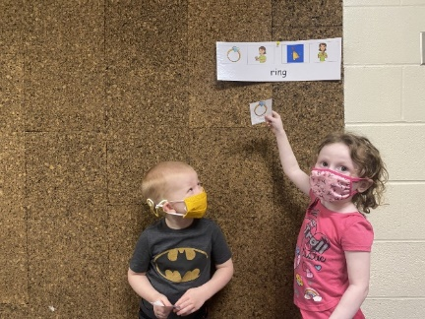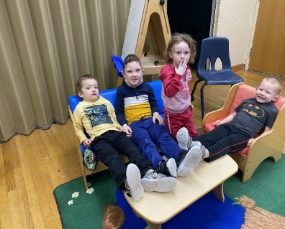
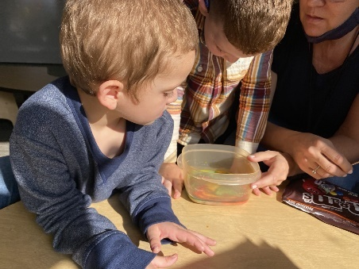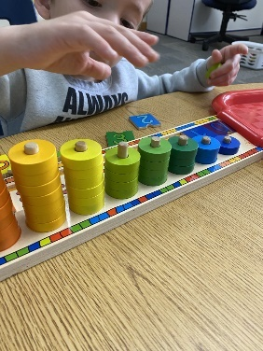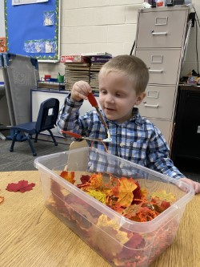

Library and Technology with Ellen

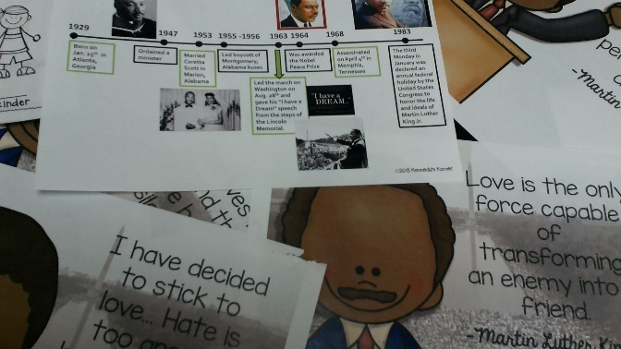

We are discovering Australia this month with animal and geography research.
Classes will use graphic organizers and materials in Google classroom for researching their topic.

During the second week, some classes will work on a timeline project and biography study of Dr. Martin Luther King Jr.

Our digital citizenship module is about Our Identity and Digital Footprint – who we are online and what we share
Great resources from Common Sense Media are available for families.

Stories this month include themes of winter play and colors, weather, penguins, polar animals, and being different, acceptance, and fairness.
For Pre-K and elementary classes, we will try re-telling using ASL, describe characters and settings, and learn about cause and effect.
Author Jack Ezra Keats’ classic story The Snowy Day, along with Tacky the Penguin are just right for making connections this time of year.

We are also learning keyboarding basics and doing some fun sensory activities including building a shelter for an arctic animal.

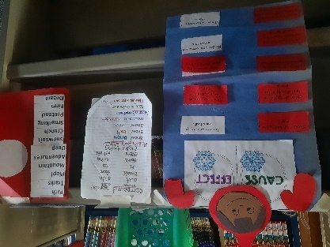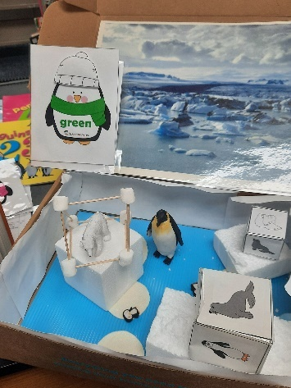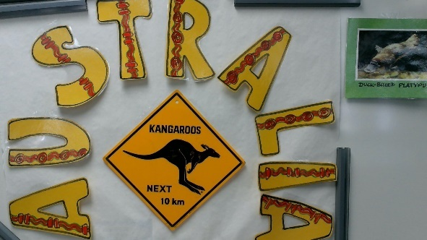

News from Kellie

The students have been working on the following areas in math:
● Practicing fact fluency
● Learning the multiplication facts up to 5
● Solving word problems involving time and measurement.
ELA
In third grade, English and Language Arts (ELA) consists of Reading, Word
Work, and Writing. This month the students are working in the following
areas:
Reading
● Determining the meaning of unfamiliar words focusing on synonyms and
antonyms.
● Citing Evidence from the Text
● Demonstrating an understanding of story elements (characters,
setting, and plot).
Word Work
● Practicing signing, writing and learning the meaning of spelling and
vocabulary words
Writing
● Writing a complete paragraph.
● Grammar - identifying nouns and verbs
Punctuation - Demonstrating an understanding of when to use the
correct punctuation mark (., ?, !)
Social Studies
Our class learned about Martin Luther King Jr. and why we honor him.
We discussed segregation and how African Americans were not treated
fair or equally. MLK Jr. was the leader of peaceful protests to fight
for civil rights.
Science
In science, our class continues to work on force and motion. The
students are exploring magnets. They are learning about the different
materials that attract or repel magnets.

Ms. Wheelock and Ms. Parson’s 1/2 Class
The 1st and 2nd Grade class kicked of the New Year with a look at the future. We talked about one goal we had for school, and how we all celebrated the holiday.
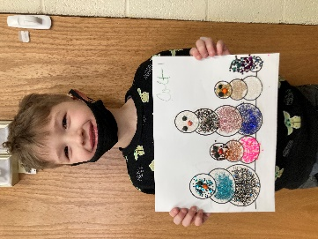
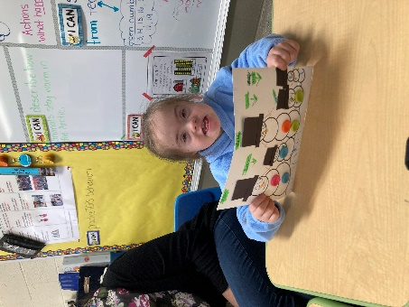
In Science and Social Studies we started our Winter Unit. We are learning about how animals adapt to the colder temperatures. We also discussed what we do with our families in the winter time. Our January Family Project was to decorate and label our Snowmen Families!
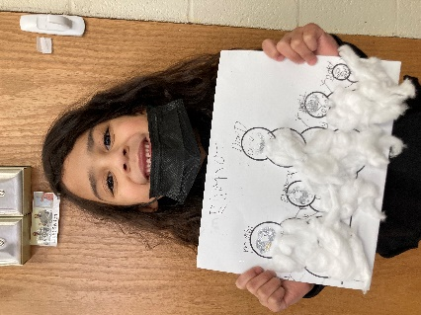
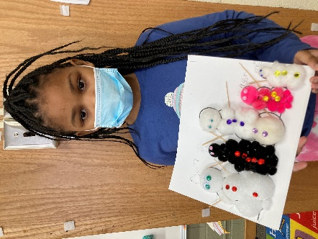

In honor of Martin Luther King Jr. Day, students learned about segregation and how people of different color skin were not always treated equally. We all wrote one dream of ours! Our kiddos ideas were pretty awesome!

ELA with Cathy Lee

ELA-7th Grade
In ELA the 7th graders have continued to read “A Long Walk to Water”. The story has shifted from a time of very little hope to the characters having hope once again. The character Nya, her village has finally got access to water through a man-made well. The other main character, Salva has been living in refugee camps. He has started to lose hope until he is chosen to move to America! We find out that he is moving to Rochester, NY! He is part of a group of boys called “The Lost Boys”. We found Rochester on the map and are now reading about his travels and experiences here.

News from Jessica

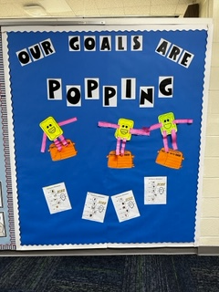
Jessica’s Class:
This month we focused on setting goals for the New Year, 2022! The students used picture choices to select their interests, what they are good at, what they enjoy doing and what their goal is for the upcoming year. We look forward to having a positive mindset and making positive choices this year. Happy New Year, family and friends! Thank you for your support.

6th Grade with Chelsea

6th Grade Update:
Other than a rough start to the New Year, quarantine, sickness, and being snowed in, the students have been GREAT!!!
The students have been working hard and just finished their first reading Magic Tree House: Dinosaurs before Dark. Their reading skills have greatly developed and their fluency was a huge improvement by reading a chapter with an adult for homework and then rereading in class. The students seemed to like the book and I plan to try and do other Magic Tree House books in the future. The students have also been making progress in math with ratios and how to identify equivalent ratios.
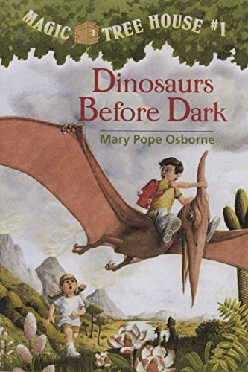

News from Bonnie Bell

It wasn’t all work and no fun! Before Christmas vacation, the students had the opportunity to make snowmen and paint a grinch rock.
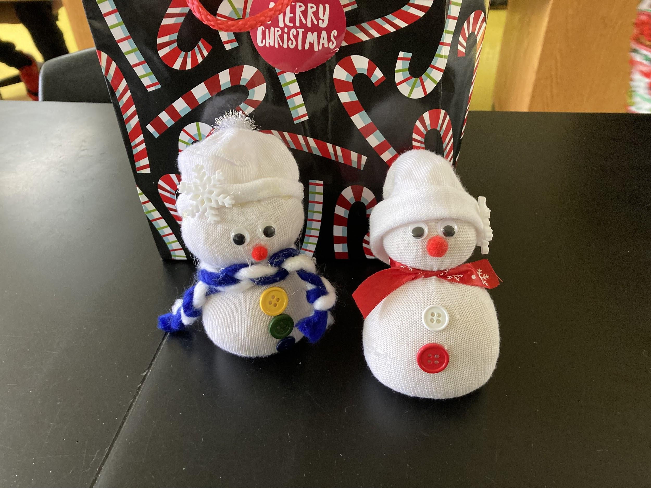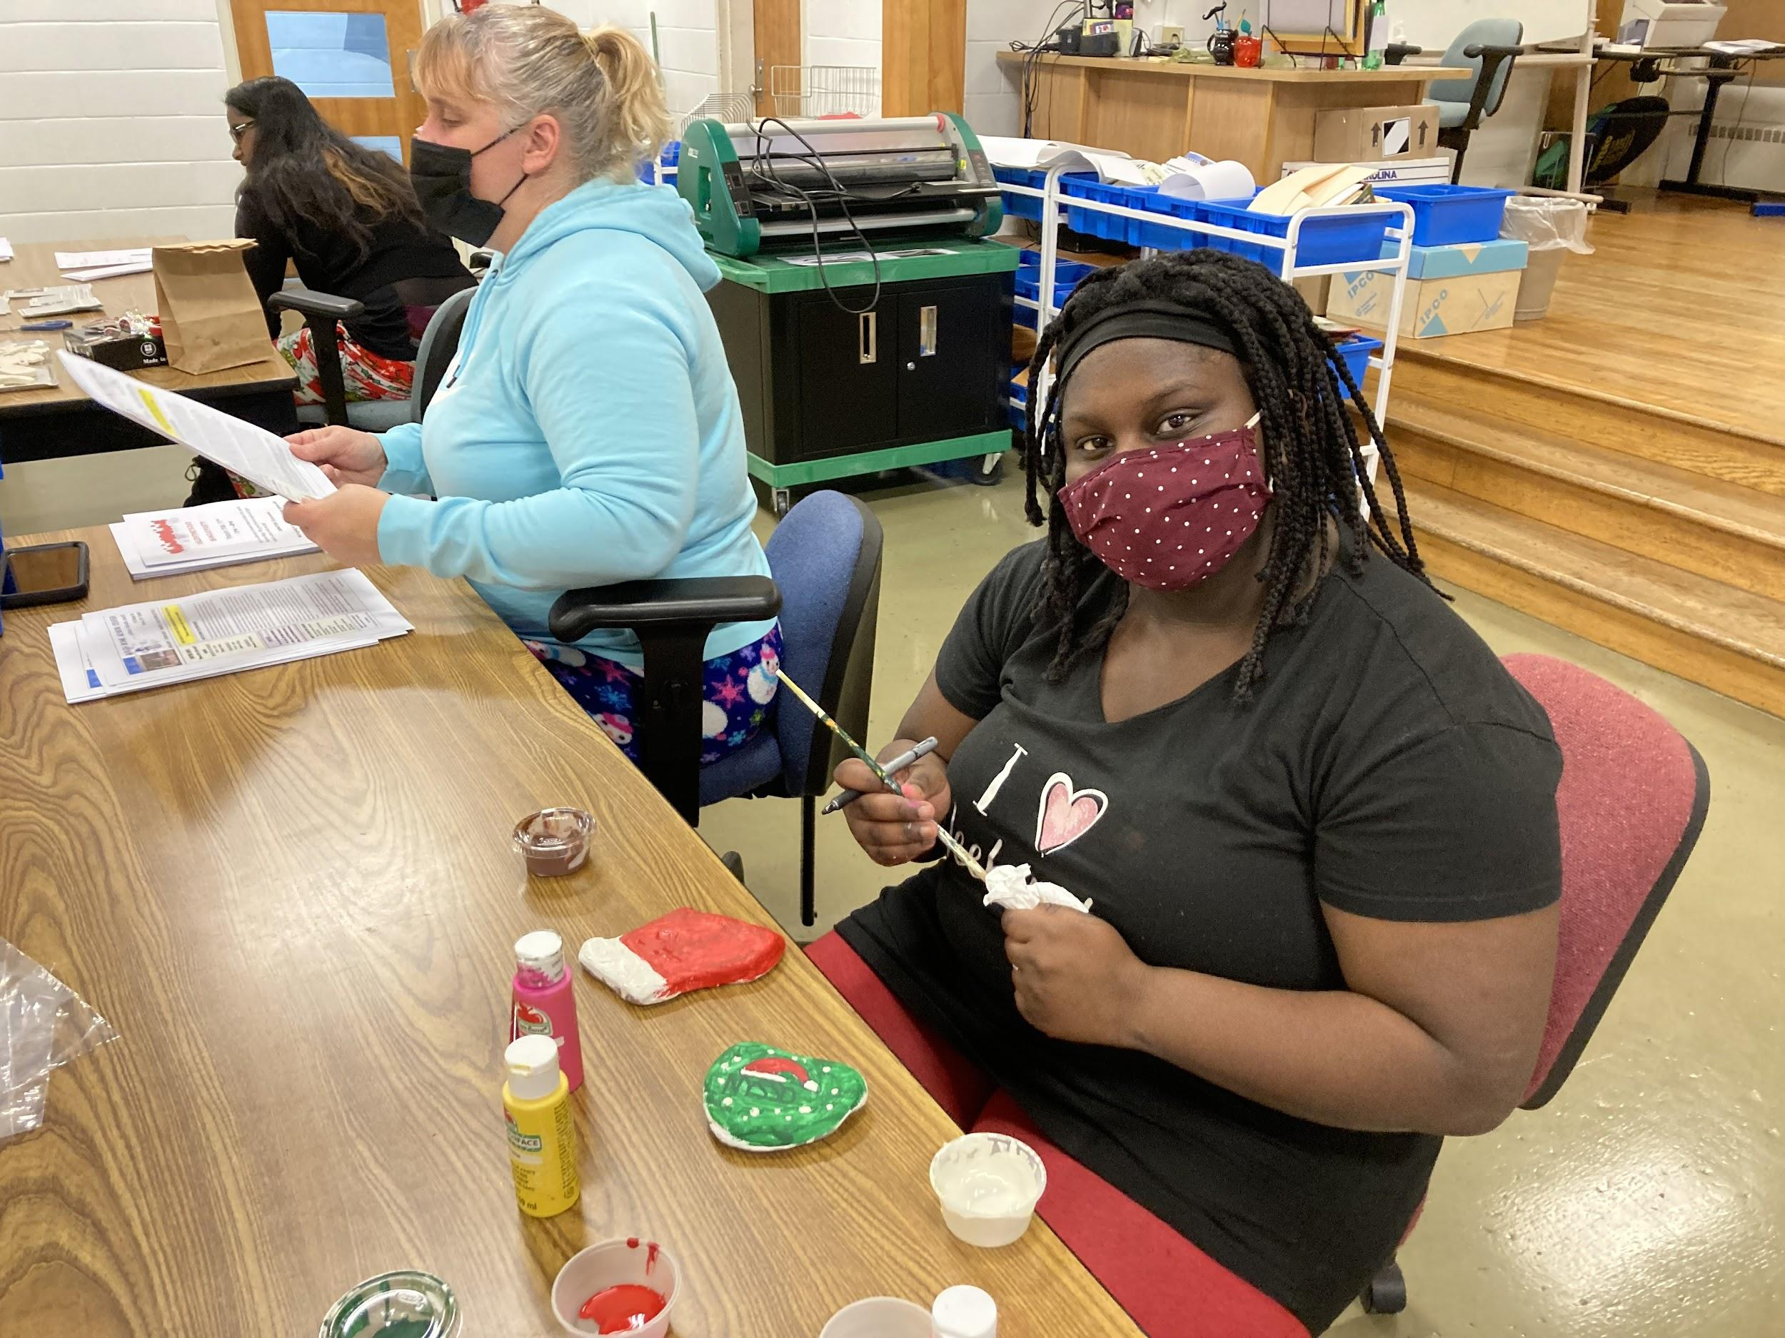

In Science 7, we will be entering a new unit on The Earth. We will take a look at Earth’s Structure and Motion by looking at the origin of the solar system. We are also going to look at carbon dating and fossils. I can’t wait to get started to see what they can do!

In Earth Science 9A as well as Earth Science 9B, we have also been investigating the Earth as a system. We just finished conducting one of our demonstrations such as: making sun tea to deepen our understanding of both open and closed systems, including discussing Earth’s 4 major spheres that interact with each other. We will also be discussing 3 very important cycles: the water cycle, the carbon cycle and the energy cycle. This unit will also give the students an opportunity to make some real-world connections through either reading articles or research.

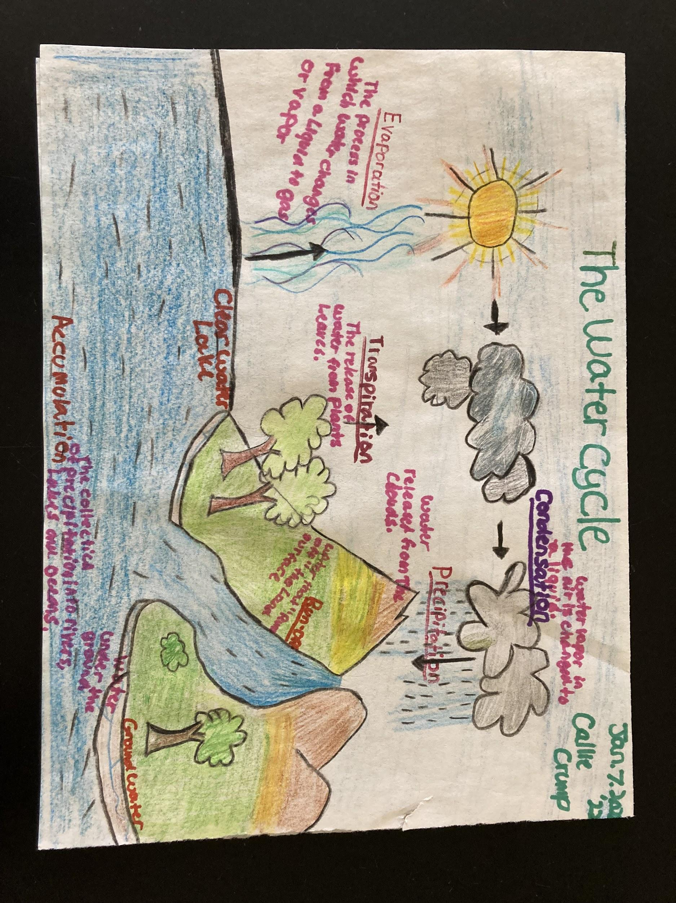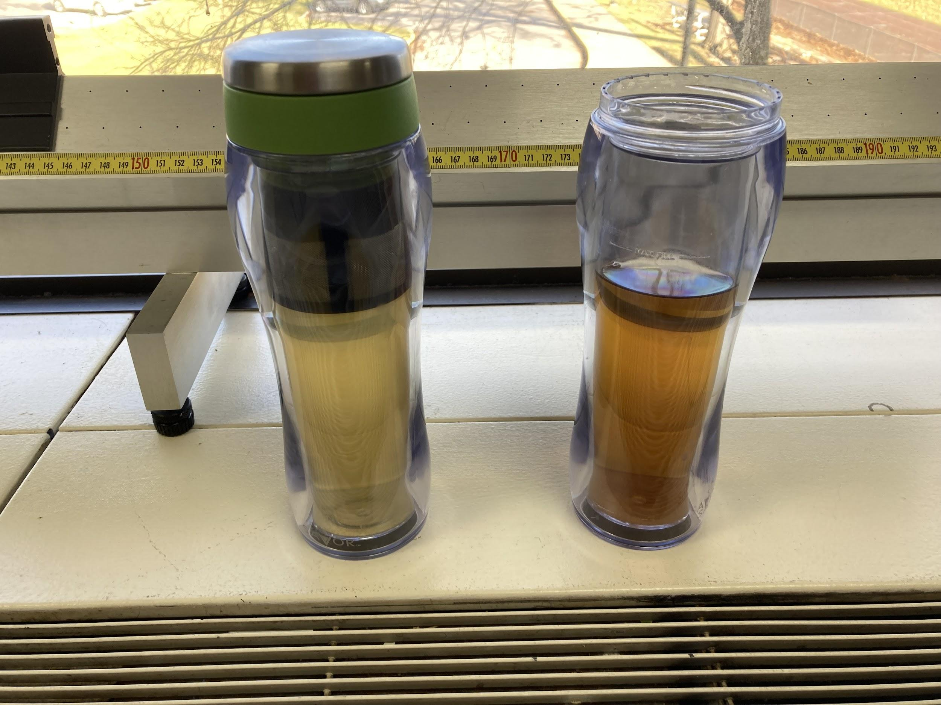

In Life Science, we discussed Classification. Namely, taxonomy and how organisms are classified. We are also just beginning to wrap up our unit review on “The Cell” which included identifying different parts of the cell, chemicals that organisms need in order to function, movement of small and large molecules across the membrane, how cells make food through photosynthesis as well as how cells break down the food into energy through the processes of cellular respiration and fermentation. Finally, just like how humans go through the stages of life, cells go through stages too.

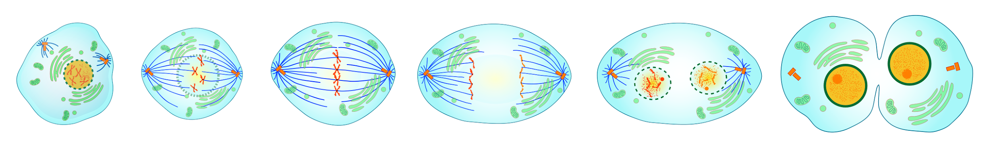

News from Gloria

Math
Students have been working on tables and graphs on paper and learning how to operate the graphing calculator. They are learning how to make new pages that will do what the students want the calculator to do. Students are working on iReady assignments that have been assigned to them.

ELA
Students have been working on book reports for their independent reading. While other students have been working on expanding their writing. Students continue to work on reading in class and gathering information from their reading. Students are working on iReady assignments that have been assigned to them.

February 2022

Jayden D. February 7
Hope V. February 7
Natasha C. February 14

News from Tom Karpe
Students learned about the paintings of the artist, Piet Mondrian. They took inspiration to create their own relief sculptures. They began created several sketches. Next, they collected and assembled materials to raise the materials to create low or high relief sculptures. Finally, they painted on their sculptures with the Piet Mondrian style.

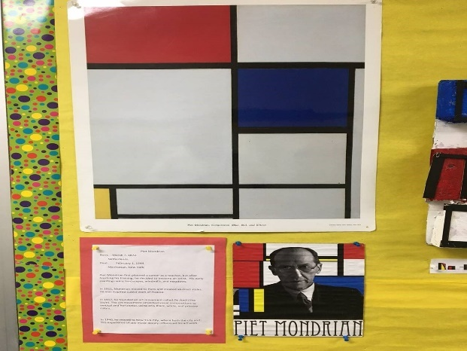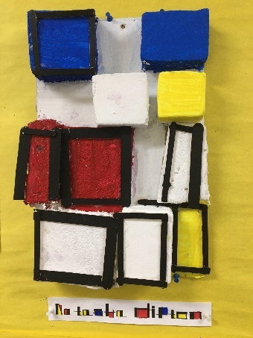

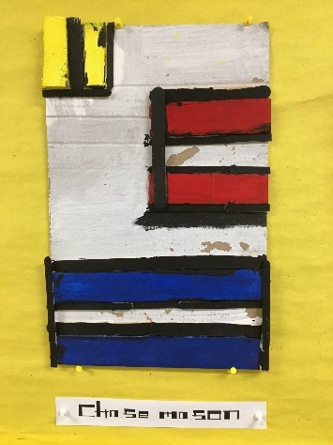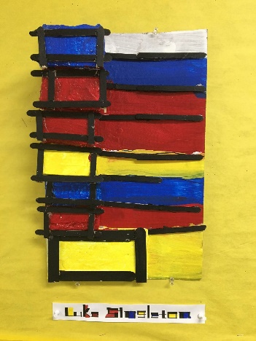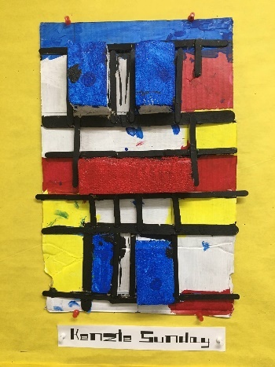

News from Erin
When we returned from break, our high school students started working on our 2021-2022 school yearbook! To accommodate all the high school students, this has been split into two sections. In the 8th period section, we have taken a thorough look at past year’s books and compiled a list of sections and topics we’d like to include in the 21-22 yearbook. We talked about what a yearbook is, and why it’s important and learned about “Superlatives.” Senior Cody Sharpsteen also taught our freshman how to use and operate our digital cameras for picture taking. Thanks Cody!

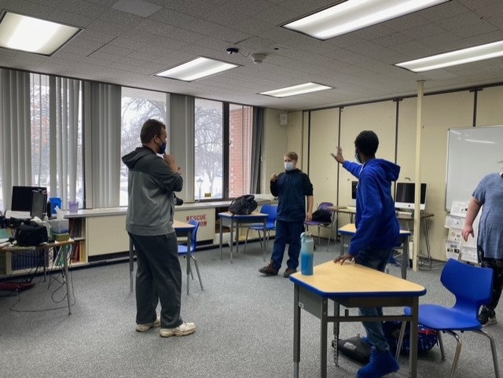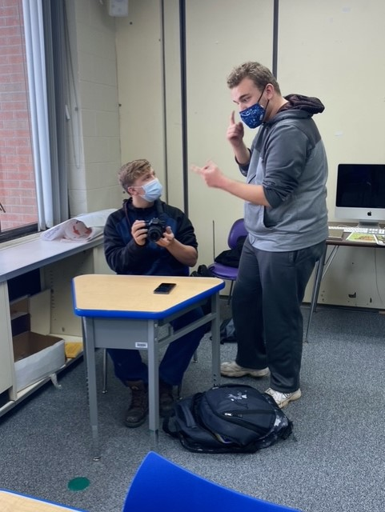

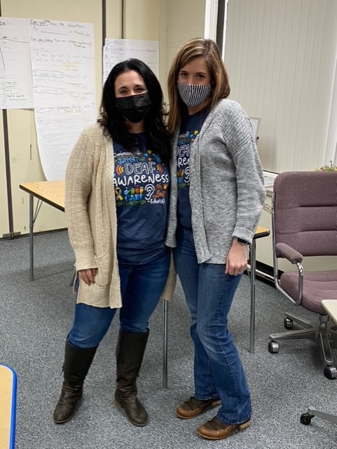

Happy Retirement, Liz!

On Thursday, January 13, 2022, Liz Bertrand, bid farewell to NYSSD and began a new chapter of her life…RETIREMENT! Liz has been a part of the NYSSD community for many years serving in several different capacities. Liz served in our work study program for several years where she helped students find employment and assisting in job coaching them. Liz also served as a childcare aide in the residential program mostly working with our boys where she continued to be an integral part in securing employment opportunities for our students in the after-school hours. Liz finished up her career at NYSSD serving as the overnight supervisor in the residential program.

In retirement Liz plans to spend time with her husband, her daughters, and her grandchildren. I’m sure she will also be spending a lot of time on her farm tending to her animals as well. Liz will certainly be missed at NYSSD. We will miss her passion for the students at NYSSD and her love for the Deaf community. Liz, we wish you all the best as you embark on this next chapter of your life. On behalf of the entire NYSSD community…THANK YOU! Thank you for your many dedicated years of service to the students of NYSSD!

