Library Services

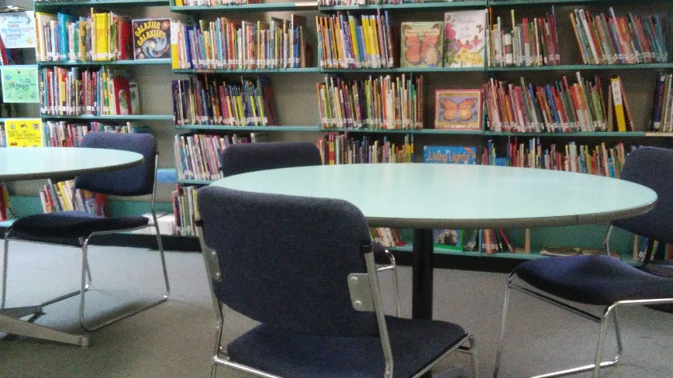
Information Resource Center for Library and Technology
The goal of the library is to provide our students with satisfaction for their curiosity, and the skills necessary to use libraries, computers, and the Internet throughout their lives. We use the Information Fluency Continuum, which places a heavy emphasis on the inquiry process, along with the AASL Standards Framework for Learners with the goal of providing a welcoming and flexible space for learning and growing. The library supports the academic programs of our school and is open year round to include the summer library program.
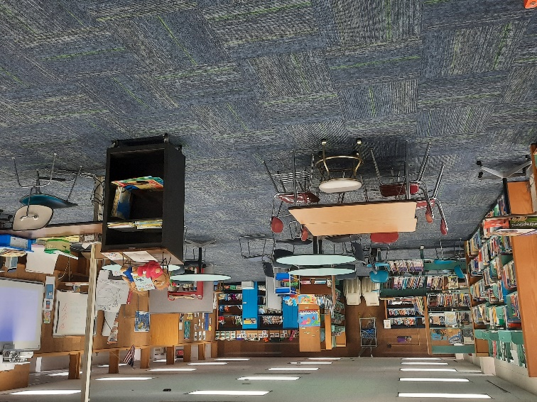
Technology
The Library maintains a Promethean interactive white board, a mounted projector, sound system, and several support technologies are available in the media center.
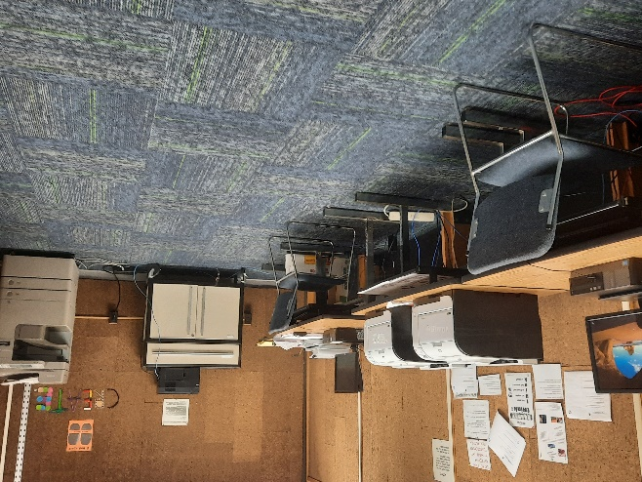
Beyond the library walls
The NYSSD Library is a member of the Madison-Oneida Boces School Libraries System.
Our collection is supported through borrowing throughout several Boces regions. We are able to provide a variety of databases and subscriptions, including e-books and learning materials through the generous lending library system and library catalog. The Library webpage is updated often and can be found here: https://mnyssd-opals2.moric.org/bin/home

