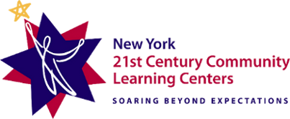

Semi-Annual Certification Form
Single Cost Objective

This is to certify that ____________Name________________, ______Job Title______, has worked 100% of his/her time for the period July 1, 20XX through December 31, 20XX on NCLB Title IVB 21st Century Community Learning Centers Grant Programs (CFDA 84.287).

_______________________________________
Signature of Employee

_______________________________________
Printed Name of Employee

_______________________________________
Date

_______________________________________
Signature of Supervisor

_______________________________________
Printed Name of Supervisor

_______________________________________
Date

